МІНІСТЕРСТВО ОСВІТИ І НАУКИ УКРАЇНИ
ОДЕСЬКИЙ НАЦІОНАЛЬНИЙ УНІВЕРСИТЕТ
імені І. І. МЕЧНИКОВА
ФАКУЛЬТЕТ РОМАНО-ГЕРМАНСЬКОЇ ФІЛОЛОГІЇ
КАФЕДРА ГРАМАТИКИ АНГЛІЙСЬКОЇ МОВИ
GENERAL ATTRACTIVENESS & APPEAL:
MENTAL-AND-LINGUAL MECHANISMS OF CREATING PARTICULAR PERSONAL IMAGES

МЕТОДИЧНІ РЕКОМЕНДАЦІЇ
до практичних занять та самостійної роботи
з навчальної дисципліни “Інтра- та екстралінгвальні детермінанти загальної привабливості” для здобувачів другого (магістерського) рівня вищої освіти спеціальності 035 «Філологія» спеціалізації 035.041 Германські мови та літератури (переклад включно), перша – англійська

ОДЕСА
2023
УДК 811.111’373.2.001.33:73/79
Н 584

Укладачі:
І. Б. Морозова, доктор філологічних наук, професор, професор кафедри граматики англійської мови
О. О. Пожарицька, кандидат філологічних наук, доцент, доцент кафедри граматики англійської мови

Рецензенти:
Н. О. Кравченко, доктор філологічних наук, професор, декан факультету романо-германської філології Одеського національного університету імені І. І. Мечникова
Н. В. Степанюк, кандидат філологічних наук, доцент, доцент кафедри лексикології та стилістики англійської мови Одеського національного університету імені І. І. Мечникова

Рекомендовано до друку вченою радою
факультету романо-германської філології ОНУ імені І. І. Мечникова
Протокол № 1 від 30 серпня 2023 року

Н584
General Attractiveness & Appeal: Mental-and-Lingual Mechanisms of Creating Particular Personal Images: метод. рекомендації до практичних занять та самостійної роботи з навчальної дисципліни «Інтра- та екстралінгвальні детермінанти загальної привабливості» для здобувачів другого (магістерського) рівня вищої освіти спеціальності 035 «Філологія», спеціалізації 035.041 Германські мови та літератури (переклад включно), перша – англійська / уклад. І.Б. Морозова, О.О. Пожарицька. – Одеса: Освіта України, 2023. – 68 с.

Розробка ставить собі завданням сформувати у здобувачів освіти знання про теорію загальної атрактивності особистості та практичні навички вербального моделювання, які б гарантували позитивне сприйняття їхнього повідомлення аудиторією. Подані питання для обговорення сприяють актуалізації отриманих знань.
УДК 811.111’373.2.001.33:73/79

(с) Морозова І.Б., Пожарицька О.О., 2023

(с) Одеський національний університет ім. І.І. Мечникова, 2023
ЗМІСТ

ПЕРЕДМОВА…………………………………………………………………………………………………………………….5
TOPIC 1: Speech Vs Language Portraits. Levels of a Personality’s Image & Speech Portrait 8
PERSON’S GENERAL APPEAL AND ATTRACTION 8
Personal Image as a Cognitive & Verbal Construct 8
TOPIC 2: Psychological Portrait of an Individual. Speech Behaviour as a Clue to the Psychological Portrait. 10
DEFINING KEY TERMS: INTERPERSONAL APPEAL, ATTRACTION, & AFFILIATION 10
TOPIC 3: Interpersonal Appeal Types and Their Roots. The Role of Associations in Making a Certain Impression on the Audience in General and One’s Interlocutor in Particular 15
Interpersonal Attraction. Leadership & Loneliness 15
Health Factors 17
DEVELOPMENT OF AFFILIATION AND ATTACHMENT 19
Smiling and affiliation. 19
Play and affiliation 22
TOPIC 4: The Concept of the Positive in the British World Picture. The Concept of the Positive in the American World Picture 24
BRITISH AND AMERICAN WORLD PICTURES & CONCEPTS OF THE POSITIVE 24
TOPIC 5: Verbal Modelling Granting a Positive Feedback from the Audience Addressed. Pinning Down the Audience’s Choices and Their Reasons. How to Look and Sound Attractive for Different Audience Types 26
HOW TO LOOK AND SOUND ATTRACTIVE? 26
GREETINGS 26
ATTACHMENT AND AFFILIATION, TO PEOPLE AND GOD 30
Initial Attraction 32
Physical Attractiveness 32
TOPIC 6: The Concept of the Negative in the British World Picture Vs the Concept of the Negative in the American World Picture: Differences and Similarities and Their Possible Origins. Real and Virtual Personalities & Their Speech Portraits 33
HOW TO BE (AND TO SOUND) BAD: THE BRITISH & THE AMERICAN PERSPECTIVES 33
TOPIC 7: Male and Female Attractiveness and Appeal. Cross-Gender Communication. General Attractiveness. Appealing and Unappealing Image & Speech Image 37
MALE & FEMALE ATTRACTIVENESS AND APPEAL 37
A pretty face 38
Affiliation & Belonging 40
HOW TO BE ATTRACTIVE ? 42
Fostering a Positive Self-Image 43
Attraction Pyramid 44
The issue of make-up 46
ATTRACTION: KEYS TO SUCCESS 47
When Complimenting a Lady… 53
Compliments for Men from women… 53
TOPIC 8: Speech Portrait of the Positive Personality Vs Speech Portrait of the Negative Personality. Psycholinguistic Experiment Results in Different Countries 58
VILLAIN’S UNSPEAKABLE APPEAL 58
SOCIAL REJECTION 65
LIST OF USED AND RECOMMENDED LITERATURE 67

ПЕРЕДМОВА

Шановні магістри!
Раді вітати вас на курсі "Інтра- та екстралінгвальні детермінанти загальної привабливості". Цей курс розкриє перед вами унікальну можливість зануритися в світ мовленнєвого спілкування, де кожне слово, жест, інтонація та міміка набувають величезного значення для створення іміджу особистості.
Мета методичних рекомендацій – ознайомити вас з теоретичними засадами ефективності мовленнєвого спілкування та побудови універсально привабливого іміджу особистості.
У даних методичних рекомендаціях до курсу розглядається проблема інтра- та екстралінгвальних засобів створення (власноруч та не тільки) іміджу привабливої особистості. Особливістю запропонованого підходу є детальне вивчення особистостей безперечних поганців, яким, як відомо, загалом співчувають, попри їхню злу сутність. Протягом курсу аналізуються різні ментально-лінгвальні механізми створення певного іміджу особистості.
Під час навчання на цьому курсі переслідуються наступні завдання:
  - 1. Окреслити основні напрями іміджології з позицій як мовної, так і позамовної комунікації.
  - 2. Навчити вас ефективному спілкуванню англійською мовою, що є важливою навичкою в сучасному світі.
  - 3. Покращити вашу професійно-педагогічну підготовку як майбутніх фахівців з іноземної мови.
  - 4. Навчити вас долати психологічні та екстралінгвістичні (позамовні) бар'єри у комунікації.
  - 5. Навчити вас моделювати універсально привабливий імідж в залежності від аудиторії слухачів.
Отже, у результаті вивчення навчальної дисципліни здобувач вищої освіти повинен знати: різницю між мовним та мовленнєвими портретами особистості; психолінгвістичні механізми людського спілкування; кореляції між мовленнєвими та психологічними рисами мовця; основні методики оптимізації англомовного мовленнєвого спілкування; що представляють собою концепти позитивності та негативності в американській та британській картинах світу; вміти: на основі спостереження мовленнєвої поведінки мовця вибрати найбільш ефективну модель спілкування; працювати з науковою лінгвістичною літературою; використовувати теоретичні знання на практиці та під час викладання англійської мови; розпізнавати та залучати до практики базові прийоми іміджології з метою забезпечення позитивного фідбеку від аудиторії; моделювати позитивний імідж в очах аудиторії за допомогою інтра- та екстра-лінгвальних засобів комунікації.
Особливу увагу у розробці приділено вербальному аспекту створення певного іміджу та вченню про комунікативні моделі.
У методичних рекомендаціях підтримується концепція Р. Сассоуера про «глобальну та універсальну привабливість». Також під час її написання увагу було приділено як роботам з іміджмейкінгу, запропонованими Гарвардським університетом, так і власним розробкам у даній царині.
На шляху навчання будуть розглянуті найважливіші аспекти мовленнєвої та позамовної комунікації, поглиблені знання англійської мови, і ви відкриєте для себе артистичні можливості створення певного іміджу.
Нехай цей курс стане для вас початком цікавого і плідного навчального шляху у світі комунікації та іміджування!

І.Б. Морозова,
О.О. Пожарицька,
iryna.b.morozova@gmail.com

TOPIC 1: Speech Vs Language Portraits. Levels of a Personality’s Image & Speech Portrait

PERSON’S GENERAL APPEAL AND ATTRACTION

Personal Image as a Cognitive & Verbal Construct

Personal Image, as a cognitive and verbal construct, refers to the mental representation or perception that individuals have of themselves. It encompasses how people see themselves, their self-concept, self-esteem, and self-identity. Personal Image is a complex construct influenced by various cognitive and verbal factors, including language and communication. It usually presupposes the following:
Self-Concept: Personal Image is closely tied to an individual's self-concept, which includes beliefs, attitudes, and perceptions about oneself. It involves understanding one's roles, abilities, and characteristics. Verbal communication, both internal (self-talk) and external (how others describe us), plays a vital role in shaping self-concept.
Self-Esteem: Personal Image is intertwined with self-esteem, which reflects one's evaluation of their self-worth. Verbal affirmations, compliments, and criticism from others, as well as self-affirmations, can impact self-esteem positively or negatively.
Self-Identity: Personal Image contributes to the formation of self-identity, which is the recognition of oneself as a unique individual with distinct qualities. Verbal constructs, such as narrative storytelling and autobiographical narratives, are instrumental in constructing and expressing self-identity.
Language and Self-Perception: Language is a tool that individuals use to describe themselves, express their emotions, and communicate their thoughts. The way people use language to describe themselves (self-descriptors) can provide insights into their Personal Image. For example, someone who frequently uses positive and self-affirming language may have a more positive Personal Image.
Social Interaction: Verbal communication in social interactions, including feedback from peers, family, and society, plays a pivotal role in shaping Personal Image. How others talk to and about an individual can significantly influence their self-concept.
Cognitive Processes: Personal Image involves cognitive processes, such as self-reflection and self-awareness. These processes often rely on internal verbalizations or thought patterns. For instance, someone reflecting on their strengths and weaknesses is engaging in internal verbal communication with themselves.
Cultural and Societal Influences: The verbal constructs associated with Personal Image can be influenced by cultural and societal norms. Different cultures may have varying ways of expressing and evaluating Personal Image.
Communication and Self-Presentation: Verbal communication also plays a role in how individuals present themselves to others. This includes the language they use to project their image to the world, such as in job interviews, dating, or public speaking.
Psychological Well-Being: Personal Image has a significant impact on an individual's psychological well-being. Positive self-perception can contribute to mental health, while negative self-image may lead to issues like depression or anxiety.
Altogether, personal image is a multifaceted construct that emerges from the interplay between cognitive processes and verbal communication. It's both an individual's perception of themselves and how they express that perception through language. Understanding one’s own or another person’s image can be crucial for fields like psychology, communication studies, and self-development, as it provides insights into how people view themselves and how verbal constructs shape their self-concept and self-esteem.
Questions for discussion:
- How do you think one’s personal image can be reflected in the way one speaks?
- What is a speech and a language portrait? What levels can it have?

TOPIC 2: Psychological Portrait of an Individual. Speech Behaviour as a Clue to the Psychological Portrait.

DEFINING KEY TERMS: INTERPERSONAL APPEAL, ATTRACTION, & AFFILIATION

ATTRACTIVE PEOPLE
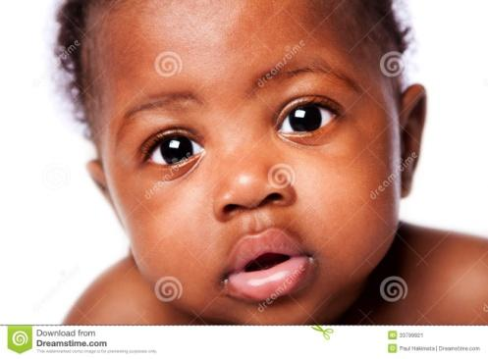

UNATTRACTIVE PEOPLE

Questions for discussion:
What makes a person attractive or unattractive?

A psychological portrait of an individual is a comprehensive analysis of their psychological characteristics, traits, behaviors, and thought patterns. It aims to provide a deeper understanding of an individual's personality, motivations, and inner workings. Speech behavior, how an individual communicates verbally, can offer valuable clues to construct such a portrait. Here's an overview of how speech behavior can provide insights into a psychological portrait:
The language an individual uses, including their vocabulary, tone, and style, can reveal aspects of their personality. For example, a person who frequently uses positive and optimistic language may have an optimistic outlook on life. Conversely, someone who uses negative or pessimistic language might be dealing with emotional challenges.
Speech behavior can indicate how expressive or reserved an individual is. Some people are naturally more talkative and open about their thoughts and feelings, while others are more introverted and reserved in their communication. Verbal expressiveness can be linked to extroversion or introversion.
The way a person communicates with others, such as being assertive, passive, or aggressive, can reflect their underlying personality traits. For instance, an assertive communication style may indicate confidence and self-assuredness, while passive-aggressive behavior might suggest unresolved conflicts.
Verbal tics, such as filler words (e.g., "um," "uh"), speech hesitations, or repetitive phrases, can offer insights into an individual's level of confidence, nervousness, or self-assuredness. These habits may manifest differently in various social situations.
How an individual listens and responds to others in conversations can provide clues about their interpersonal skills and empathy. Active listening and empathetic responses suggest good social awareness and emotional intelligence.
Speech behavior can change when an individual is under stress or experiencing strong emotions. For instance, a typically calm and composed person might become more agitated or less articulate when stressed.
The way an individual constructs and shares narratives about their life experiences can reveal underlying themes, values, and priorities. For example, someone who frequently discusses their achievements and goals may place a high value on ambition and success.
Non-verbal cues, such as body language, facial expressions, and gestures, accompany speech behavior. These cues can provide valuable context and insights into an individual's emotional state and intentions.
The topics an individual chooses to discuss and how they frame those discussions can be indicative of their interests, values, and concerns. Frequent discussions about family, career, or hobbies can reveal a person's priorities.
Analyzing how an individual's speech behavior changes across various contexts, such as work, social settings, or family interactions, can help create a more comprehensive psychological portrait. People may adapt their communication style to suit different environments.
It's important to note that constructing a psychological portrait based on speech behavior is a complex and nuanced process. Speech behavior should be considered alongside other psychological assessments and observations to form a complete understanding of an individual's psyche. Additionally, cultural and contextual factors can influence speech behavior, making it essential to consider these influences when drawing conclusions about an individual's psychological profile.
Psychological stereotypes about appearances and verbal behavior are cognitive biases or preconceived notions that individuals may hold about others based on their physical appearance and the way they speak. These stereotypes can lead to unfair judgments and assumptions about a person's character, abilities, or background. It's important to recognize and challenge these stereotypes to promote fairness and reduce discrimination.
The most popular stereotype assumes that physically attractive individuals are more intelligent, competent, and trustworthy than less attractive individuals. It can lead to preferential treatment in various contexts, such as job interviews or social interactions.
People often hold stereotypes about individuals based on their race or ethnicity, assuming that certain traits or behaviors are associated with specific racial or ethnic groups. These stereotypes can lead to discrimination and prejudice.
Gender stereotypes involve assuming that individuals of a particular gender have certain personality traits or abilities. For example, the belief that women are more nurturing and men are more assertive is a common gender stereotype.
People may make judgments about a person's intelligence, education, or background based on their accent or dialect. This can lead to discrimination against individuals who speak differently.
Judging someone based on their clothing choices or fashion style can lead to assumptions about their socioeconomic status, interests, or personality traits. For example, assuming that a person in formal attire is more professional than someone in casual clothing.
Verbal Behavior stereotypes involve making assumptions about a person's intelligence, education, or social status based on the way they speak. For instance, assuming that someone who uses slang or regional dialects is less educated or articulate.
Stereotypes related to age can lead to assumptions about a person's abilities, interests, or adaptability based on their age. For example, assuming that older individuals are less tech-savvy or that younger individuals lack experience.
People may judge others based on their body size or weight, assuming that individuals who are overweight are lazy or lack self-control, while those who are thin are disciplined and hardworking.
Stereotypes related to disabilities can lead to assumptions about a person's competence or limitations based on their disability. This can result in discrimination and exclusion.
It's important to note that these stereotypes are often inaccurate and unfair. People are complex and unique, and their appearances or verbal behaviors do not provide a complete picture of their character or abilities. Recognizing and challenging these stereotypes is essential for promoting equality, diversity, and inclusion in society.
Questions for discussion:
- What psychological stereotypes do you know?
- What verbal behaviour stereotypes do you know?

TOPIC 3: Interpersonal Appeal Types and Their Roots. The Role of Associations in Making a Certain Impression on the Audience in General and One’s Interlocutor in Particular

Interpersonal Attraction. Leadership & Loneliness

Have you ever wondered why people are motivated to spend time with some people over others, or why they chose the friends and significant others they do? If you have, you have given thought to.
Interpersonal attraction is showing a preference for another person (remember, inter means between and so interpersonal is between people).
This relates to the need to affiliate/belong which is our motive to establish, maintain, or restore social relationships with others, whether individually or through groups (McClelland & Koestner, 1992).
It is important to point out that we affiliate with people who accept us though are generally indifferent while we tend to belong to individuals who truly care about us and for whom we have an attachment.
In terms of the former, you affiliate with your classmates and people you work with while you belong to your family or a committed relationship with your significant other or best friend. The literature shows that:
- Leaders high in the need for affiliation are more concerned about the needs of their followers and engaged in more transformational leadership due to affiliation moderating the interplay of achievement and power needs (Steinmann, Otting, & Maier, 2016).
- “Who wants to take online courses?” Seiver and Troja (2014) found that those high in the need for affiliation were less, and that those high in the need for autonomy were more, likely to want to take another online course. Their sample included college students enrolled in classroom courses who had taken at least one online course in the past.
- Though our need for affiliation is universal, it does not occur in every situation and individual differences and characteristics of the target can factor in. One such difference is religiosity and van Cappellen et al. (2017) found that religiosity was positively related to social affiliation except when the identity of the affiliation target was manipulated to be a threatening out-group member (an atheist). In this case, religiosity did not predict affiliation behaviors.
Risk of exclusion from a group (not being affiliated) led individuals high in a need for inclusion/affiliation to engage in pro-group, but not pro-self, unethical behaviors (Thau et al., 2015).
- When affiliation goals are of central importance to a person, they perceive the estimated interpersonal distance between them and other people as smaller compared to participants primed with control words (Stel & van Koningsbruggen, 2015).
Loneliness occurs when our interpersonal relationships are not fulfilling and can lead to psychological discomfort. In reality, our relationships may be fine and so our perception of being alone is what matters most and can be particularly troublesome for the elderly. Tiwari (2013) points out that loneliness can take three forms. First, situational loneliness occurs when unpleasant experiences, interpersonal conflicts, disaster, or accidents lead to loneliness. Second, developmental loneliness occurs when a person cannot balance the need to relate to others with a need for individualism, which “results in loss of meaning from their life which in turn leads to emptiness and loneliness in that person.” Third, internal loneliness arises when a person has low self-esteem and low self-worth and can be caused by locus of control, guilt or worthlessness, and inadequate coping strategies. Tiwari writes, “Loneliness has now become an important public health concern. It leads to pain, injury/loss, grief, fear, fatigue, and exhaustion. Thus, it also makes a person sick and interferes in day to day functioning and hampers recovery…. Loneliness with its epidemiology, phenomenology, etiology, diagnostic criteria, adverse effects, and management should be considered a disease and should find its place in classification of psychiatric disorders.”

Questions for discussion:
- What do you think about the info above?
- Is loneliness a disease, needing to be listed in the DSM?

Health Factors
“Loneliness kills.” These were the opening words of a March 18, 2015 Time article describing alarming research which shows that loneliness increases the risk of death. How so? According to the meta-analysis of 70 studies published from 1980 to 2014, social isolation increases mortality by 29%, loneliness does so by 26%, and living alone by 32%; but being socially connected leads to higher survival rates (Holt-Lunstad et al., 2015). The authors note, as did Tiwari (2013) earlier, that social isolation and loneliness should be listed as a public health concern as it can lead to poorer health and decreased longevity, as well as CVD (coronary vascular disease; Holt-Lunstad & Smith, 2016). Other ill effects of loneliness include greater stimulated cytokine production due to stress which in turn causes inflammation (Jaremka et al., 2013); greater occurrence of suicidal behavior (Stickley & Koyanagi, 2016); pain, depression, and fatigue (Jarema et al., 2014); and psychotic disorders such as delusional disorders, depressive psychosis, and subjective thought disorder (Badcock et al., 2015).
On a positive note, Stanley, Conwell, Bowen, and Van Orden (2013) found that for older adults who report feeling lonely, owning a pet is one way to feel socially connected. In their study, pet owners were found to be 36% less likely than non-pet owners to report feeling lonely. Those who lived alone and did not own a pet had the greatest odds of reporting loneliness. But the authors offer an admonition – owning a pet, if not managed properly, could actually be deleterious to health. They write, “For example, an older adult may place the well-being of their pet over the safety and health of themselves; they may pay for meals and veterinary services for their pet at the expense of their own meals or healthcare.” Bereavement concerns were also raised, though they say that with careful planning, any negative consequences of owning a pet can be mitigated.
To read the Time article, please visit: http://time.com/3747784/loneliness-mortality/

DEVELOPMENT OF AFFILIATION AND ATTACHMENT

Smiling and affiliation.

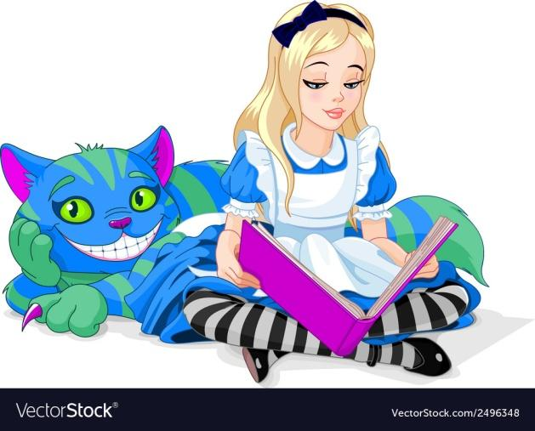
As early as 6-9 weeks after birth, children smile reliably at things that please them. These first smiles are indiscriminate, smiling at almost anything they find amusing. This may include a favourite toy, mobile over their crib, or even another person.
Smiles directed at other people are called social smiles. Like smiles directed at inanimate objects, they too are indiscriminate at first but as the infant gets older, come to be reserved for specifal people. These smiles fade away if the adult is unresponsive. Smiling is also used to communicate positive emotion and children become sensitive to the emotional expressions of others.
This indiscriminateness of their smiling ties in with how they perceive strangers. Before 6 months of age, they are not upset about the presence of people they do not know. As they learn to anticipate and predict events, strangers cause anxiety and fear. This is called stranger anxiety. Not all infants respond to strangers in the same way though. Infants with more experience show lower levels of anxiety than infants with little experience. Also, infants are less concerned about strangers who are female and those who are children. The latter probably has something to do with size as adults may seem imposing to children.
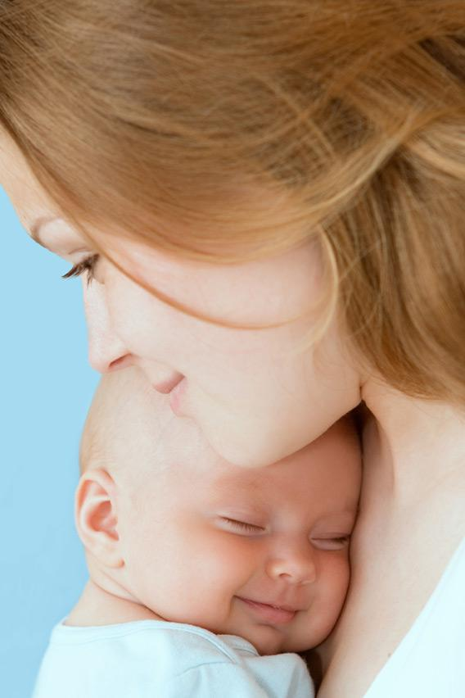
Important to stranger anxiety is the fact that children begin to figure people out or learn to detect emotion in others. They come to discern vocal expressions of emotion before visual ones, mostly due to their limited visual abilities early on.
As vision improves and they get better at figuring people out, social referencing emerges around 8-9 months. When a child is faced with an uncertain circumstance or event, such as the presence of a stranger, they will intentionally search for information about how to act from a caregiver. So, if a stranger enters the room, an infant will look to its mother to see what her emotional reaction is. If the mother is happy or neutral, the infant will not become anxious. However, if the mother becomes distressed, the infant will respond in kind. Outside of dealing with strangers, infants will also social reference a parent if they are given an unusual toy to play with. If the parent is pleased with the toy, the child will play with it longer than if the parent is displeased or disgusted.
Human appeal is closely connected with affiliation and the sense we are “taken in”. Smile is a silent non- verbal sign of liking and good humour.

Questions for discussion:
What kind of smile is it recommended to employ to arouse a subconscious sympathy for the first acquaintance?

In fact, none of the smiles given above is good for the first acquaintance.

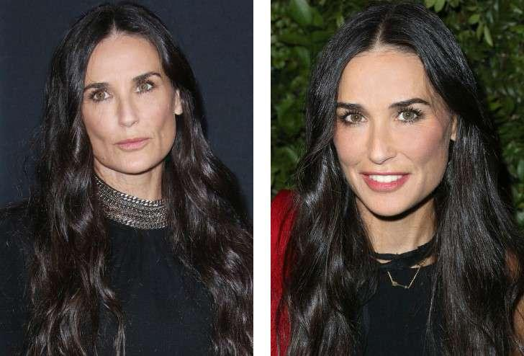

Here above is an example of the so-called social smile.

The ideal social smile should correlate with the attentive look of the smiling person, his/ her eyes open and focused on the interlocutor. The eye-contact is a must. The smile is not to be too wide demonstrating all teeth shown in a line. Such “Hollywood smiles” are usually believed to be insincere and self-confident.

Play and affiliation
Children are also motivated to engage in play. Up to about 1.5 years of age, children play alone called solitary play. Between 1 ½ and 2 years of age, children play side-by-side, doing the same thing or similar things, but not interacting with each other. This is called parallel play.
Associative play occurs next and takes place when two or more children interact with one another by sharing or borrowing toys or materials. They do not do the same thing though. Around 3 years of age, children engage in cooperative play which includes games that involve group imagination such as “playing house.” Finally, onlooker play is an important way for children to participate in games or activities they are not already engaged in. They simply wait for the right moment to jump in and then do so. Though play develops across time, or becomes more complex, solitary play and onlooker play do remain options children reserve for themselves. Sometimes we just want to play a game by ourselves and not have a friend split the screen with us, as in the case of video games and if they are on the couch next to you.
The children play is a shining example of the necessity of cooperation for the purpose of arousing attraction. People, who do not come in social touch with others, seldom produce the impression of attractive personalities, to say nothing of their general appeal. As a rule, they are lost in the crowd and fog , and other people cannot even recollect their faces. Here we do not speak about milkmen, postmen, porters, etc., whose presence is usually neglected by the others.
Hence, to be attractive one must be noticed and welcomed as a cooperation partner.

Questions for discussion:
- Why do people who do not come in social touch with others seldom produce the impression of attractive personalities? Give a reasonable explanation.
- Why is the presence of service people usually neglected and unnoticed? Give a reasonable explanation.

TOPIC 4: The Concept of the Positive in the British World Picture. The Concept of the Positive in the American World Picture

BRITISH AND AMERICAN WORLD PICTURES & CONCEPTS OF THE POSITIVE

British and American worldviews and concepts of the positive are shaped by a combination of historical, cultural, and social factors. While there are many similarities between these two Western societies, there are also some differences in their perspectives on what is considered positive. Here's an overview of some key aspects of British and American worldviews and their concepts of the positive:
1. Individualism vs. Collectivism:
- American Perspective: The United States is often characterized by its strong emphasis on individualism. Americans tend to value personal freedom, autonomy, and self-reliance. The "American Dream" embodies the idea that individuals can achieve success through hard work and determination.
- British Perspective: While individualism is also present in British culture, there is a historical tradition of collectivism, particularly seen in the welfare state. British society values social safety nets and a sense of community responsibility.
2. Optimism and Positivity:
- American Perspective: Americans are often associated with a can-do attitude and optimism. There's a cultural belief in the possibility of upward mobility and success. Positive thinking and a focus on achieving one's goals are highly valued.
- British Perspective: British culture may be perceived as more reserved and cautious in expressing optimism. British humor, characterized by dry wit and self-deprecation, often plays on the theme of finding humor in adversity.
3. Work Ethic:
- American Perspective: The Protestant work ethic, which emphasizes hard work, ambition, and success as signs of God's favor, has had a significant influence on American culture. Americans often value long hours and are driven by the pursuit of success.
- British Perspective: The British also value hard work, but there's a tradition of work-life balance and shorter workweeks. The idea of "keeping a stiff upper lip" in the face of challenges is part of British culture.
4. Social Welfare and Healthcare:
- American Perspective: The United States tends to have a more individualistic approach to social welfare, with limited government intervention in areas like healthcare. Access to healthcare is often seen as a personal responsibility.
- British Perspective: The UK has a National Health Service (NHS) that provides publicly funded healthcare to all residents. This reflects a more collectivist approach to healthcare and social welfare.
5. National Identity:
- American Perspective: American identity is often tied to ideas of freedom, democracy, and the American Dream. Patriotism and a strong sense of national pride are common.
- British Perspective: British identity is complex, encompassing England, Scotland, Wales, and Northern Ireland. It often includes historical elements and a sense of both national and regional identity.
6. Attitudes Toward Authority:
- American Perspective: There's a strong tradition of individual rights and skepticism of government authority in the United States, reflected in the Bill of Rights and the Constitution.
- British Perspective: The UK has a constitutional monarchy with a parliamentary system. British culture often includes respect for tradition and authority figures, although there is also a tradition of political dissent and protest.
It's important to note that these generalizations don't apply to everyone in either British or American society, and there is significant diversity within both cultures. People's perspectives on what is positive and their worldviews can vary widely based on factors such as region, socioeconomic background, and personal beliefs.
Questions for discussion:
- Who do you believe is the embodiment / are the embodiments of the British and the American concepts of the positive? Why?
- Find the examples of the speech behaviour discussed above in the films or TV shows illustrating a clash of mentalities. Discuss them in class.

TOPIC 5: Verbal Modelling Granting a Positive Feedback from the Audience Addressed. Pinning Down the Audience’s Choices and Their Reasons. How to Look and Sound Attractive for Different Audience Types

HOW TO LOOK AND SOUND ATTRACTIVE?

GREETINGS
Entering a conversation one should greet the perspective interlocutor.

Questions for discussion:
- Which form of greeting will you choose for the first acquaintance?
Hello! Hi!, Good morning/evening, sir/ madam! What’s cooking, good looking? Sorry! Aloha!
- Is a hearty shake-hand necessary? Or, perhaps, a hug?
- Motivate your choice

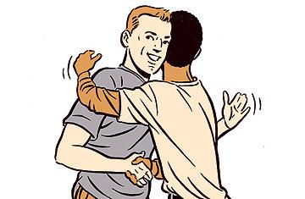
It is crucial to note that speech etiquette possesses a significant role in communication, in all spheres of life and situations ranging from formal communication to informal ones.
According to the linguistic dictionary, speech etiquette represents the system of sustainable speech formulas imposed by the society in order to maintain communication in a chosen tone according to social roles and role positions relative to each other.
Speech etiquette is applied in different situations: greetings, getting acquainted, farewells, gratitude, condolences, apologizing and others. Brits demonstrate their own national-cultural peculiarities of the speech etiquette. The etiquette formulas are connected with the life style and national traditions
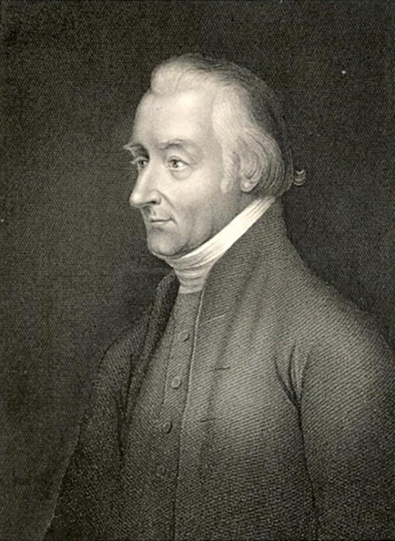
The notion of the speech etiquette dates back to the 19th century when there appeared a very popular grammar book after the authorship of Lindley Murray. Basing upon R. Lowth’s method L. Murray wrote a book «English Grammar Adapted to Different Classes of Learners», 1795. It was so popular in its time that first book underwent 50 editions and its abridged version more than 120.
At the outset, the speech etiquette is closely correlated with the topic of the conversation. It is frequently observed that British people are skilled at small talks. In other words, they try to avoid controversial or critical discussions when they communicate with strangers.

Lindley Murray

One of the peculiar features of English speech etiquette is that English people tend to choose a safe and personally unobtrusive topic such as the weather as an appropriate starter.
It is assumed that English people talk about the weather because they are interested in this subject. Conversely, Kate Fox considers a different point of view concerning this topic. In the book "Watching the English" she mentions that English conversations about the weather are not really about the weather, but it is a form of code and envolved to help them overcome their natural reserve. (Fox K. (2014). Watching the English. The Hidden Rules of English Behaviour, UK)
It is known that the greeting expressions 'Nice day, isn't it?', 'Isn't it cold?', 'Still raining eh?' and other variants on the theme are not requests for meteorological facts. They are ritual greetings, conversation starters or default 'fillers"
Greetings are important as well as frequent in everyday social interactions all over the world. Appropriate greeting behaviour is crucial for the establishment and maintenance of interpersonal relationships. According to Spolsky, greetings are considered to be "the basic oil of social relations'' (Spolsky B. (1998). Sociolinguistics. Oxford: Oxford University Press, p.20.).
English greetings are short. They are varied according to the social distance and social status of the interlocutors. When an English speaker asks you, "How are you? "or "How is your work?", he is not concerned much about your physical condition or work, but showing his politeness.
But personal interest is an obligatory touch of arousing the interlocutor’s liking. Hence, instead of "How are things with you?" the winning policy would be saying something, like “I remember you told me about your new manager last time. Has he changed much in the office?”or “ I have recently chanced to see your daughter . She has taken much after her mother/ evidently your kin/ the same eyes of yours.”
In English, greetings such as "Hello!", "How do you do?"and "I am pleased to meet you" are used to maintain the hearer's positive face, depending on the status of the participants and the social setting.
"Morning, Boardman, " ...
"How are you today?"
"Oh, middlin', lad, just middlin'."( J. Harriot)
In the English culture, the words such as Miss, Sir, and Madam are used express respect to the interlocutor. "Sir" is particular for adult men who are the same or higher in job position, social status or age. For instance:
“Can I help you, sir?” addressed the shop keeper Thane (J.Oke).
On the other hand, being addressed to children “Sir” and “Madam” to demonstrate the speaker’s irritation with the child’s behaviour or are used as mockery. “What are doing, Jane, madam?”
Greetings and the form of address differ greatly, depending upon the age or social position of the interlocutor, i.e. in vertical and horizontal dialogues they are different.

Communicative task 1. You want to get registered for the week-end outing with the group of students unknown to you. Your actions? Discuss pros and cons of your behaviour.
- I come to the most pleasant looking boy/girl and ask her/him to help me.
- I ask who is the monitor/ group-leader.
- I go to the dean’s office and try to get registered there.
Dramatise the situation.

ATTACHMENT AND AFFILIATION, TO PEOPLE AND GOD
Attachment is an emotional bond established between two or more individuals and involving one’s sense of security.
Our attachments during infancy have repercussions on how we relate to others the rest of our lives.
Ainsworth et al. (1978) identified three attachment styles an infant possesses.
The first is a secure attachment and results in the use of a mother as a home base to explore the world. The child will occasionally return to her. She also becomes upset when she leaves and goes to the mother when she returns.
Next is the avoidantly attached child who does not seek closeness with her and avoids the mother after she returns. Finally, is the ambivalent attachment in which the child displays a mixture of positive and negative emotions toward the mother. She remains relatively close to her which limits how much she explores the world. If the mother leaves, the child will seek closeness with the mother all the while kicking and hitting her.
A fourth style has been added due to recent research. This is the disorganized-disoriented attachment style which is characterized by inconsistent, often contradictory behaviours, confusion, and dazed behaviour (Main & Solomon, 1990). An example might be the child approaching the mother when she returns, but not making eye contact with her.
The interplay of a caregiver’s parenting style and the child’s subsequent attachment to this parent has long been considered a factor on the psychological health of the person throughout life. For instance, father’s psychological autonomy has been shown to lead to greater academic performance and fewer signs of depression in 4th graders (Mattanah, 2001).
Attachment is also important when the child is leaving home for the first time to go to college. Mattanah, Hancock, and Brand (2004) showed in a sample of four hundred and four students at a university in the Northeastern United States that separation mediated the link between home and children, and prevented 2/3 of them from college adjustment.
The nature of adult romantic relationships has been associated with attachment style in infancy (Kirkpatrick, 1997). One final way this appears in adulthood is through a person’s relationship with a god figure.

Initial Attraction

Interpersonal Attraction is the strength of our liking or loving for another person.

Physical Attractiveness
Although it may seem inappropriate or shallow to admit it, and although it is certainly not the only determinant of liking, people are strongly influenced, at least in initial encounters, by the physical attractiveness of their partners (Swami & Furnham, 2008). Elaine Walster and her colleagues (Walster, Aronson, Abrahams, & Rottman, 1966) arranged a field study in which college boys and girls were randomly paired with one another at a “computer dance.” After the partners had danced and talked for a couple of hours, they were interviewed separately about their own preferences and characteristics as well as about their perceptions of their date.
The dance-partnrs could’t tell anything about each other, their hobbies, family,tastes
Hence..
Walster and her colleagues found that the only important determinant of participants’ liking for their date was his or her physical attractiveness. None of the other characteristics—even the perceived intelligence of the partner—mattered.
We all think we know instinctively what we find attractive in other people. Off the top of our heads, we will probably mention attributes such as facial appearance, physical build, mannerisms and behaviours. But how do we define physical appeal and attraction? What, precisely, makes an attractive woman or man?
To understand better their seductive effects, Shakespeare's love sonnets were analysed through the mathematics of rhythm and the structure of language and vocabulary. In the result of analysis there were found specific algorithms and regularities which manifest their influencing the sub-consciousness.. Nevertheless, breaking down the aspects of attractiveness into their component parts and then subjecting them to rigorous scientific testing has provided answers to many of the basic questions about the judgements we make in the first few moments of meeting a potential partner.
The psychological mechanisms underlying these judgements of attractiveness in humans have evolved with the primary purpose of finding a high quality mate. Animals display traits and receive multiple signals related to some basic physical quality or attribute and science shows we are not very far removed from animals in these respects.

TOPIC 6: The Concept of the Negative in the British World Picture Vs the Concept of the Negative in the American World Picture: Differences and Similarities and Their Possible Origins. Real and Virtual Personalities & Their Speech Portraits

HOW TO BE (AND TO SOUND) BAD: THE BRITISH & THE AMERICAN PERSPECTIVES

The British and American worldviews and concepts of the positive and the negative are often reflected in verbal behavior through language choices, communication styles, and the emphasis placed on certain values. Here are some ways in which these cultural differences can manifest in verbal behavior:
1. Politeness and Indirectness:
- British Perspective: British communication often involves politeness, indirectness, and the use of euphemisms. For example, saying "It's not quite what I had in mind" instead of a direct criticism.
- American Perspective: Americans tend to be more direct in their communication, often preferring to state opinions or feedback more explicitly.
2. Humor and Self-Deprecation:
- British Perspective: British humor often involves self-deprecating jokes and irony. It's common to downplay one's achievements or make light of difficult situations.
- American Perspective: American humor may be more focused on positivity and optimism, with an emphasis on humorous anecdotes or observations.
3. Confidence and Positivity:
- American Perspective: Americans may use confident and positive language to express their ideas and aspirations. Phrases like "I can do it" or "I believe in myself" are encouraged.
- British Perspective: British communication may contain a degree of caution and self-restraint, even when expressing positivity. Phrases like "I hope it goes well" or "We'll see how it turns out" reflect this tendency.
4. Modesty and Avoiding Bragging:
- British Perspective: British individuals may downplay their accomplishments and avoid appearing boastful. They might say, "It was a team effort" or "I got lucky."
- American Perspective: Americans may be more comfortable discussing their achievements and ambitions openly, without the same degree of reservation.
5. Expressing Thanks and Gratitude:
- British Perspective: British people often use polite language to express thanks, such as "Thank you very much" or "I appreciate your help."
- American Perspective: Americans tend to be more effusive in expressing gratitude, using phrases like "Thanks a million" or "I'm so grateful for your assistance."
6. Social Norms and Formality:
- British Perspective: British communication can be more formal, particularly in certain situations like business meetings or official gatherings.
- American Perspective: American communication may be less formal and more casual in similar settings, often using first names and friendly language.
7. Handling Criticism:
- British Perspective: British individuals may be more accustomed to receiving and giving constructive criticism in a polite and subtle manner.
- American Perspective: Americans may be more direct in their feedback, aiming to be clear and straightforward when addressing issues.
8. Politeness in Criticism:
- British Perspective: British communication often involves a certain level of politeness and indirectness when delivering criticism. For instance, using phrases like "I'm not entirely sure about that" to express disagreement.
- American Perspective: Americans may tend to be more direct and straightforward in their criticism, using clear language to express their negative opinions or concerns.
9. Expressing Displeasure:
- British Perspective: In the UK, it's common to employ understatement or humor when expressing displeasure. For example, saying "It's not my cup of tea" to indicate that one dislikes something.
- American Perspective: Americans may use more direct language to express their dislikes, such as "I really don't like it" or "I can't stand it."
10. Apologies and Avoiding Confrontation:
- British Perspective: British communication often includes apologies and attempts to avoid confrontation. Phrases like "I'm sorry, but..." or "I don't mean to be a bother, but..." are frequently used.
- American Perspective: Americans may be more assertive and less likely to use apologies as a precursor to expressing negative feedback.
11. Sarcasm and Irony:
- British Perspective: British humor often includes sarcasm and irony as ways to express negativity or criticism indirectly.
- American Perspective: While Americans also use sarcasm and irony, they may employ more straightforward language when expressing negative opinions.
12. Handling Disappointment:
- British Perspective: British individuals might use phrases like "Oh, that's a shame" or "I was rather hoping for something else" to express disappointment with a more restrained tone.
- American Perspective: Americans may use language that conveys disappointment more explicitly, such as "I'm really disappointed" or "I had higher expectations."
13. Use of Softeners:
- British Perspective: British speakers may use softening phrases like "I don't want to be too critical, but..." or "Perhaps it's just me, but..." before expressing negative opinions.
- American Perspective: Americans may be less likely to use such softeners and get to the point more directly when discussing negative topics.
14. Avoiding Bluntness:
- British Perspective: British communication often avoids bluntness and strives for a more nuanced approach, even when discussing negative topics.
- American Perspective: Americans may be more comfortable with directness and straightforwardness in their language, particularly in conflict or negative situations.
It's important to remember that these are general tendencies and that there is significant variation within both British and American cultures. People from these cultures can adapt their verbal behavior to different contexts and individuals. Furthermore, globalization and increased cultural exchange have led to some convergence in communication styles, making it important to consider individual preferences and context when interpreting verbal behavior.

Questions for discussion:
Think of real and virtual personalities, their speech behaviour and personal image. Watch their interviews and say whether they comply with the concept of the positive or the concept of the negative more? Why?

TOPIC 7: Male and Female Attractiveness and Appeal. Cross-Gender Communication. General Attractiveness. Appealing and Unappealing Image & Speech Image

MALE & FEMALE ATTRACTIVENESS AND APPEAL

It might be interesting to take a moment and consider the things you would look for if you were, for example, about to embark on a speed dating mission to find the partner of your dreams.

Questions for discussion:
What would you look for on a speed dating mission?

In a BBC internet survey of the top three most desirable traits in a potential partner, after breaking down the results according to gender, men ranked good looks and facial attractiveness higher than women, combined with honesty, humour, kindness.
Women preferred intelligence, honesty, humour, and dependability in their men.
On the other hand, women would also seek men with good earning potential and nurturing capabilities. Women were also much more choosey about the type of man they were attracted to, while men were far less discriminating. This is in line with the Darwinian theory of mate selection, with choosey females and competitive males.

Questions for discussion:
- What men find attractive about women and vice versa?
- What makes a pretty face?

A pretty face
What makes a pretty face? Studies have found that average, symmetrical faces are attractive and it is thought they honestly signal good traits such as healthiness, including how well a person has adapted to the stresses of genetic and environmental development. Hence, facial symmetry suggests "good genes". In a recent survey, women with symmetrical faces were considered to have more feminine facial proportions and such feminine features are considered to be more attractive.
While facial symmetry is regarded as an attractive quality, most people don't actually realise they are looking for symmetry. Once again, unconscious mechanisms come into play in determining face preferences. This may help explain why the reasons behind attraction are often so difficult to describe.
Women also prefer symmetrical open faces with men. But if men would like to see kind and demure faces of their feminine partners, women would prefer candid brutal faces of males.

Physical attractiveness presupposes a person having large, round, and widely spaced eyes, a small nose and chin, prominent cheekbones, and a large forehead.

60% people find blondes more attractive than brunettes. Girls with more feminine forms have over 30% more chances to settle matrimonial relations with men.

Zebrowitz has found that individuals who have youthful-looking faces are more liked, are judged as warmer and more honest, and also receive other positive outcomes. Parents give baby-faced children fewer chores and punishments, and people with young-looking faces are also required to pay lower monetary awards.

Questions for discussion:
Can you explain why these very face peculiarities make a face attractive?

Affiliation & Belonging
On the other hand, the American psychologists Michael Koeble and Peter Parsa have shown that physical attraction we feel to other people is closely connected with our of previous feelings of affiliation and belonging.

Their experiments with volunteers prove that 82% of women tend to find babies resembling their own children physically attractive.

In their turn, 87% children (aged 6-14) find attractive those women who belong their mothers’ type.

Communicative task 2. Read the dialogues and analyse them. Why do people feel affection for others?
- In the famous children's book “Little Lord Fauntleroy”, Cedric tells his granddad the following: “We usually love our relatives”
“Why?” wonders His Grace. “Because we are a part of them. And you can’t hate your hand or arm.”

“Which of the puppies do you like?” Dad asked, pointing at two collie-pups. The bigger one with the beautiful silver coat was gloomily staring ahead. It was a boy. I had always dreamt to have a male dog. I stretched out my hand to pet it. The dog looked at me askance and moved aside, while the ginger-coloured girl suddenly jumped at my hand, rubbed her silky nose against my palm and … finally licked it!

“This one!” I said half-audibly and stroke the girl’s head.

(Audrey Harriette. Animal Stories. )

So, as a conclusion from the Lord Fauntleroy story, we can say that to feel someone’s appeal one should feel affiliation with that person. There is even a saying “kin souls”. And then appearances don’t matter so much.

The fragment about the dogs, in its turn, describes the boy choosing a puppy for the long-run life and friendship. His being attracted to a certain puppy is motivated not by the objective state of things and his preferences, but by his being liked by the puppy. Actually, he likes and chooses the puppy because he was already chosen by dog!

Hence, attraction and appeal are usually mirrored!

HOW TO BE ATTRACTIVE ?
The answer lies in creating an attractive personality or building up an image, i.e. the general impression that a person, organization, or product presents to the public.
Your image reflects who you are, not only your personality and lifestyle, but also your values and goals. It is a way of communication and says about you much more than you may think. Reflect for a minute on your image… What is your image of yourself?
Self-image is the personal view, or mental picture, that we have of ourselves. Self-image is an “internal dictionary” that describes the characteristics of the self, including such things as intelligent, beautiful, ugly, talented, selfish, and kind.

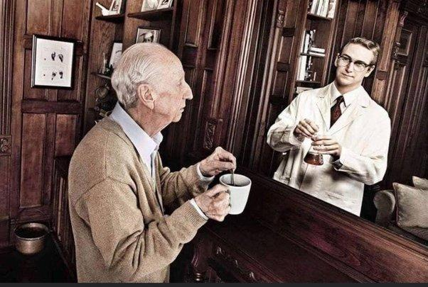

"He strives to project an image of youth" – IS HE really YOUNG?
It is always subjective!
Either underestimated or overestimated

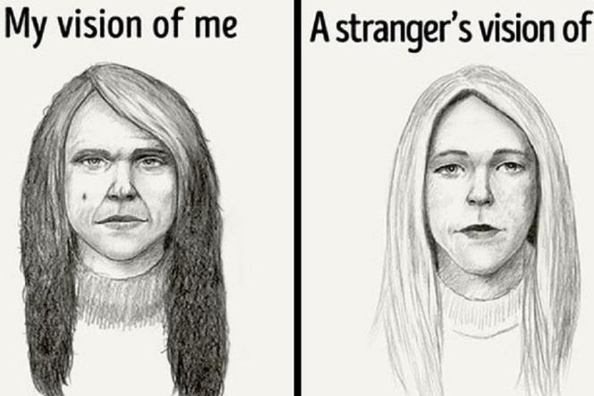

Fostering a Positive Self-Image
Our self-image is dynamic and changing. Creating and growing a positive self-image is a process that can go on over a lifetime.

Self-image is the personal view, or mental picture, that we have of ourselves. Self-image is an “internal dictionary” that describes the characteristics of the self, including such things as intelligent, beautiful, ugly, talented, selfish, and kind.
These characteristics form a collective representation of our assets (strengths) and liabilities (weaknesses) as we see them. A positive self-image can boost our physical, mental, social, emotional, and spiritual well-being. On the other hand, a negative self-image can decrease our satisfaction and ability to function in these areas.

Attraction Pyramid
On April 7, 2015, Psychology Today published an article entitled, “The Four Types of Attraction. POSITIVE, NEGATIVE, MIRRORED. IMAGINARY.”
In the attraction pyramid, the INDIVIDUAL is understood as a sphynx, and his/her personality as a pyramid.

The attraction pyramid places status and health at the bottom, emotional in the middle, and logic at the top of the pyramid.
Status takes on two forms.
Internal refers to confidence, your skills, and what you believe or your values. External refers to your job, visual markers, and what you own such as a nice car or house. Health can include the way you look, move, smell, and your intelligence.
The middle level is emotional which includes what makes us unique, trust and comfort, our emotional intelligence, and how mysterious we appear to a potential suitor.
And then at the top is logic which helps us to be sure this individual is aligned with us in terms of life goals such as having kids, getting married, where we will live, etc. The article says – “With greater alignment, there is greater attraction.”

To read the article for yourself, visit:
https://www.psychologytoday.com/us/blog/valley-girl-brain/201504/the-four-types-attraction

Questions for discussion:

What can be forged in the attraction pyramid? In what way?

How to use the attraction pyramid to modify one’s image?

Which face below do you find more attractive? Why? How to achieve that effect?

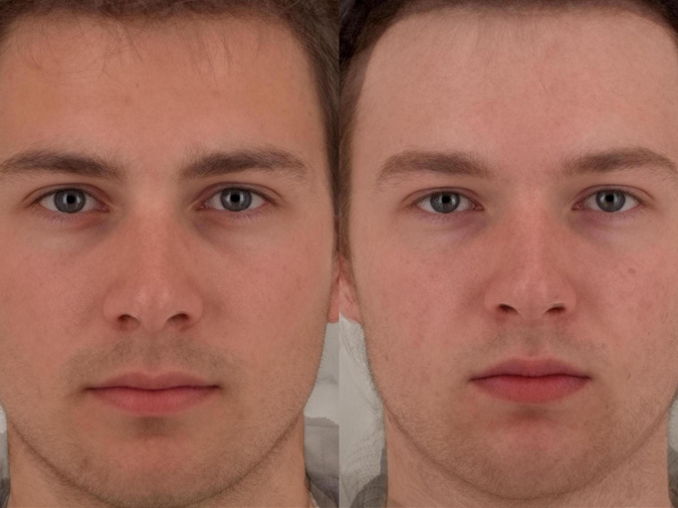

The issue of make-up
The link between attractiveness and hormone levels is lost when women wear make-up. However, both men and women judge full facial make-up to be more attractive than wearing no facial makeup. Men prefer women with full eye make-up and foundation, but lipstick is not necessarily considered an enhancement to beauty. Men find a greater contrast between the darkness of the eyes and lips and the lightness of the surrounding skin to be most beautiful.
Hence, to create a desired look both men and women resort to make up.
Here we mean appropriate not obligatory grease-paint, but a hair style and colour, wearing a beard, type of pronunciation, wearing a perfume , etc, things that help to conceal faults or eve to create an appealing image.

Questions for discussion:
- What else can be fixed in the pyramid? How to fix or change the following?
- What can produce a positive and what can produce a negative effect in:
- Appearance;
- Manners;
- Pronunciation;
- Grammar?
Why?
- Think of five things that make a person disgusting. Give examples.

ATTRACTION: KEYS TO SUCCESS
Present a neat appearance. Pay attention to how you will appear to others. Brush your hair, trim your facial hair and be sure to wash your face and neck before attending a social situation. If desired, use minimal makeup, and keep it natural for first impressions. Choose clothing colours and styles that compliment your figure but are not over flashy, skimpy or inappropriate. Dress for the event or meeting you will be attending. Don’t put on an evening gown or a tuxedo to a casual encounter or jeans to a formal event.
Smile. Smiling can help keep you in a positive mood, and people will be more willing to approach a person who seems friendly and is enjoying themselves. Be sure not to smile immediately when you meet someone, though. First, pause and look at the person’s face when greeting them, then smile warmly and let it show in your eyes as well. This makes them feel as if your smile is meant only for them.
Make eye contact. When you make eye contact with someone, it signals that you are wanting to connect and are approachable. If you are interested in someone, occasionally look at them, no matter who is talking, to show that you want to see how they react. During conversations, hold eye contact for as long as is comfortable.
- One trick is to pretend your eyes are glued to the other person’s eyes with sticky taffy. Don’t break eye contact until a few moments after they are done speaking. Slowly and reluctantly look away, pretending like you are stretching the sticky taffy between you until it breaks.
- Another trick is to count the number of times the other person blinks while you are having a conversation.
- Know that some people may be uncomfortable with this type of attention. If you notice that the other person seems to be reacting negatively to your behavior or seems nervous, break eye contact more often .
Turn your body toward the person. People pay attention to the way you act towards them. When you first meet someone, turn your body completely toward them so you face them directly. When you turn toward someone this way, it tells the other person that you feel they are very special.
Don’t fidget. Moving around a lot or using frequent hand motions near your face can make the other person feel unimportant or that you are anxious to get the conversation over with. It can even give the impression that you can’t be trusted. Earn credibility by keeping your eyes on the other person during the conversation and not fidgeting, twitching, wiggling, squirming, hair-twirling or scratching.
Keep an upright posture. A straight but comfortable posture can give the impression of confidence. Hold your head high, put your shoulders back and step lightly. Move with self-assurance and poise, and sit with your back straight. Don’t stare at your feet, make your back overly rigid or slump over.
- One trick you can use to help you do this is to visualize a leather bit is hanging from the ceiling or doorway. Pretend to take a bite on the leather bit. This will put a sweeping smile on your face, keep your posture lifted upright and your feet weightless.
Imagine every person you meet is an old friend. Think of a person you care about who you have known a long while, and picture that person when you first meet someone. This can trick your body and facial expressions into relaxing and becoming more open and friendly. For example, your eyebrows will soften, and smiling will come naturally. Additionally, when you pretend to like someone it is easier to actually start to enjoy their company.
Greet the person. Always remember to give an introductory greeting—even something as informal as "hello" works fine in most situations. This opens up communication between you and sets the tone for the interaction. If the other person hasn’t noticed you, you will now be on their radar.
- Tell the person your name and inquire about theirs if it isn’t offered.
- Tell the person, "So nice to meet you" or something along those lines that tells them you are happy to be talking with them.

Pay attention to body cues. Not only do you want to utilize body language that will attract people to you, but you need to be able to read others’ body cues as well. When you understand how people are feeling by the expression on their face, posture, ect., you will be able to react appropriately. People may give you clues that they are engaged, bored, disagree with you or are ready to flirt, and if you can recognize them, you will know what to do next.
- Look for a genuine smile. When a person smiles, the corners of his or her eyes will crinkle and the cheeks will lift along with the mouth. This is a true smile and means the individual is enjoying your company.
- See where the individual's feet are pointed, while either sitting or standing. if the feet are pointed toward you, then the person is having a good time with you. Likewise, if they are angled away, then that person is ready to leave.
- While a torso facing you can be a sign that the other person is engaged, turning one's belly in another direction shows that that person may be defensive or not enjoying the conversation.
- Fidgeting hands or legs and arm or leg crossing can signal that the person is anxious, bored or angry.

You can read more about the body language here: https://www.wikihow.com/Read-Body-Language
Make contact. Move closer, and check to see how the other person reacts. If they tense up or seem nervous, then gradually increase a little more space between you. If they seem more comfortable or encourage the closeness, touch an arm to build more positive energy.
Start your initial conversation with a question or a compliment.
Ask questions. One of the biggest things to remember when meeting and trying to attract new people is that people like to talk about themselves. If you seem genuinely interested in them, they may seek you out again or become more curious about you. Find out as much about the person as you can—ask what they like to do, the things they enjoy or find interesting or what their goals are. Open-ended questions work the best because they encourage the person to share more information.
- If you are attending a party or other special event, you might ask, "How do you know the host?"
- You can ask questions like, "What’s your favourite type of music" or "What movies have you seen lately?" as ice breakers.
- Point out something you have in common, such as "It looks like we’re both wine/art/fashion fans. What is your favourite kind?"
Make your questions sound genuinely interested and short enough for the interlocutor to easily grasp the meaning.
On the other hand, don’t be prying! Avoid asking personal questions, like: Have you got a promotion? I know it’s long enough since you have been working in this company. Or: Is that guy your boy-friend? I think I have recently seen you two in a disco bar.
Remember names. Remembering someone’s name is a sure way to come across as interested. Repeat the name after you hear it out loud. Then, try to remember it with a mnemonic device, such as a rhyme or alliteration, by repeating it in your head.
- Something like Joe, Joe from So-Co can work wonders to help you put a face to a name later.
Start with a compliment, such as one regarding their outfit. If they just performed or spoke during a conference or meeting, for example, then compliment them on what they did or said. If you know about their work, find something about it to praise. Say something like, "I love your shoes" or "I really admired what you said…"
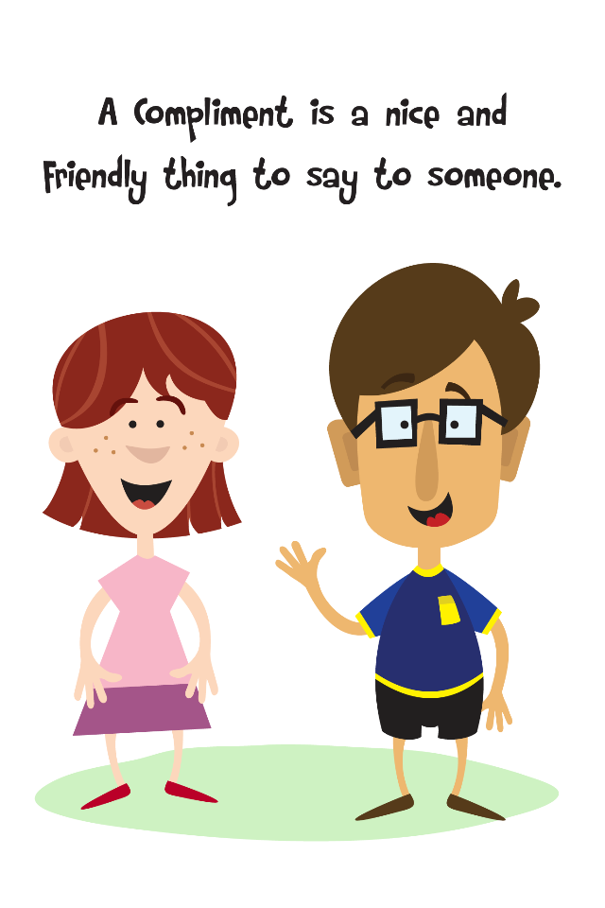
Compliments are universally considered to be a verbal bribery or a verbal gift. The best compliment is that which is not trite, but aimed at certain features of a human personality one would like to possess, or has strived hard to obtain. Hence, a good complment is always personal.

Communicative task 3. Think of five compliments for women and men, paid within the gender or to the opposite gender. Try to dramatize the situations in class. Tip: The easiest way to receive compliments is to say: THANK YOU! But there may be more…

When Complimenting a Lady…
- Gorgeous. Instead of telling her she's pretty, tell her she's gorgeous. ...
- Stylish. Telling a woman that she's stylish accomplishes two things: first, you're saying that she looks wonderful; and second, you're saying that she has impeccable taste. ...
- Refreshing. ...
- Witty. ...
- Disarming.

Compliments for Men from women…
- You look so reliable..
- You have a great sense of style. ...
- I love to watch you move/ smile /drive a car/ work in the garden. It is so manly ...
- When I look into your eyes, I see intelligence, humour, and kindness. ...
- Your perfume smells fantastic. ...
- That blue/brown/green shirt of yours matches your eyes. I have never known they are so blue/green, etc.

Communicative task 4. Dramatize the following situations.
1.You are a guest at a social party of archaeologists. Here is Prof. Brown present. You want to use this chance to produce the right impression on him and the others to fill in a possible vacancy of an interpreter in his group going to Egypt.
2. At the conference, you see a pretty girl in a company of her collegues. You want to strike an acquaintance with her.

Avoid certain topics. Negative energy tends to push people away. Don’t complain, insult the person, gossip or use sarcasm during your conversation. Stay away from controversial topics or ones that may make you seem superficial, such as money, religion or health.
Be polite and respectful. Being a little more formal than necessary and using a sign of respect can earn you positive attention. Use words like "sir" and "ma’am" to refer to older individuals or superiors and always be sure to say, "thank you" and "you're welcome."
Be open, honest and helpful. These factors are always important in any relationship but can be especially beneficial in a professional environment where information can sometimes be guarded. If there is something you don’t know but can find out for the person, let them know that you will be seeking an answer for them. This shows that you are willing to go out of your way to help.
- Try phrases like, "Here's what's happening," "How can I help?" or "I'll find out."
- Offering to help is a great way to earn appreciation and gratitude. If you can make an impact on another person’s success, then go for it. People will notice you, and you will begin to attract more people who like your proactive, supportive nature.
- Don’t be afraid to admit your weaknesses. People like those who are willing to confess what they need to work on or who aren’t afraid to acknowledge when they need help. Showing some humility will go a long way to make people like you.
- Ask for minor assistance yourself!

Offer words of encouragement. Validation from others can inspire us to work harder so we achieve more. You can really make a positive impact by offering words of encouragement. "I believe in you" is a heartening and reassuring thing for someone to hear. It also greatly increases your likeability factor.
Talk more. People like those who aren’t afraid to fill the silences. When people are quiet during conversations, we tend to wonder what they are thinking and if they like us. When you let your thoughts be heard, you take the guesswork out of the interaction, and make others feel at ease.
- If you need something to talk about, share good news. Be the person who has the positive outlook and has something uplifting to say. This could be anything from good national or world news, to good news for a company or organization. It could even be something personal, like the birth of a child.
- Have a few funny or interesting stories ready. You can start the conversation off this way after your introduction to show that you are easy-going. These can also be used to fill silences.

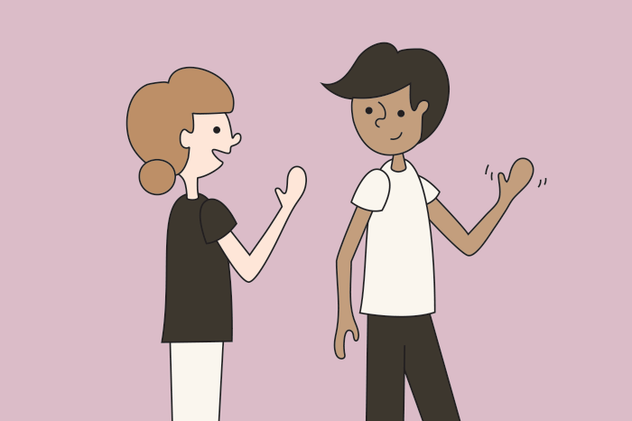
Exit the conversation when you’ve made a good impression.
Excuse yourself and repeat the person’s name to leave the person feeling good after your interaction. The key is to make the person want something more from you, perhaps another conversation or maybe they are curious about something you said or did. Excuse yourself and ask for a number or email exchange before busying yourself with some other task or conversation.
- Say "It’s been a pleasure to get to know you, John."
- Some relationship counselors recommend waiting to consummate a romantic relationship. Holding off can increase attraction, allowing you to try a relationship and get to know the person first.

Your words say more about you than you have ever thought.

Questions for discussion:
Do you know that the way you talk and how you sound to other people reflect your personal image?

A distinctive tone of voice and expressions used consistently can become easily recognizable as your clothes or makeup or colours you wear and reinforce some aspects of your image.
  - Keep a distinctive and consistent tone
No matter what business you represent, you will likely make a first impression on your clients or followers with words through a webinar, an article on your website, a post, or emails.
Whatever words and tone you use, it must be consistent throughout your communications so your clients can recognize who is speaking.
  - Create an emotional connection
The words you use shape how your clients see you and build ongoing relationships based on emotional engagement.
Verbal communication can convey more meaning when the tone of voice is natural and express the right emotions with the message sent.
The pitch used assists in emphasizing certain words that help people identify the intention of your message.
Add to your message more credibility being:
- Sincere
- Straightforward yet kind
- Authentic
- Attentive
Whatever words and tone you use, it must be consistent throughout your communications, so your message is perfectly understandable.
3. Try to make your speech complete so as to bring home the main message, but brief enough lest the audience should be bored
Remember! Your sentences should be lineally brief and structurally simple or complicated. Using complex constructions stick to the clauses of reason and result.
e.g.- I want you to…
- Our task is…
- Since the weather is hot, our deliveries will be…

TOPIC 8: Speech Portrait of the Positive Personality Vs Speech Portrait of the Negative Personality. Psycholinguistic Experiment Results in Different Countries

VILLAIN’S UNSPEAKABLE APPEAL

“What a man is, such is his speech,” says the well-known Latin saying. From this it is clear that by finding a correspondence between mental models and their reflection in the structures of speech, it is possible with sufficient probability to judge the personality of the speaker.
It is known that the brain of any person can be programmed like a computer, and then "decompose human behavior down to the most secret thought".
From this it is clear that with the help of special mental-communicative techniques it is possible to influence the subconscious of people so that the interlocutor is perceived by them as a person of a certain type. In other words, a change in the verbal code of the message is reflected in the image of the speaker and his perception by the interlocutor.
Studying the positivity of the image of the speaker, Professor of Philosophy R. Sassoer points out personal attractiveness as its defining characteristic. On the other hand, T. A. van Dijk connects the creation of a positive image by the speaker with the interlocutor with the conscious or subconscious use of the strategy of positive self-representation.

Questions for discussion:
Is Hannibal Lecter a Monster to Like? What is appealing in him?
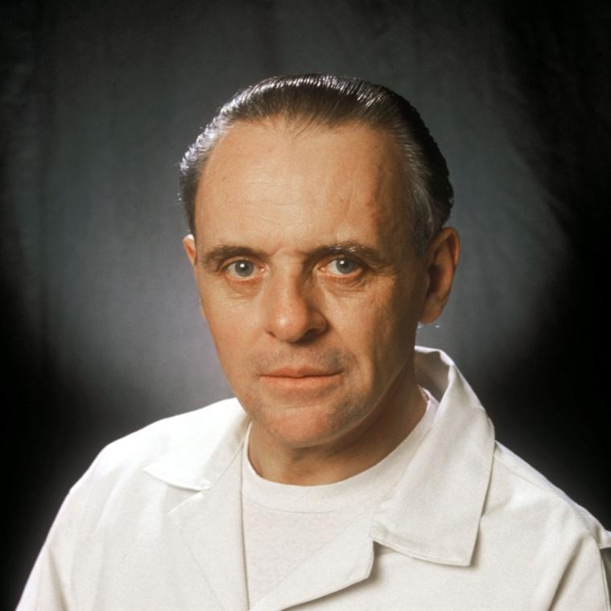

Obviously, different people like psychologically different personalities. At the same time, based on the developments of J. Boolos in the field of marketing, it can be argued that there are certain stereotypes of the human personality that impress everyone. In his study of the “universal attractiveness of the personality”, R. Sassoer considers various types of human attractiveness that meet the internal psychological needs of the widest sections of the population.
Summarizing his observations, we can distinguish the following characteristics of a universally attractive personality:
1) arousal of interest,
2) intelligence combined with the availability of presentation of thoughts,
3) independence,
4) fidelity to certain principles,
5) sexual attractiveness,
6) physical or spiritual strength.

Questions for discussion:
How does the film form a positive perception of the cannibal maniac Dr. Hannibal Lecter? Find what his personal attraction is and how he implements his strategy of positive self-representation.

From the first shots of the film, where only the brutal maniac-cannibal Hannibal Lecter contained in isolation is mentioned, the audience's interest is fueled by the mystery of his personality, his special position among other prisoners and the story of his appearance in a psychiatric hospital. Even his name mysteriously bears a resemblance to his addiction to cannibalism: Hannibal (the great commander of antiquity) and cannibal (savage who eats human meat). Hannibal Lecter is an intellectual, highly educated person, freely quoting Latin proverbs: “Quid pro quo”. He is a famous psychiatrist, connoisseur of nature, an artist who draws beautiful pictures from memory. “What I want is a view. I want a window where I can see a tree, or even water… Memory, Officer Starling, is what I have instead of view.” So, demanding the improvement of his conditions, Hannibal first of all wants closeness to nature: to see a tree, water. His speech is full of aphorisms, it enchants the listener: “Life's too slippery for books, Clarice. Typhoid and swans came from the same God."
He is independent. Throughout the short period of screen time, when the viewer sees Hannibal, the latter takes the position of a communicative leader in the conversation, calls the FBI intern by name: “Sit. Please”, “Your first lie to me, Clarice”, “Now go. go.”
Most of his utterances are correlated with short, structurally simple sentences, which makes his speech especially penetrating and easy to understand. Hannibal is quite principled and, in his own way, logical in his actions. He is honest with Clarice that he won't hurt her: "I have no plans to call on you, Clarice, the world being more interesting with you in it."
Hannibal is sexy. At the same time, his attractiveness is explained not only by the magnetism and charisma of the actor, Anthony Hopkins, but is also a consequence of his statements. Evyan skin cream, and sometimes you wear L'Air du Temps, but not today. You brought your best bag, though, didn't you?' 'Come closer. Clo-ser". His physical strength is demonstrated in the film, both by a muzzle on the face of a maniac, and by repeated attempts to escape from imprisonment. The strength of his spirit is undeniable. Sitting in a cage, he is ready to protect Clarissa: “I would not have had that happen to you. Discourtesy is - unspeakably ugly to me.
Having analyzed the image of Hannibal Lecter through the prism of the qualities of the universal attractiveness of the personality, it is easy to see his almost complete compliance with these criteria.
It can be concluded that, being fixed in certain mental stereotypes of a particular national community, the image has an associative nature and is perceived by the surrounding people according to their already accumulated cognitive experience.

Der Führer
Hitler’s oratory skills helped him rise quickly through the ranks of his new party. In February he spoke before a crowd of nearly 6,000 in Munich.
To publicise the meeting, he engaged in propaganda tactics – sending out party supporters in trucks with swastikas to leaflet the area. But the party executive, including founder Anton Drexler, were uneasy at Hitler's growing popularity. In an effort to weaken his position, they formed an alliance with a socialist group while Hitler was in Berlin visiting other nationalist parties. It backfired spectacularly. Hitler promptly resigned and rejoined only when he was handed sole control.

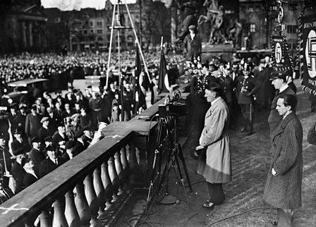
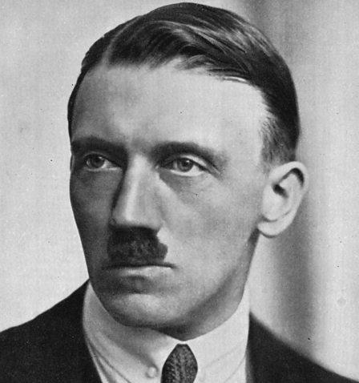

Questions for discussion:
- Find some more examples of appealing villains. What makes them appealing?
- Study the pictures below. Do you recognize the people in them? Regardless of whether you do or you don’t, say what you find appealing (or not) in them.

A

B

C

SOCIAL REJECTION
Being rejected or ignored by others is called ostracism.
Ostracism literally hurts. Research done by Kross, Berman, Mischel, Smith, and Wager (2011) has shown that when rejected, brain areas such as the secondary somatosensory cortex and dorsal posterior insula which are implicated in the experience of physical pain, become active.
So are not only the experiences of physical pain and social rejection distressing, the authors say that they share a common somatosensory representation too.
So, what do people do if they have experienced social rejection? A 2012 article written by the American Psychological Association recommends seeking inclusion elsewhere. Those who have been excluded tend to become more sensitive to opportunities trying to act more likable, show greater conformity, and comply with the requests of others.
On the other hand, some respond with anger and aggression instead. The article runs as following,
“If someone’s primary concern is to reassert a sense of control, he or she may become aggressive as a way to force others to pay attention. Sadly, that can create a downward spiral. When people act aggressively, they’re even less likely to gain social acceptance.”
The effects of long-term ostracism can be devastating but non-chronic rejection can be easier to alleviate.
Seek out healthy positive connections with both friends and family as a way to combat rejection.

If you want to know more info about social rejection, use the link below: https://www.apa.org/monitor/2012/04/rejection.

LIST OF USED AND RECOMMENDED LITERATURE
- Морозова І.Б. Мовленнєві сигнали як особлива техніка оптимізації міжособистісного спілкування. Одеська лінгвістична школа: інтеграція підходів : Колективна монографiя / за заг. ред. Ковалевської Т.Ю. Одесса: ПолиПринт, 2016. 362 с. Розділ 3. Лінгвістична інтерпретація сугестивних дискурсів: С. 247 – 254.
- Морозова І.Б. Синтаксичне варіювання особливостей мовлення віртуальної особистості в залежності від рівня її когнітивних здібностей: гештальт-аналіз. Одеська лінгвістична школа: траєкторії досліджень : колект. моногр. / за заг. ред. Ковалевської Т. Ю. Одеса: ПолиПринт, 2021. С.240-250
- Морозова І. Б. Формування лінгвальної поведінки англомовної елітарної особистості (на матеріалі промов герцогині кембриджської кейт міддлтон). Вчені записки Таврійського національного університету імені В. І. Вернадського Серія: Філологія. Журналістика. Том 32 (71). № 1. Частина 1. Видавничий дім «Гельветика», 2021. С.157-164
- Морозова І.Б., Єршова К. І. Лінгвальні засоби вираження емотивності в жіночому романі. Мова. Науково-теоретичний часопис з мовознавства. Одеса: «Астропринт», 2019. №31. С. 20-26.
- Пожарицька О.О. Авторський концепт позитивності у мовленнєвому портреті головного героя: Комунікативно-парадигматичний аналіз (на матеріалі англомовних романів жанру «вестерн»). Дис. на здобуття наук. ступеню канд. філол. наук : спец. 10.02.04 «Германські мови». Одеськ. Нац.. ун-т імені І.І. Мечникова, 2014. 244 с.
- Dion, K. K., Berscheid, E., & Walster, E. (1972). What is beautiful is good. Journal of Personality and Social Psychology, 24(3), 285-290.
- Langlois, J. H., Kalakanis, L., Rubenstein, A. J., Larson, A., Hallam, M., & Smoot, M. (2000). Maxims or myths of beauty? A meta-analytic and theoretical review. Psychological Bulletin, 126(3), 390-423.
- Morozova I. B., Abramova Ie. Yu. Compliments as a specific methodological approach of optimizing the process of teaching foreign languages. Advanced trends of the modern development of philology in European countries : Collective monograph. Riga : Izdevnieciba “Baltija Publishing”, 2019. Pp. 136-156 [equal to a Web of Science edition]
- Morozova Iryna, Pozharytska Olena Speech Roles and Games We Play. Institute of English Studies, School of Advanced Study. ISLE 5 - The 5th International Conference of the International Society for the Linguistics of English. London, United Kingdom, 17 − 21 July, 2018. Pp. 9-10.
- Morozova I. B., Pozharytska O.O. Literary Characters and their Verbal Mimicry through the Prism of Gestalt Analysis. Arab World English Journal (AWEJ). Volume 12. Number2 June 2021. Pp. 457-468 DOI: https://dx.doi.org/10.24093/awej/vol12no2.31 Web of Science
- Morozova I., Pozharytska О. Handsome is as handsome speaks. IAFOR; ECAH ECCS Libeuro Euromedia. Brighton, United Kingdom, 2015. Pр. 41-54.
- Pozharytska O. Speaking like a good guy: Speech Carnivalisation Algorithm. Науково-теоретичний часопис з мовознавства. Одеса: «Астропринт», 2015. № 23. С. 61-68.

Навчальне видання
GENERAL ATTRACTIVENESS & APPEAL:
MENTAL-AND-LINGUAL MECHANISMS OF CREATING PARTICULAR PERSONAL IMAGES

МЕТОДИЧНІ РЕКОМЕНДАЦІЇ
до практичних занять та самостійної роботи
з навчальної дисципліни “Інтра- та екстралінгвальні детермінанти загальної привабливості” для здобувачів вищої освіти другого (магістерського) рівня за спеціальністю 035 «Філологія», спеціалізації 035.041 Германські мови та літератури (переклад включно), перша англійська

Укладачі
Морозова Ірина Борисівна
Пожарицька Олена Олександрівна

В авторській редакції
Підп. до друку 15.02.2023. Формат 60x84/16
Ум.-друк. арк. 2,1. Наклад 100 пр.
Зам. № 1546. (16 кегль)
(заповнюється видавництвом,
можуть бути відмінності в залежності від видавництва)

Видавець і виготовлювач (16 кегль)
(назва видавництва)
(Свідоцтво суб’єкта видавничої справи)
(адреса видавництва)
(тел., е-mail видавництва)

