МІНІСТЕРСТВО ОСВІТИ І НАУКИ УКРАЇНИ
ОДЕСЬКИЙ НАЦІОНАЛЬНИЙ УНІВЕРСИТЕТ
імені І. І. МЕЧНИКОВА
ФАКУЛЬТЕТ РОМАНО-ГЕРМАНСЬКОЇ ФІЛОЛОГІЇ
КАФЕДРА ГРАМАТИКИ АНГЛІЙСЬКОЇ МОВИ
CURRENT TRENDS IN GRAMMAR

МЕТОДИЧНІ РЕКОМЕНДАЦІЇ
до практичних занять та самостійної роботи
з навчальної дисципліни “Сучасні граматичні течії” для здобувачів другого (магістерського) рівня вищої освіти спеціальності 035 «Філологія» спеціалізації 035.041 Германські мови та літератури (переклад включно), перша – англійська

ОДЕСА
2023
УДК 811.111’373.2.001.33:73/79
Н 584

Укладачі:
І. Б. Морозова, доктор філологічних наук, професор, професор кафедри граматики англійської мови
О. О. Пожарицька, кандидат філологічних наук, доцент, доцент кафедри граматики англійської мови
М. Ю. Карпенко, кандидат філологічних наук, доцент, доцент кафедри граматики англійської мови

Рецензенти:
Н. О. Кравченко, доктор філологічних наук, професор, декан факультету романо-германської філології Одеського національного університету імені І. І. Мечникова
Н. В. Степанюк, кандидат філологічних наук, доцент, доцент кафедри лексикології та стилістики англійської мови Одеського національного університету імені І. І. Мечникова

Рекомендовано до друку вченою радою
факультету романо-германської філології ОНУ імені І. І. Мечникова
Протокол № 1 від 30 серпня 2023 року

Н584
Сurrent Trends in Grammar: метод. рекомендації до практичних занять та самостійної роботи з навчальної дисципліни «Сучасні граматичні течії» для здобувачів другого (магістерського) рівня вищої освіти спеціальності 035 «Філологія», спеціалізації 035.041 Германські мови та літератури (переклад включно), перша – англійська / уклад. І.Б. Морозова, О.О. Пожарицька, М.Ю. Карпенко. – Одеса: Освіта України, 2023. – 49 с.

Розробка ставить собі завданням поглибити філологічну підготовку здобувачів освіти, систематизувати набуті теоретичні та практичні знання й навички та сформувати вміння користуватися здобутками сучасних граматистів як у процесі власного наукового пошуку, так і під час спілкування та викладання англійської мови. У методичних рекомендаціях наведено запитання для дискусій та QR-коди на відео з відомими граматистами.

УДК 811.111’373.2.001.33:73/79
(с) Морозова І.Б., Пожарицька О.О., Карпенко М.Ю., 2023
(с) Одеський національний університет ім. І.І. Мечникова, 2023
ЗМІСТ
ПЕРЕДМОВА 4
СURRENT TRENDS IN GRAMMAR: A BRIEF OUTLINE 6
GENERATIVE GRAMMAR 8
COGNITIVE GRAMMAR 10
Langacker's Four Principles: 14
FUNCTIONAL GRAMMAR 16
PRAGMATICS AND COMMUNICATIVE GRAMMAR 18
Why is pragmatics important? 20
Pragmatics: The Cooperative Principle 21
Pragmatics: conversational implicature 23
What is the difference between pragmatics and semantics? 23
Pragmatics: key takeaways 24
Communicative grammar 25
TEXT GRAMMAR & TEXT LINGUISTICS 26
TOP FAMOUS LINGUISTS 30
Noam Chomsky 30
Paul Grice 31
David Crystal 31
Eve Clark 32
Steven Pinker 32
George Philip Lakoff 33
Michael Halliday 34
Umberto Eco 34
William Labov 35
Michael Swan 36
Henry Watson Fowler 36
Randolph Quirk 38
Rodney Desmond Huddleston 40
Huddleston's Approach to Grammar 41
GESTALT GRAMMAR & ITS PRACTICAL APPLICATION 44
LIST OF USED AND RECOMMENDED LITERATURE 48

ПЕРЕДМОВА

Представлені методичні рекомендації розроблені для студентів факультету романо-германської філології, які обрали спеціальність 035 "Філологія" і спеціалізацію 035.041 "Германські мови та літератури (переклад включно)" та є частиною освітньо-професійної програми підготовки магістрів.
Метою даної розробки є поглиблення філологічної підготовки студентів, систематизація їх теоретичних та практичних знань у галузі сучасної граматики, а також формування навичок використання сучасних граматичних підходів у науковому дослідженні та викладанні англійської мови.
Методична розробка ознайомить студентів-магістрів з основними науковими течіями у сучасній граматиці як науці та видатними їх представниками. Так, методичні рекомендації містять основні концепції, теми та завдання, які допоможуть студентам розширити свої знання у галузі сучасної граматики та стати більш компетентними в цій області. Акцентуючи найбільш важливі здобутки сучасних граматичних студій у науковому плані, автори також пропонують магістрантам дізнатися нову інформацію про сучасні граматичні проблеми від самих представників окреслених граматичних шкіл за допомогою переходу за інтернет-посиланнями у QR-кодах.
У результаті вивчення навчальної дисципліни здобувач вищої освіти повинен знати: термінологічний апарат дисципліни; сучасні граматичні течії, типові для теоретичних та практичних граматичних студій; історію становлення, ключові граматичні проблеми та дискусійні моменти, що розглядаються у межах когнітивної лінгвістики та граматики, психолінгвістики, гештальт-аналізу; сучасні граматичні школи, представлені в Україні та Одеському національному університеті ім. Мечникова; сучасні тенденції у синтаксисі та морфології англійської мови; вміти: оперувати термінологічним апаратом кожного з напрямів сучасних граматичних студій; орієнтуватися у сучасних наробках з теоретичних граматичних студій загальносвітового рівня, всеукраїнського та тих, що представлені в Одеському національному університеті ім. Мечникова; читати й розуміти наукові статті та розуміти принципи проведення граматичних досліджень; користуватися вербальними та невербальними граматичними засобами оптимізації ефективності мовної комунікації.
Курс «Сучасні граматичні течії» загалом та дана розробка зокрема стануть корисними для магістрів у підготовці до їхньої майбутньої кар'єри в галузі філології та сприятиме їхньому науковому розвитку.

СURRENT TRENDS IN GRAMMAR: A BRIEF OUTLINE

Modern trends in grammar encompass a wide range of developments and shifts in the study and usage of language structure. Here are some prominent trends in modern grammar:
- Generative Grammar: This theory, pioneered by Noam Chomsky, focuses on the innate structure of language and how it generates sentences. It's concerned with syntax and underlying grammatical rules.
- Performative Grammar: This approach, associated with J.L. Austin and John Searle, examines how language can perform actions or speech acts, such as making promises or giving commands.
- Communicative Grammar: This grammar emphasizes effective communication, considering not only sentence structure but also the broader context and intentions of the speaker and listener.
- Text Grammar: Text grammar looks beyond individual sentences and studies the structure of larger units of discourse, like paragraphs and texts, to understand coherence and cohesion.
- Psycholinguistics: This field explores the relationship between language and cognitive processes, investigating how humans produce, comprehend, and acquire language.
- Gender Linguistics: Gender linguistics examines how language reflects and influences social and cultural perceptions of gender, including the study of gendered language and its impact on society.
- Cognitive Grammar: This approach focuses on how language reflects human cognitive processes. It explores how our mental concepts and structures shape language. Cognitive linguistics examines metaphors, mental spaces, and conceptual blending as important aspects of grammar.
- Functional Grammar: Functional grammar emphasizes the communicative function of language. It examines how language elements like words, phrases, and clauses function to convey meaning. Functional grammar also looks at the context and discourse in which language is used.
- Construction Grammar: This theory posits that grammar is a network of constructions, each with its own meaning and usage patterns. It emphasizes the importance of pairing form and meaning in language analysis.
- Corpus Linguistics: Modern grammar analysis often relies on large corpora, which are vast collections of written and spoken texts. Researchers use corpora to study real-world language usage, including variations in grammar across different contexts and registers.
- Dependency Grammar: Unlike traditional phrase structure grammar, dependency grammar focuses on the relationships between words. It represents these relationships as directed links between words in a sentence.
- Sociolinguistics and Variationism: Grammar is studied in the context of sociolinguistics to understand how language varies across different social groups, regions, and communities. Variationist linguistics explores these variations systematically.
- Computational Linguistics: With the advancement of technology, computational linguistics plays a crucial role in parsing and generating human language. It involves the development of algorithms and models for natural language understanding and generation.
- Minimalism: A theory in generative grammar, minimalism posits that linguistic structures should be as simple as possible, with an emphasis on economy in language production and comprehension.
- Multimodal Grammar: In the age of multimedia communication, multimodal grammar studies how language integrates with other modes of communication, such as visuals and gestures, to convey meaning effectively.
- Internet and Digital Communication: The internet and digital communication platforms have given rise to new forms of grammar and linguistic creativity, including emojis, acronyms, and internet slang.
- Language Evolution and Change: Modern grammar also explores how languages evolve and change over time, influenced by factors such as globalization, migration, and cultural shifts.
- Neurolinguistics: Research in neurolinguistics delves into the neurological basis of language processing and how the brain encodes and decodes grammar.
These trends reflect the evolving nature of linguistic research and our understanding of how language functions in various contexts. Modern grammar is an interdisciplinary field that combines insights from linguistics, cognitive science, computer science, and other disciplines to provide a comprehensive view of language structure and usage. In the next units, we shall discuss some of the trends mentioned above in more detail.

GENERATIVE GRAMMAR

Today, in linguistics, generative grammar is a type of grammar (a set of language rules) that indicates the structure and interpretation of sentences that native speakers of a language accept as belonging to their language.
Generative grammar accepts as a basic premise that native speakers of a language will find certain sentences grammatical or ungrammatical and that these judgments give insight into the rules governing the use of that language.
Generative grammar is a "theory of competence," & its validity can be tested with a grammaticality judgment task. This involves presenting a native speaker with a series of sentences and having them decide whether the sentences are grammatical (acceptable) or ungrammatical (unacceptable). For example:
- The man is happy.
- Happy man is the.
A native speaker would judge the first sentence to be acceptable and the second to be unacceptable. From this, we can make certain assumptions about the rules governing how parts of speech should be ordered in English sentences. For instance, a "to be" verb linking a noun and an adjective must follow the noun and precede the adjective.
In Linguistics for Non-Linguists: A Primer With Exercises, Frank Parker and Kathryn Riley argue that generative grammar is a kind of unconscious knowledge that allows a person, no matter what language they speak, to form "correct" sentences. They continue:
"Simply put, a generative grammar is a theory of competence: a model of the psychological system of unconscious knowledge that underlies a speaker's ability to produce and interpret utterances in a language ... A good way of trying to understand [Noam] Chomsky's point is to think of a generative grammar as essentially a definition of competence: a set of criteria that linguistic structures must meet to be judged acceptable," (Parker and Riley 2009).
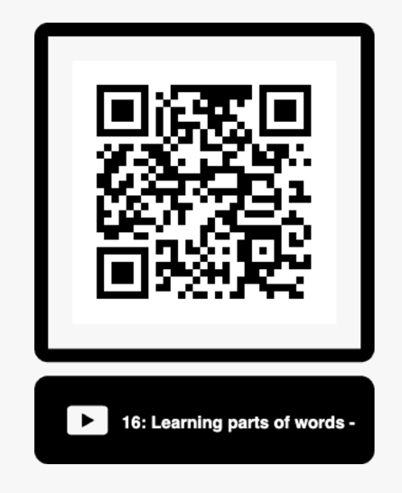

Assignment 1: Listen to Lingthusiasm episode 16 podcast (33 mins) & be ready to discuss it 16: Learning parts of words - Morphemes, the wug test, and child language acquisition linguistics.
https://www.youtube.com/watch?v=W6LRcaiWNX8&list=PLcqOJ708UoXQ2wSZelLwkkHFwg424u8tG&index=16

COGNITIVE GRAMMAR

Cognitive grammar is a cognitive approach to language developed by Ronald Langacker, who hypothesizes that grammar, semantics, and lexicon exist in a continuum instead of separate processes. It emphasizes symbolic and semantic definitions of theoretical concepts.
Cognitive Grammar is a radical alternative to the formalist theories that have dominated linguistic theory during the last half century. Instead of an objectivist semantics based on truth conditions or logical deduction, it adopts a conceptualist semantics based on human experience, our capacity to construe situations in alternate ways, and processes of imagination and mental construction. A conceptualist semantics makes possible an account of grammar which views it as being inherently meaningful (rather than an autonomous formal system). Grammar forms a continuum with lexicon, residing in assemblies of symbolic structures, i.e. pairings of conceptual structures and symbolizing phonological structures. Thus all grammatical elements are meaningful.
The guiding word in cognitive grammar is meaning. Grammar itself refers to the basic modes of implementing a written and spoken language. While some theories focus on the purely structural aspects of language, cognitive grammar — developed by Ronald Langacker and others — recognizes that language patterns and sounds are a symbolic representation of human thoughts and perceptions about the surrounding world. Perception, memory, and attention are therefore crucial aspects of developing grammar. Forms of cognitive grammar include construction grammar and generative grammar.
Cognitive linguists apply theories regarding cognition to grammar. Cognition focuses on human thought patterns and how humans form and maintain ideas. Language is simply a natural extension and expression of human mental capacities and not a specialized practice in and of itself.
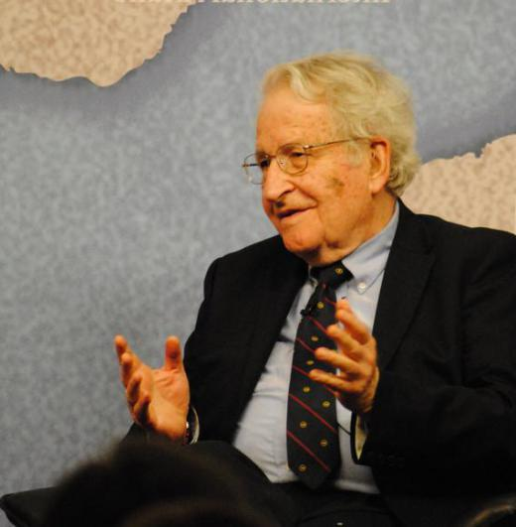
Massachusetts Institute of Technology linguist Noam Chomsky has contributed to theories of language acquisition.

Thus, letters, words, and sounds are language symbols that represent thought processes. A cognitive schema, for example, is a mental plan that a human being develops to address recurrent specific situations. For example, a human might form a step-by-step plan for how to react when meeting a stranger and carry out this plan unconsciously. In linguistic terms, languages might create a certain standard, or schema, for putting action words in different tenses.
Cognitive grammar practitioners are also interested in how words and phrases can be altered and moved to create a certain effect or express a certain idea. Rhetoric, or the use of language for persuasive purposes, might be a particular topic of focus for many cognitive grammar researchers. Even literary devices like comparative similes and metaphors can become important areas of study in cognitive-based focuses.
Several specific sub-fields of cognitive grammar exist. For one, famed language scholar Noam Chomsky introduced generative grammar in the mid-20th century. This theory deals with syntax, or the particular ordering of words. Chomsky proposed that the human mind contained instinctual guidelines for using words and sounds — or phonology — to create comprehensible phrases and sentences. These ideals were universal to all humans in general terms if not in specifics, and thus the human brain naturally contained mental capacities for language from birth.
Other cognitive grammar approaches consider different aspects of how the mind forms relationships between words, their sounds, and their meanings. Word grammar, for example, proposes that the human mind has a vast, almost computer-like network where it stores words, sounds, and meanings. Such modes of cognitive grammar owe much of their origin to gestalt psychology, which focuses on organized groupings, building-block rules and customs, and a holistic philosophy.
Construction grammar furthers the aims of word grammar by considering how words are linked with specific and categorized sounds and meanings. As an example, the English words knife and gun can both be categorized under another word: weapon. In this and countless other examples, the brain creates pathways between the specific profiles, or definitions, and the more general domain categories. This gradual building of associations eventually generates whole languages.
Cognitive grammar is a usage-based approach to grammar that emphasizes symbolic and semantic definitions of theoretical concepts that have traditionally been analyzed as purely syntactic.
Cognitive grammar is associated with wider movements in contemporary language studies, especially cognitive linguistics and functionalism.

The term cognitive grammar was introduced by American linguist Ronald Langacker in his two-volume study Foundations of Cognitive Grammar (Stanford University Press, 1987/1991).

Observations
- "Portraying grammar as a purely formal system is not just wrong but wrong-headed. I will argue, instead, that grammar is meaningful. This is so in two respects. For one thing, the elements of grammar—like vocabulary items—have meanings in their own right. Additionally, grammar allows us to construct and symbolize the more elaborate meanings of complex expressions (like phrases, clauses, and sentences). It is thus an essential aspect of the conceptual apparatus through which we apprehend and engage the world." (Ronald W. Langacker, Cognitive Grammar: A Basic Introduction. Oxford University Press, 2008)
- Symbolic Associations "Cognitive grammar . . . chiefly departs from 'traditional' theories of language in its contention that the way in which we produce and process language is determined not by the 'rules' of syntax but by the symbols evoked by linguistic units. These linguistic units include morphemes, words, phrases, clauses, sentences and whole texts, all of which are deemed inherently symbolic in nature. The way in which we join linguistic units together is also symbolic rather than rule-driven because grammar is itself 'meaningful' (Langacker 2008a: 4). In claiming a direct symbolic association between linguistic form (what it terms ' phonological structure') and semantic structure, Cognitive Grammar denies the need for an organizational system to mediate between the phonological and semantic structures (i.e. syntax)." (Clara Neary, "Profiling the Flight of 'The Windhover.'" (Cognitive Grammar in Literature, ed. by Chloe Harrison et al. John Benjamins, 2014)​.
- Assumptions of Cognitive Grammar
"A Cognitive Grammar is based on the following assumptions... .:
  - The grammar of a language is part of human cognition and interacts with other cognitive faculties, especially with perception, attention, and memory. . . .
  - The grammar of a language reflects and presents generalizations about phenomena in the world as its speakers experience them. . . .
  - Forms of grammar are, like lexical items, meaningful and never 'empty' or meaningless, as often assumed in purely structural models of grammar.
  - The grammar of a language represents the whole of a native speaker's knowledge of both the lexical categories and the grammatical structures of her language.
  - The grammar of a language is usage-based in that it provides speakers with a variety of structural options to present their view of a given scene."
(G. Radden and R. Dirven, Cognitive English Grammar. John Benjamins, 2007)

Langacker's Four Principles:
"A primary commitment to Cognitive Grammar is . . . to provide an optimal set of constructs for explicitly describing the linguistic structure. Its formulation has been guided throughout by a number of principles thought to be helpful in achieving such optimality.
- The first principle . . . is that functional considerations should inform the process from the outset and be reflected in the framework's architecture and descriptive apparatus.
- Because the functions of language involve the manipulation and symbolization of conceptual structures, a second principle is the need to characterize such structures at a reasonable level of explicit detail and technical precision. To be revealing, however, descriptions must be natural and appropriate.
- Thus, a third principle is that language and languages have to be described in their own terms, without the imposition of artificial boundaries or Procrustean modes of analysis based on conventional wisdom. As a corollary, formalization is not to be considered an end in itself, but must rather be assessed for its utility at a given stage of an investigation. That no attempt has yet been made to formalize Cognitive Grammar reflects the judgment that the cost of the requisite simplifications and distortions would greatly outweigh any putative benefits.
- Finally, a fourth principle is that claims about language should be broadly compatible with secure findings of related disciplines (e.g., cognitive psychology, neuroscience, and evolutionary biology). Nevertheless, the claims and descriptions of Cognitive Grammar are all supported by specifically linguistic considerations." (Ronald W. Langacker, "Cognitive Grammar." The Oxford Handbook of Cognitive Linguistics, ed. by Dirk Geeraerts and Herbert Cuyckens. Oxford University Press, 2007)

Assignment 2:
- Read up on Cognition and modern views on it.
https://www.thehealthboard.com/what-is-cognition.htm
- Watch the video on YouTube & discuss it in class.

Idea Framing, Metaphors, and Your Brain - George Lakoff (5 mins). Discuss George Lakoff’s linguistic views and their development.
https://www.youtube.com/watch?v=S_CWBjyIERY

FUNCTIONAL GRAMMAR

Functional grammar is a linguistic theory first proposed in the 70s by such linguists as Michael Halliday, Simon Dik, Ronald Kaplan, J. Mackenzie who studied functional grammar and discourse. It focuses on the way language is put together so that meaning is communicated for particular purposes.

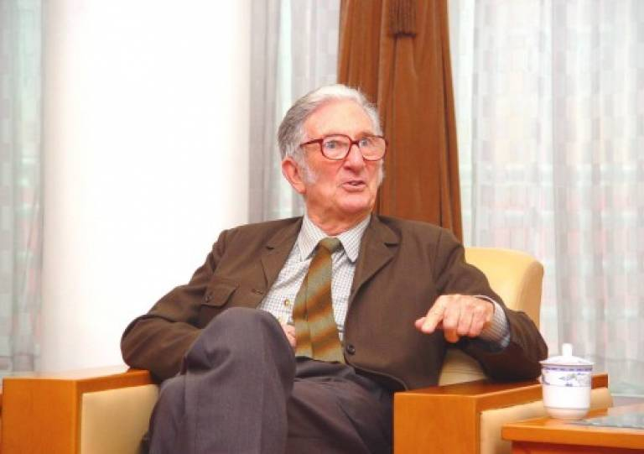
Michael Halliday

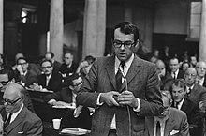
Simon Dik (Holland)

Functional Grammar theory was first proposed by a Dutch linguist named Simon Dik. It was renamed Functional Discourse Grammar in the 1990s, but the theory can go by either name. This theory is called functional because it states that all constituents, whether affixes, words, phrases, or sentences, have semantic, syntactic, and pragmatic functions. Functional grammarians can analyze linguistic utterances as pragmatic, semantic, morphosyntactic, or phonological.
Several linguistic theories are also known as functional grammars, as opposed to formal grammars. The most famous of these is Systemic Functional Grammar, which was first published by British linguist Michael Halliday in 1961. Other functional grammars include Danish Functional Linguistics, lexical functional grammar, and Role and Reference Grammar. These should not be confused with the theory of Functional Grammar as described by Dik while he held the General Linguistics chair at the University of Amsterdam in the Netherlands from 1969 to 1994.
Functional grammar is a linguistic theory that states all constituents, whether affixes, words, phrases, or sentences, have semantic, syntactic, and pragmatic functions.
According to Dik’s Functional Grammar, each constituent has a semantic, syntactic, and pragmatic function. Semantic function refers to the role participants play in the sentence’s action, such as agent or recipient. The various perspectives, such as subject or object, are analyzed as the syntactic function. Pragmatic function concerns the meaning of the constituent in reference to its context.
Functional grammarians can classify linguistics as semantic, pragmatic, morphosyntactic, or phonological.
Conceptual, grammatical, contextual, and output components are present in each linguistic utterance. The conceptual component is the idea that the speaker wants to communicate to his or her audience. A concept to share must come first, or no linguistic utterance will be made.
In the grammatical component, the concept is formed into words through four steps. First, the words are constructed on an interpersonal level, taking into account the context, through pragmatics. Second, each word and phrase is checked for meaning at the representational level during the semantic step. On the third level, the morphosyntactic step, the syntax and morphology are taken into account. Lastly, the phonological level considers the sound of a linguistic utterance.
The contextual component is the portion of the utterance which can only be understood in reference to what has already been shared in the conversation or to a shared knowledge of the environment. All pronouns are part of the contextual component because they require knowledge of an earlier antecedent. The last component of Functional Grammar is the output component, in which all the other pieces come together as a linguistic utterance, whether spoken, written, or signed.

PRAGMATICS AND COMMUNICATIVE GRAMMAR

Pragmatics is an important branch of linguistics in the English language. It helps us look beyond the literal meaning of words and utterances and allows us to focus on how meaning is constructed in specific contexts. When we communicate with other people, there is a constant negotiation of meaning between the listener and the speaker. Pragmatics looks at this negotiation and aims to understand what people mean when they communicate with each other.
Pragmatics looks at the difference between the literal meaning of words and their intended meaning in social contexts. It takes into account things such as irony, metaphor and intention.
The Oxford Companion to Philosophy (1995) defines pragmatics as:
The study of language which focuses attention on the users and the context of language use rather than on reference, truth, or grammar"
Pragmatics in the English language is one of the youngest of the linguistic disciplines. However, its history can be traced back to the 1870s and the philosophers Charles Sanders Pierce, John Dewey, and William James.
Pragmatism is a philosophical tradition that considers words as tools for understanding the world and rejects the idea that the function of thought is to mirror reality directly. Pragmatists suggest that all philosophical thought, including language, is best understood in terms of its practical uses.
In 1947, Charles Morris drew upon pragmatism and his background in philosophy, sociology, and anthropology to set out his theory of pragmatics in his book 'Signs, Language and Behaviour'. Morris said that pragmatics "deals with the origins, uses, and effects of signs within the total behaviour of the interpreters of signs." ¹
In the case of pragmatics, signs refer to the movements, gestures, body language, and tone of voice that usually accompanies speech rather than physical signs, such as road signs.
Pragmatics considers the meaning of language within its social context and refers to how we use words in a practical sense. To understand what is genuinely being said, we must examine the contexts (including the physical location) and look out for social cues, for example, body language and tone of voice.
Let's look at some different pragmatic examples, and their contextual meaning, and see if it starts to make a bit more sense.
Example 1
Picture this: You and your friend are sitting in your bedroom studying, and she says, 'It's hot in here. Can you crack open a window? '
If we take this literally, your friend is asking you to crack the window - to damage it. However, taken in context, we can infer that they are actually asking for the window to be opened a little.
Example 2
Picture this: You're talking to a neighbour and they look bored. Your neighbour keeps looking at their watch, and they don't appear to be paying much attention to what you're saying. Suddenly, they say, 'Gosh, would you look at the time! '
The literal meaning is that your neighbour is instructing you to look at the time. However, we can infer that they are trying to get away from the conversation due to their general body language.
Example 3
Picture this: You are walking through college, and you bump into a friend of a friend, who says, "Hey, how're you doing? "
In this case, it is unlikely that your friend wants to hear the highs and lows of your entire week. A common answer would be something like, "Good thanks, and you? "

Why is pragmatics important?
Pragmatics is key to understanding language use in context and is a useful basis for understanding language interactions.
Imagine a world where you had to explain everything you meant in full; there could be no slang, jokes probably wouldn't be funny, and conversations would be twice as long!
Let's take a look at what life would be like without pragmatics.
'What time do you call this?! '
Literal meaning = What time is it?
Real meaning = Why are you so late?!
Because of the insights of pragmatics, we know that the speaker does not actually want to know what time it is, but is making the point that the other person is late. In this case, it would be best to apologise rather than give the speaker the time!
Now, consider the following sentences. How many different meanings can they have? How important is context when inferring the meaning of each sentence?
- You're on fire!
- You have the green light.
- This way.

Pragmatics: The Cooperative Principle
The 'cooperative principle' is a theory by Paul Grice. Grice's theory explains how and why conversations tend to succeed rather than fail. Grice's theory is based on the idea of cooperation; he suggests that speakers inherently want to cooperate when communicating, which helps remove any obstacles to understanding. In order to facilitate successful communication, Grice says that when we talk, it is important to say enough to get your point across, be truthful, be relevant, and be as clear as possible.
This brings us to Grice's 4 Maxims. These are the four assumptions we make when talking with other people.
- Maxim of Quality: They will tell the truth or what they think is the truth.
- Maxim of Quantity: They will give sufficient information.
- Maxim of Relevance: They will say things that are relevant to the conversation.
- Maxim of Manner: They will be clear, pleasant and helpful.
Pragmatics: politeness theory
Penelope Brown and Steven Levinson created 'politeness theory' in the 1970s. It seeks to explain how politeness in conversation works. Politeness theory was built around the concept of 'saving face' - this means maintaining your public image and avoiding humiliation.
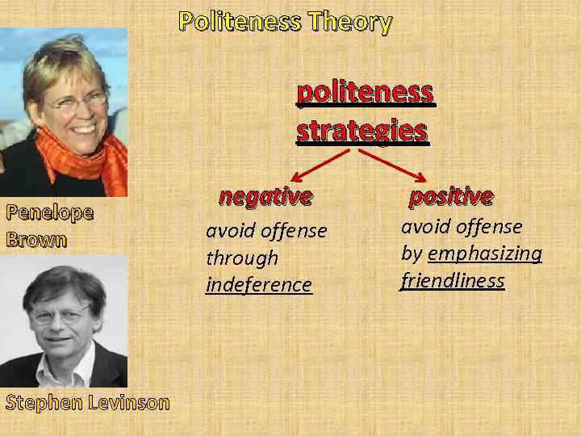
Brown and Levinson suggest that we have two types of face: positive face and negative face.
- Positive face is our self-esteem. For example, our desire to be liked, loved, and reliable.
- Negative face is our desire to be free to act as we wish, to be unimpeded.
When we are polite to people, we are appealing to either their positive or negative face.
Appealing to a person's positive face = Making the individual feel good and positive about themselves.
"You always wear such lovely clothes! I'd love to borrow something one day. "
Appealing to a person's negative face = making the other person feel like they haven't been taken advantage of.
"I know it's a real pain, and I hope you don't mind, but could you please print these off for me? "

Pragmatics: conversational implicature
'Conversational implicature', sometimes known simply as 'implicature', is another theory from Paul Grice. It looks at indirect speech acts. When examining implicatures, we want to know what the speaker means, even though they haven't explicitly said it. It's an indirect form of communication.
Conversational implicature is directly linked to the co-operative theory. It relies on the basis that the speaker and the listener are cooperating. When a speaker implies something, they can be confident that the listener will understand it.
A couple are watching TV, but they are both looking at their phones and not paying much attention to the TV. The boy says, "Are you watching this? " The girl grabs the remote and changes the channel.
Nobody explicitly suggested changing the channel, but the meaning was implied.

What is the difference between pragmatics and semantics?
Semantics and pragmatics are two of the main branches of linguistics. While both semantics and pragmatics study the meaning of words in language, there are a couple of key differences between them.
Semantics refers to the meaning that grammar and vocabulary provide, and does not consider the context or inferred meanings. In contrast, pragmatics looks at the same words but in their social context. Pragmatics considers the relationship between social context and language.
Example 1.
"It's cold in here, isn't it?"
Semantics = the speaker is asking for confirmation that the room is cold.
Pragmatics = there may be another meaning associated with this question. For example, the speaker may be hinting that they want the heating turned on or the window closed. The context would make this clearer.
Here's a handy table for you that sets out some of the key differences between semantics and pragmatics.
Semantics | Pragmatics
The study of words and their meanings. | The study of words and their meanings in context.
The literal meanings of words. | The intended meaning of words.
Limited to the relationship between words. | Covers the relationships between words, interlocutors (people engaged in a conversation), and context.

Pragmatics: key takeaways
- Pragmatics is the study of the meaning of language in social context.
- Pragmatics is rooted in philosophy, sociology, and anthropology.
- Pragmatics considers the construction of meaning through the use of context and signs, such as body language and tone of voice.
- Pragmatics is similar to semantics, but not quite the same! Semantics is the study of words and their meanings, whereas pragmatics is the study of words and their meanings in social context.
- Some of the main pragmatic theories are the 'Co-operative principle', 'Politeness theory', and 'Conversational implicature'.

Communicative grammar

Communicative grammar studies the grammar of monologues & dialogues; spoken language & functional styles; teaching grammar; & communicating effectively (G. Leech, J. Svartvik).
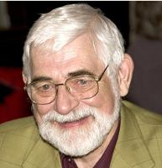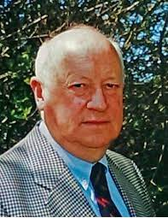
J.Svartvik
Geoffrey Leech

Assignment 3:
- Read up on the problem of communicative grammar. What are G. Leech & J. Svartvik famous for?
- What are the connections between pragmatics and communicative linguistics?
- Prepare to discuss Paul Grice & his maxims of politeness. What’ s important about them?
- Listen to Lingthusiasm episode 11 podcast 11: Layers of meaning - Cooperation, humour, and Gricean Maxims (Intro to Pragmatics Linguistics (33 mins) & be ready to discuss it https://www.youtube.com/watch?v=dw46d7I9AEs&list=PLcqOJ708UoXQ2wSZelLwkkHFwg424u8tG&index=11

TEXT GRAMMAR & TEXT LINGUISTICS

Text linguistics is a branch of linguistics concerned with the description and analysis of extended texts (either spoken or written) in communicative contexts.
Text linguistics overlaps considerably with discourse analysis. There are the following trends within text grammar & text linguistics:
- text grammar (Van Dijk) aims to establish a model with which the grammatical structures of texts can be described (quite similar to Chomsky’s transformational approach).
Van Dijk (2004) “Critical Discourse analysis is a type of discourse analysis research that primarily studies the way social power abuse, dominance, and inequality are enacted, reproduced, and resisted by text and talk in social and political contexts”
Van Dijk argues that participants of communicative situations, for an effective interaction, need to “read” each other's mind in a metaphorical sense.

Among the descriptive, explanatory and practical aims of CDA-studies is the attempt to uncover, reveal or disclose what is implicit, hidden or otherwise not immediately obvious in relations of discursively enacted dominance or their underlying ideologies.
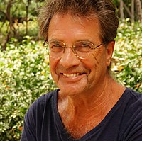
The main aim of critical discourse analysis is to explore the links between language use and social practice. The focus is the role of discursive practices in the maintenance of the social order and in social change.

Discourse analysis helps researchers uncover the motivation behind a text by allowing them to view a problem from a higher stance. It is useful for studying the underlying meaning of a spoken or written text as it considers the social and historical contexts.
Discourse analysis is interpretative and explanatory. Critical analysis implies a systematic methodology and a relationship between the text and its social conditions, ideologies and power-relations.
The weaknesses include: CDA is interpretive and subjective in its analysis, CDA analysts often arrive at their analyses with their subjective agendas and preconceptions, CDA is mainly conducted using qualitative research methods
Other representatives: Fairclough, R. Wodak

- text linguistics is devoted to describing how texts are created and understood and in so doing studies the defining properties of texts - what constitutes their textuality or texture (David Crystal).
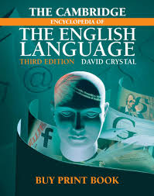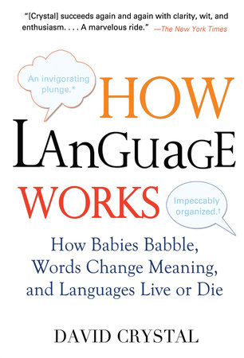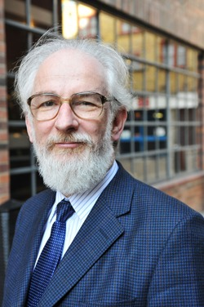
David Crystal

- discourse analysis (Renkema, Schiffrin) traditionally analyses chiefly written texts. However, it seems that it is very difficult to define “discourse” precisely - Schiffrin (1994) for example says that discourse analysis “... is one of the most vast, but also least defined, areas in linguistics”.

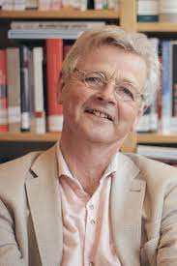Jan Renkema

Andre Schiffrin 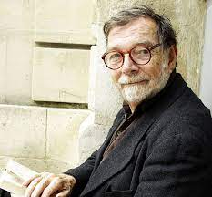

A text is defined as a communicative occurrence which meets seven standards (principles) of textuality:
- cohesion,
- coherence,
- intentionality,
- acceptability,
- informativity,
- contextuality
- and intertextuality.

TOP FAMOUS LINGUISTS

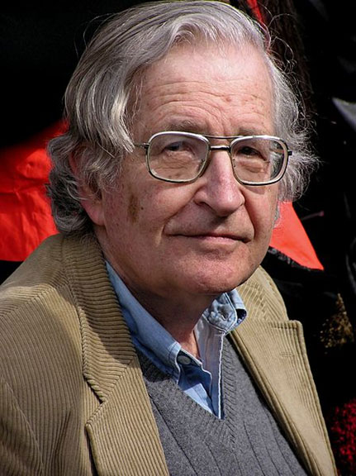
Noam Chomsky
Noam Chomsky (1928 - ): Universal grammar
Probably the best-known name on this list, Noam Chomsky is famous for many things. But within the realm of linguistics, he’s most famous for his idea of universal grammar, which poses that all languages have the same underlying structure, and simply use different words and sounds on the surface. Humans, Chomsky claims, are biologically equipped with a language acquisition device, which endows us with the innate ability to learn language According to Chomsky, UG is the basic rules and grammar of every language in the world and it is hard-wired to the brain of every human being. It is the UG that helps a person to learn any natural language in the world after he/she is born. To support his theory, Chomsky said that every child in the world learns language in the exact same way!
Chomsky, an American linguist, philosopher, cognitive scientist, logician and political commentator, has written more than a hundred books and spent most of his career at the Massachusetts Institute of Technology. His contributions to the subject are so comprehensive, entire books can be written about them!

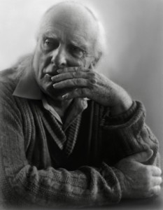
Paul Grice
(1913 - 1988): Cooperative principle

Paul Grice is one of the most important contributors to pragmatics, which is the study of how context contributes to meaning. His best-known idea is the cooperative principle, which breaks down how people behave in conversations in order to enable effective communication. In general terms, Grice articulates that speakers must be truthful, relevant, and unambiguous, and must say neither too much nor too little. If a speaker violates one of these principles (known as “maxims” in Grice’s terminology), communication is compromised. A classic example of a violation of the cooperative principle is if somebody says to you, “I love you. Do you love me?” and you answer, “Yes.” This is saying too little, which suggests that your answer might be a lie. If a speaker violates one of these principles (known as “maxims” in Grice’s terminology), communication is compromised.

David Crystal
David Crystal is a refined linguist. He has written many books on linguists like Cambridge Encyclopedia of Language and Cambridge Biographical Cambridge Encyclopedia of the English Dictionary and many more. His books regarding English literature and linguistics are very famous.
In his books, he has explained technical knowledge at an understandable and accessible level. According to one of his hypotheses, the English language will mix with local languages, and it will not be comprehensible. Therefore, there is a need for standardizing spoken English.

Eve Clark
Eve Clark (1942 - ): First language acquisition Users of Immersia are most likely interested in learning a second (or third, or fourth!) language. However, in order to understand how it’s best to learn a second language, we must also understand how we acquire our first language. Eve Clark is a pioneer in the field of first language acquisition, and has revolutionized the way in which we understand how children pick up language. From babbling to coherent conversation, Eve Clark proposes theories and cites evidence that sheds insight into the mystifying topic of how children learn their first language so successfully and efficiently. Ultimately, this information will help us understand how to maximize efficiency in second language acquisition, too.

Steven Pinker
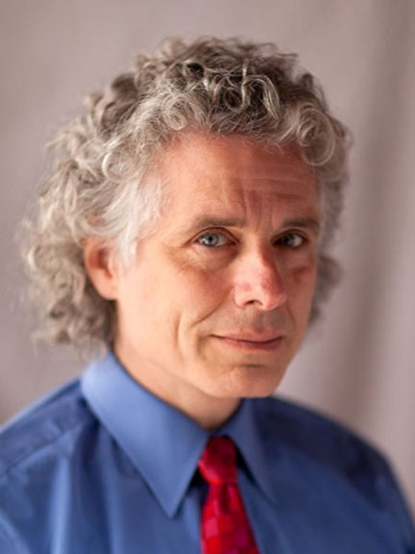
Steven Pinker (1954 - ): Popularizing linguistics In his wildly popular books such as The Language Instinct, Steven Pinker argues for a biological basis of language acquisition. As the title suggests, he proposes that language is an instinct — a behavior which, like any other instinct, was formed by natural selection, and has adapted to suit humans’ communicative needs throughout time. His accessible, fun-to-read books have made great strides in popularizing the field of linguistics, and making it accessible to those outside the realm of academia.

An experimental psychologist, cognitive scientist, and linguist, Professor Steven Arthur Pinker is one of the most influential figures in the present era. His specializations includes Psycholinguistcs, children's language development, shape recognition, the neural bases of words and grammar and the theory of language acquisition. Some of his famous works are The Language Instinct, How the Mind Works, Words and Rules, The Blank Slate, The Sense of Style, etc.

George Philip Lakoff

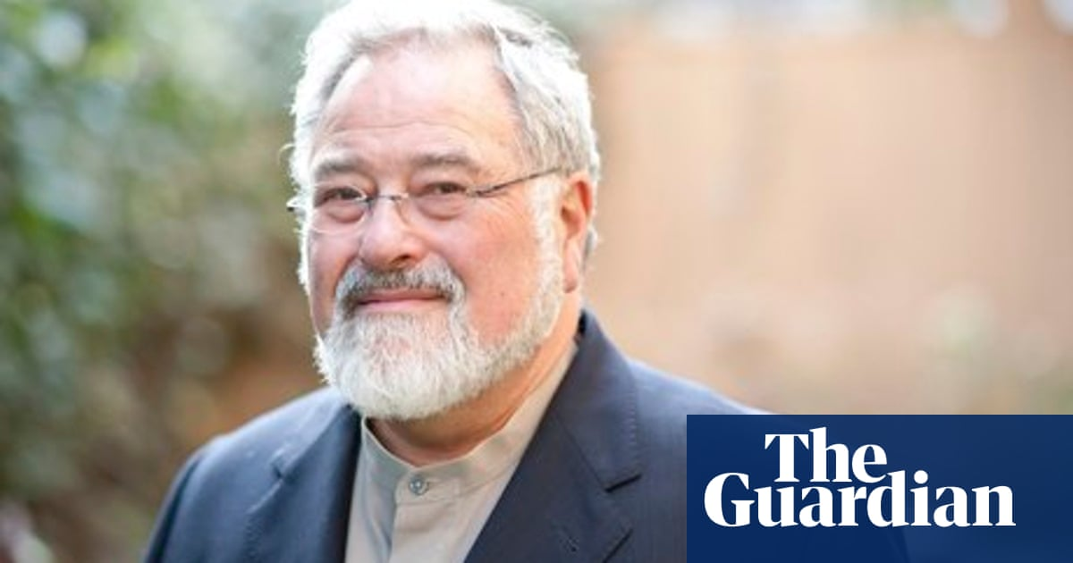
George Philip Lakoff is a famous linguist and philosopher. He stated that the life of people is influenced by the conceptual metaphors that they use to explain difficult situations. He introduced this concept in his and Mark Johnson’s book, Metaphors We Live by. His thesis is being used in many disciplines.

Michael Halliday
(1925-2018)
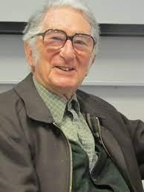
Michael Halliday was a British linguist. He got popularity because of his famous neo-Firthian theory of language. His mother was a teacher and his father was a dialectologist. From childhood, he has had a great love for languages.
He was an expert in the Chinese language, and he has researched the theory of grammar and child language development. According to him, language doesn’t just mimic meaning, but it creates new meaning. He is also famous for his theory of child language acquisition which argues about the impact of language functions in society and how these functions find the language structure. The neo-Fithian theory was also introduced by him that views language as a social phenomenon.

Umberto Eco
Umberto Eco is famous for his novels and critical work in linguistics. He worked on semiology with a touch of philosophy. According to him, symbols are the philosophical reflection of signs, and they depict both culture and things.
Umberto Eco was primarily known as a semiotician, philosopher, novelist, and literary critic rather than a traditional grammarian. While his work often touched upon linguistic and semiotic topics, including discussions of language and communication, he was not primarily focused on the technical aspects of grammar or language structure.
Eco's notable works include "The Name of the Rose," a historical murder mystery, and "Semiotics and the Philosophy of Language," which delves into semiotics, the study of signs and symbols, and its relationship to language.
While Eco's writings explored various aspects of language, including its use in literature and communication, he cannot be categorized as a grammarian in the traditional sense, as his contributions to linguistics were more broadly centered on semiotics, philosophy, and literature, but since current trends are mostly interdisciplinary, we can broadly classify him as belonging to the philosophic school of thought in grammar.

William Labov
(1927-)

Another famous linguist, also known as the Father of Sociolinguistics, is William Labov. He has been described as one of the most original and influential figures for his methodology. His study of The Social Stratification of Language has made the way for modern Sociolinguistics. He was one of the first persons to say that the use of language depends on the social context. He is also the creator of Observer's Paradox, which refers to the phenomena where the observation of an event or action is influenced by the observer.
He majorly investigated the relationship between language and society. As a variationist, William Labov uses a method in which he collects data about a language from various native and non-native speakers and does a comparative analysis of the different ways of saying things and how it changes the meaning derived from them.

Michael Swan
Michael Swan is a writer of English language teaching and reference materials. He graduated from University of Oxford with a bachelor's degree in modern foreign languages and has later gone for a postgraduate research degree. He is the founder of Swan School of English. Major publications include Practical English Usage and Basic English Usage (Oxford University Press). Other books are Grammar, an introductory book on why languages need grammar and what they do with it and, with David Baker, Grammar Scan (Oxford University Press), a collection of diagnostic language tests.
Michael Swan is also the co-author, with Catherine Walter, of The Oxford English Grammar Course, of How English Works and The Good Grammar Book (all with Oxford University Press), and the New Cambridge English Course series (with Cambridge University Press). In 2012 the Advanced level of the Oxford English Grammar Course won the newly established Award in English Language Teaching (ELT) Writing, conferred by the British Council in collaboration with The (UK) Society of Authors.
Michael Swan's interests include pedagogic grammar, mother-tongue influence in second language acquisition, and the relationship between applied linguistic theory and classroom language-teaching practice. He has written articles on all these topics, and is known for influential articles on the communicative approach and on task-based learning. Michael Swan is also a widely published poet.

Henry Watson Fowler
He wrote “Modern English Usage” in 1926, and the book was updated recently to reflect modern usage. It’s interesting to read the three main editions (1926, about 1960, and the modern one) and compare them.
H.W. Fowler, whose full name was Henry Watson Fowler, was a renowned English grammarian and lexicographer known for his significant contributions to the study of English usage and style. He is perhaps best known for his influential work, "A Dictionary of Modern English Usage," often referred to simply as "Fowler's Modern English Usage." Here's an overview of H.W. Fowler's contributions as a grammarian:
"A Dictionary of Modern English Usage": Fowler's most famous work, first published in 1926, is a comprehensive guide to English usage and style. It provides clear and practical advice on grammar, punctuation, word choice, and common language pitfalls. The book has been updated and revised by other linguists and writers over the years, but Fowler's original insights and principles continue to shape discussions on language use.
Prescriptive Approach: Fowler adopted a prescriptive approach to language, meaning that he believed in establishing and promoting certain rules and conventions for English usage. His work aimed to provide guidelines for using the language correctly and effectively.
Clarity and Precision: Fowler emphasized the importance of clarity and precision in language. He advocated for clear and concise writing that avoided unnecessary verbosity and ambiguity.
Common Usage and Elegance: Fowler recognized that language evolves, and he encouraged writers to balance established grammatical norms with common usage. He believed in preserving the elegance and expressiveness of the English language while acknowledging that some language changes were inevitable.
Cautions Against Pedantry: While Fowler provided guidelines for proper language usage, he cautioned against excessive pedantry or rigid adherence to outdated rules. He recognized that language is a living, evolving entity and that some traditional rules might no longer be relevant or effective.
Skepticism Toward Neologisms: Fowler was known for his skepticism toward newly coined words and phrases. He advocated for a conservative approach to language change and encouraged writers to use established vocabulary when possible.
Influence and Legacy: "Fowler's Modern English Usage" has had a lasting impact on English language reference works and style guides. Many subsequent language experts and grammarians have drawn inspiration from Fowler's approach to language, making his work a foundational text in the field of English usage.
H.W. Fowler's contributions as a grammarian and his dedication to promoting clear, effective, and elegant English prose continue to be appreciated by writers, editors, and language enthusiasts. His work remains a valuable resource for those seeking guidance on language usage and style.

Randolph Quirk
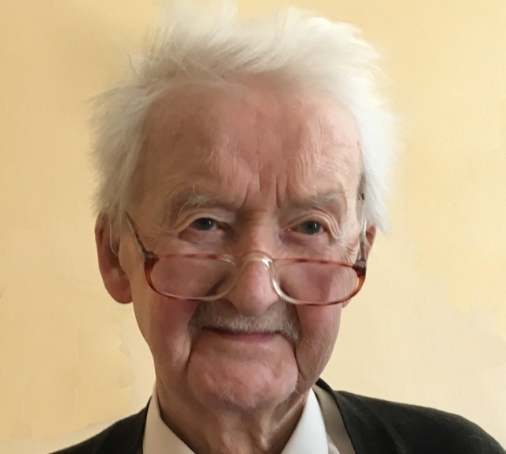
Randolph Quirk (1920-2017) was a prominent British grammarian and linguist who made significant contributions to the field of linguistics, particularly in the area of English grammar. He was highly influential in both descriptive and theoretical linguistics. Here is an overview of Randolph Quirk's career and contributions:
Randolph Quirk was born in London, England. He studied at University College London (UCL) and later earned his Ph.D. from the University of London. He spent much of his academic career at UCL.
The Comprehensive Grammar of the English Language: Perhaps the most notable achievement in Randolph Quirk's career was his role as the principal author of "A Comprehensive Grammar of the English Language" (1985), commonly referred to as the "Quirk Grammar." This extensive work, co-authored with Sidney Greenbaum, Geoffrey Leech, and Jan Svartvik, is a comprehensive and descriptive grammar of English. It is considered a foundational reference in the field of English grammar.
Transformational Grammar: Quirk made contributions to transformational grammar, a theory of syntax developed by Noam Chomsky. He applied transformational principles to the analysis of English sentence structures, contributing to our understanding of how sentences are formed and transformed in English.
Linguistic Analysis: In addition to his work on English grammar, Quirk conducted extensive linguistic analysis across various areas of language study, including syntax, semantics, and pragmatics. His research was characterized by its empirical rigor and systematic approach.
Language Teaching: Quirk's work also had a significant impact on English language teaching. His grammar publications, including the "Quirk Grammar," have been widely used as resources for English teachers and learners around the world.
Honors and Recognition: Randolph Quirk received numerous honors and awards during his lifetime, including being knighted in 1985 for his services to the study of English language and linguistics. He was also elected as a Fellow of the British Academy, further underscoring his contributions to the field.
Legacy: Randolph Quirk's legacy lies in his dedication to the scientific study of language and his contributions to the analysis of English grammar. His work continues to influence linguists, grammarians, and educators, shaping the way English grammar is both described and taught.
Randolph Quirk's commitment to descriptive linguistics and his collaborative efforts in producing a comprehensive grammar of English have left an enduring mark on the field of linguistics. His work remains an essential resource for scholars and students interested in the study of English language and grammar.

Rodney Desmond Huddleston
Professor Rodney Desmond Huddleston is a highly regarded grammarian and linguist known for his significant contributions to the field of linguistics, particularly in the area of grammar and syntax. Here is an overview of Professor Rodney Huddleston's career and contributions:
Rodney Huddleston was born in 1937 in New Zealand. He studied at the University of Canterbury, where he earned his Bachelor's and Master's degrees. He later pursued doctoral studies at the University of London.
Collaboration with Geoffrey K. Pullum: Huddleston is perhaps best known for his collaboration with Geoffrey K. Pullum on the influential work "The Cambridge Grammar of the English Language." This comprehensive grammar book, published in 2002, provides an in-depth analysis of English grammar based on modern linguistic principles. It is often referred to as "CGEL" and is considered a landmark publication in the study of English grammar.
Systemic Functional Grammar: Huddleston is associated with Systemic Functional Linguistics (SFL), an approach to linguistics that focuses on the relationship between language structure and its function in communication. His work in CGEL reflects the principles of SFL and offers a detailed description of English grammar within this framework.
Role in Grammar Teaching: Huddleston's work has had a significant impact on the teaching of grammar. "The Cambridge Grammar of the English Language" provides teachers, linguists, and language enthusiasts with a comprehensive resource for understanding the structure of the English language and its grammatical features.
Continued Research: Huddleston's contributions to the field of linguistics extend beyond CGEL. He has published numerous articles and papers on topics related to syntax, grammar, and language structure. His research has helped shape the way linguists and grammarians approach the study of language.
Recognition and Influence: Huddleston's work, especially CGEL, is highly regarded and widely cited in linguistic and grammatical studies. His contributions have influenced the development of linguistic theory and have provided valuable insights into the structure and function of the English language.
Legacy: Rodney Huddleston's legacy as a grammarian lies in his commitment to advancing our understanding of English grammar through systematic analysis and linguistic theory. His work continues to be an important reference for linguists, educators, and researchers in the field of grammar and linguistics.
Professor Rodney Desmond Huddleston's work has made a lasting impact on the study of English grammar and linguistics. His collaborative efforts with Geoffrey K. Pullum in producing "The Cambridge Grammar of the English Language" have solidified his place as a prominent figure in the field of modern grammatical analysis.

Huddleston's Approach to Grammar
Descriptive Grammar: Huddleston's work, including CGEL, is firmly rooted in descriptive grammar. Rather than prescribing how language should be used, he focuses on describing how English is actually used by native speakers. This approach makes his grammar a valuable resource for linguists, educators, and learners interested in understanding English as it is spoken and written.
Systematic Analysis: Huddleston's syntactic analysis is known for its systematic and comprehensive nature. CGEL provides an in-depth examination of English syntax, breaking down the structure of sentences and phrases into detailed categories. The grammar is organized in a clear and hierarchical manner, making it accessible to those studying the intricacies of English grammar.
Function-First Approach: Huddleston's grammar places a strong emphasis on the functions that different grammatical structures serve in communication. This means that he analyzes sentence structures not only in terms of their form but also in terms of their communicative functions. This approach helps users of the grammar understand why certain structures are used in specific contexts.
Cognitive Grammar Influence: Huddleston's work shows influences from cognitive linguistics, which explores how language reflects human cognition. His analysis takes into account the cognitive aspects of language use, such as the mental processes involved in constructing sentences and conveying meaning.
Syntactic Trees: Huddleston's syntactic analysis often employs tree diagrams to represent the hierarchical structure of sentences. These trees visually depict the relationships between words and phrases in a sentence, making complex sentence structures more transparent and comprehensible.
Comprehensive Coverage: CGEL provides extensive coverage of English grammar, including not only standard English but also variations and regional differences. Huddleston's approach acknowledges the diversity of English and aims to encompass a broad range of language use.
Empirical Basis: Huddleston's analysis is grounded in empirical data, drawing on a wide range of linguistic corpora and real-world language examples. This empirical foundation ensures that the analysis reflects actual language usage.
Pedagogical Application: While CGEL is primarily a descriptive grammar, Huddleston and his co-author Geoffrey K. Pullum have also considered its pedagogical implications. Teachers and learners can use CGEL to gain insights into English grammar and improve their language skills.
Influence on Linguistics: Huddleston's work has had a significant influence on the field of linguistics, particularly in the study of English grammar. CGEL is considered a landmark publication in modern linguistics and has informed subsequent research and grammatical analyses.
In summary, Rodney Huddleston's specific approach to syntactic analysis is characterized by its descriptive, systematic, and function-first nature. His work, especially "The Cambridge Grammar of the English Language," is a comprehensive and influential resource in the field of English linguistics, providing valuable insights into the structure and usage of the English language.

Assignment 5:
- Read the discussion in the thread and prepare some info about one of the linguists mentioned there. What other famous grammarians impress you?
https://www.reddit.com/r/linguistics/comments/prx2si/which_linguists_should_be_famous_in_2021_apart/

- Read the article about H.W. Fowler. Discuss it in class.
https://www.nytimes.com/2009/12/13/books/review/Holt-t.html
- Watch the video and discuss it in class. Do you agree with Michael Swan? Michael Swan: What exactly is grammar? (5.50)

https://www.youtube.com/watch?v=35Y0J6tsJrI&list=PLvCfA99qTst8YWl1U9rqRyyZEpEGkpIsO

GESTALT GRAMMAR & ITS PRACTICAL APPLICATION

Gestalt theory, originally developed in the field of psychology and later applied to various other disciplines, including linguistics, offers insights into how people perceive and organize information. In linguistics, the Gestalt principles have been used to understand language structure, processing, and meaning. Gestalt theory can be applied in linguistics & grammar in several ways today.
Phonological Perception
Gestalt principles can be applied to the perception of speech sounds. Listeners often group phonemes together to form larger perceptual units, such as syllables and words. This grouping helps in speech perception and segmentation.
Segmentation and Parsing
Language users often rely on Gestalt principles to parse and segment sentences. They use principles like proximity, similarity, and closure to group words and phrases into meaningful units, aiding in sentence comprehension.
Semantic Organization
Gestalt principles also play a role in how people organize and interpret the meanings of words and phrases. For example, the principle of similarity can help explain why semantically related words are often grouped together in the mental lexicon.
Syntax and Sentence Processing
Gestalt principles can be applied to sentence structure. The principle of closure, for instance, helps in understanding incomplete or ambiguous sentences by filling in missing information to create a coherent structure. Gestalt principles are used by Professor Iryna Morozova (Ukraine) in her research into the essence of syntactic phenomena (like the simple sentence) as well as in her psycho- and sociolinguistic works.
Text Processing
When reading longer texts, readers use Gestalt principles to organize information into coherent mental representations. This helps in understanding the relationships between different parts of a text.
Figurative Language
Gestalt theory can be applied to understand the comprehension of figurative language, such as metaphors and idioms. Listeners and readers often use perceptual grouping to make sense of these expressions.
Language Acquisition
In language acquisition, children may use Gestalt principles to make generalizations about linguistic structures. For example, they might group together similar linguistic patterns as they learn grammar rules.
Discourse Analysis
In discourse analysis, researchers consider how people organize information in conversations and texts. Gestalt principles help explain how information is structured and connected in discourse.
Cognitive Linguistics
Cognitive linguists often draw on Gestalt principles to explain language phenomena. They argue that linguistic structures and meanings are shaped by cognitive processes, including perceptual organization.
Metaphor and Image Schemas
Cognitive linguists, such as George Lakoff and Mark Johnson, have explored the role of image schemas, which are related to Gestalt principles, in understanding abstract concepts and metaphorical language.
In summary, Gestalt theory provides a framework for understanding how people perceive, organize, and make sense of linguistic information. Its principles are applied to various aspects of linguistics, including phonology, syntax, semantics, and discourse analysis, contributing to a deeper understanding of language structure and processing.

Assignment 7:
Read about a Gestalt Theory approach to structure in language. Prepare to discuss the article in class.
https://www.readcube.com/articles/10.3389/fpsyg.2021.649384

Assignment 8:
Think about some possible research done within the framework of the current grammar & linguistic trends mentioned above. How do you think it could be carried out? Try your hand at implementing at least some bit of it & present your results in class.

LIST OF USED AND RECOMMENDED LITERATURE
- Морозова І.Б., Пожарицька О.О., Степаненко О.О. Мовленнєвий портрет комунікативного лідера (гештальт-синтаксичний аспект розгляду). Актуальні проблеми філологічної науки: сучасні наукові дискусії: матеріали міжнародної науково-практичної конференції, присвяченої 80-річчю д.філол.н., проф. Таранця В.Г., м. Одеса, 23-24 березня 2018. Одеса : Міжнародний гуманітарний університет, 2018. С. 98-100.
- Морозова І.Б. Синтаксичне варіювання особливостей мовлення віртуальної особистості в залежності від рівня її когнітивних здібностей: гештальт-аналіз. Одеська лінгвістична школа: траєкторії досліджень : колект. моногр. / за заг. ред. Ковалевської Т. Ю. Одеса: ПолиПринт, 2021. С.240-250
- Лимаренко О.А. Речення як складна одиниця : структурно-семантичний та функціональний аспекти. Одеська лінгвістична школа : у просторах інтерпретацій : колект. моногр. 2017. С. 49-62.
- Пожарицька О.О. Авторський концепт позитивності у мовленнєвому портреті головного героя: Комунікативно-парадигматичний аналіз (на матеріалі англомовних романів жанру «вестерн»). Дис. на здобуття наук. ступеню канд. філол. наук : спец. 10.02.04 «Германські мови». Одеськ. Нац. ун-т імені І.І. Мечникова, 2014. 244 с.
- Пожарицька О.О. Полікодовість в інформаційному просторі літературно-графічних художніх творів. Одеська лінгвістична школа: інтеграція підходів : Колективна монографія / за заг. ред. Ковалевської Т.Ю. Одесса: ПолиПринт, 2020. С. 462-484.
- Bemposta-Rivas S., Bouzada-Jabois C., Fernández-Pena Y., Bouso T., J. Calvo-Benzies Y., Tamaredo I. New trends and methodologies in applied English language research III. NY: Peter Ling, 2017. 298 p.
- Kühne R., Weber P., Sommer K. Beyond Cognitive Framing Processes: Anger Mediates the Effects of Responsibility Framing on the Preference for Punitive Measures. Journal of Communication. 2015. Vol. 65. Issue 2. P. 259-279. DOI: 10.1111/jcom.12151
- Karpenko M. The Linguistic Aspects of Hypnotic Discourse (Case Study of English and Chinese Hypnotic Texts) Науковий вісник ПНПУ ім. К. Д. Ушинського. 2019. № 28. P. 109-117
- Karpenko M. The onymic space of the internet. ІІ Міжнародна науково-практична конференція «Актуальні проблеми філології і професійної підготовки фахівців у полікультурному просторі»: 16-17 травня 2016 р. Одеса : ПНПУ імені К. Д. Ушинського, Секція теоретичної та прикладної лінгвістики Південного регіонального наукового центру НАН і МОН України. 2016. С. 21-24.
- Karpenko O. Cognitive Onomastics. ‘Names and Their Environment’ Proceedings of the 25th International Congress of Onomastic Sciences. Volume 4: Theory and Methodology, Socio-onomastics. University of Glasgow, 2016. P. 69-74.
- Kortmann B. Turns and trends in 21st century linguistics. English Linguistics. J.B. Metzler, Stuttgart. 2020. https://doi.org/10.1007/978-3-476-05678-8_9
- Langacker Ronald. Cognitive Grammar: A Basic Introduction. New York, 2008; online edn, Oxford Academic, 1 May 2008. URL: https://doi.org/10.1093/acprof:oso/9780195331967.001.0001, accessed 1 Sept. 2022
- Methods and Applications in Language Sciences: Recent Trends in Linguistics URL: https://www.frontiersin.org/research-topics/27225/methods-and-applications-in-language-sciences-recent-trends-in-linguistics#impact
- Morozova I., Pozharytska O. Literary Dialogue: Syntactic Structures and Communicative Leadership. International Association of Literary Semantics: Keynes College, University of Kent. Canterbury, United Kingdom, 13-16 August 2014. P. 23.
- Morozova I. B., Abramova Ie. Yu. Compliments as a specific methodological approach of optimizing the process of teaching foreign languages. Advanced trends of the modern development of philology in European countries : Collective monograph. Riga : Izdevnieciba “Baltija Publishing”, 2019. Pp. 136-156
- Morozova I., Pozharytska О. Handsome is as handsome speaks. IAFOR; ECAH ECCS Libeuro Euromedia. Brighton, United Kingdom, 2015. Pр. 41-54.
- Morozova Iryna, Pozharytska Olena Speech Roles and Games We Play. Institute of English Studies, School of Advanced Study. ISLE 5. The 5th International Conference of the International Society for the Linguistics of English. London, United Kingdom, 17 − 21 July, 2018. Pp. 9-10.
- Morozova I. B., Pozharytska O.O. Characters’ Pilgrimage from the Canon to Fanfiction: A Gestalt Approach. The IAFOR Journal of Literature and Librarianship. Volume 10. Issue 1. 2021. Published July 28, 2021. Pp. 78-96. DOI: doi.org
- https://iafor.org/journal/iafor-journal-of-literature-and-librarianship/volume-10-issue-1/
- Morozova І. B., Repushevska І.І. Section 3. The Evolution Of Female Speech From The Perspective Of Gender. Innovative pathway for the development of modern philological sciences in Ukraine and EU countries : Collective monograph. Vol. 2. Riga, Latvia : “Baltija Publishing”, 2021. 392 p. Р. 32-48.

Навчальне видання
CURRENT TRENDS IN GRAMMAR

МЕТОДИЧНІ РЕКОМЕНДАЦІЇ
до практичних занять та самостійної роботи
з навчальної дисципліни “Сучасні граматичні течії” для здобувачів вищої освіти другого (магістерського) рівня за спеціальністю 035 «Філологія», спеціалізації 035.041 Германські мови та літератури (переклад включно), перша англійська

Укладачі
Морозова Ірина Борисівна
Пожарицька Олена Олександрівна
Карпенко Максим Юрійович

В авторській редакції
Підп. до друку 15.02.2023. Формат 60x84/16
Ум.-друк. арк. 1,8. Наклад 100 пр.
Зам. № 1546. (16 кегль)
(заповнюється видавництвом,
можуть бути відмінності в залежності від видавництва)

Видавець і виготовлювач (16 кегль)
(назва видавництва)
(Свідоцтво суб’єкта видавничої справи)
(адреса видавництва)
(тел., е-mail видавництва)

