МІНІСТЕРСТВО ОСВІТИ І НАУКИ УКРАЇНИ
ОДЕСЬКИЙ НАЦІОНАЛЬНИЙ УНІВЕРСИТЕТ ІМЕНІ І. І. МЕЧНИКОВА
ФАКУЛЬТЕТ РОМАНО-ГЕРМАНСЬКОЇ ФІЛОЛОГІЇ
КАФЕДРА ІНОЗЕМНИХ МОВ ГУМАНІТАРНИХ ФАКУЛЬТЕТІВ

“PRESENTATION TECHNIQUE”
МЕТОДИЧНІ РЕКОМЕНДАЦІЇ
для здобувачів вищої освіти першого (бакалаврського) рівня
I-II років навчання спеціальності 081 Право
та III-IV років навчання спеціальності 071 Облік і оподаткування
економіко-правового факультету

Одеса
2021
УДК 001.818(072)
P91
Укладач:
І. В. Рудік, кандидат філологічних наук, доцент кафедри іноземних мов гуманітарних факультетів Одеського національного університету імені І. І. Мечникова.

Рецензенти:
Н. Р. Григорян, кандидат філологічних наук, доцент кафедри теоретичної та прикладної фонетики англійської мови Одеського національного університету імені І. І. Мечникова.
К. Д. Долбіна, кандидат філологічних наук, доцент кафедри іноземних мов природничих факультетів Одеського національного університету імені І. І. Мечникова.
Рекомендовано до друку вченою радою факультету романо-германської філології
ОНУ імені І. І. Мечникова
Протокол № 3 від 8 грудня 2021 р.

P91 | Presentation technique: метод. рек. для здобувачів вищ. освіти першого (бакалавр.) рівня I-II років навчання спец. 081 Право та III-IV років навчання спец. 071 Облік і оподаткування економіко-правового факультету / уклад. І. В. Рудік ; Одес. нац.. ун-т ім.. І. І. Мечникова. – Одеса : Жмай О. В., 2021. – 45 с.

Методичні рекомендації призначені для здобувачів вищої освіти першого (бакалаврського) рівня І-II року навчання спеціальності 081 Право та ІII-IV року навчання спеціальності 071 Облік і оподаткування економіко-правового факультету. Мета методичних рекомендацій полягає в збагаченні лексичного запасу здобувачів новими мовленнєвими одиницями, у опануванні навичок публічного виступу та у вивченні методик та технік створення презентацій. Потреба у оволодінні навичками презентації іноземною мовою пояснюється тим, що виступ перед аудиторією як вид мовленнєвої діяльності є потужним засобом подолання мовного бар’єру, розвитку коректності та плинності мовлення. Матеріал розрахований як для аудиторної, так і для самостійної роботи здобувачів.
УДК 001.818(072)

© Одеський національний університет імені І. І. Мечникова, 2021

CONTENT
ПЕРЕДМОВА …………………………………………………………..….. | 4
LESSON I …………………………………………………………..……….. | 6
LESSON II ………………………………………………………..……….. | 12
LESSON III ………………………………………………………..……….. | 20
LESSON IV ………………………………………………………..……….. | 24
LESSON V ………………………………………………………..……….. | 30
LESSON VI ………………………………………………………..……….. | 39
REFERENCES ……………………………………………………………… | 43

ПЕРЕДМОВА
Виокремлення змістового модуля «Техніка презентації» зумовлене тим, що в своїй професійній діяльності майбутні фахівці економіко-правового профілю постійно стикаються з необхідністю виступати публічно.
Поширеною формою таких виступів є презентація, тобто виступ перед аудиторією з метою представити ідею, проект, програму тощо; проінформувати про хід виконання або результати проведеної роботи; переконати аудиторію у правильності підходу або позиції, у перевагах запропонованої програми тощо.
Техніка презентації – це важлива комунікативна навичка, якої треба спеціально навчатись і яка вимагає не тільки знання мови, але й уміння правильно відібрати, обробити та подати інформацію, адаптувати її до конкретної аудиторії, враховуючи її професійні, соціальні, гендерні і культурні особливості. Принципово важливим є володіння прийомами невербальної комунікації, оскільки, як відомо, саме через засоби невербальної комунікації сприймається 93% усно викладеної інформації. Звичайно, існують так звані природжені промовці, які цим навичкам не вчились і все ж здатні робити блискучі презентації, але на жаль, таких меншість. Та хоч талантом оратора володіють одиниці, навчитися здійснювати якісні презентації, вміло користуючись прийомами цієї комунікативної діяльності, можуть усі.
Важливість оволодіння навичками презентації іноземною мовою пояснюється також тим, що виступ перед аудиторією як вид мовленнєвої діяльності є потужним засобом подолання мовного бар’єру, розвитку коректності та плинності мовлення, а також навчання творення зв’язного тексту.
Методичні рекомендації «Presentation technique» до курсу «Іноземна мова (англійська)» для здобувачів вищої освіти першого (бакалаврського) рівня І-II року навчання спеціальності 081-право та ІII-IV року навчання спеціальності 071-облік і оподаткування економіко-правового факультету – навчальне видання, що має за мету розвиток комунікативних компетентностей, таких як вміння представити ідею, проект, програму, результати проведеної роботи; переконати аудиторію у правильності підходу або позиції, у перевагах пропонованої програми тощо.
Зміст узгоджено зі змістом робочих програм навчальних дисциплін вказаних спеціальностей, забезпечено реалізацію основних дидактичних принципів науковості, систематичності, послідовності та доступності викладу.
Структура матеріалу методичних вказівок сприяє вдосконаленню, систематизації та збагаченню словникового запасу в межах запропонованої тематики із урахуванням кросдисциплінарного інтегрованого підходу; розвитку навичок правильного розуміння та презентації інформації; формуванню загальнонаукових компетентностей; а також подальшому розвитку професійних загальних компетентностей: навичок спілкування іноземною мовою.
Авторка методичних рекомендацій сподівається на те, що в результаті аудиторної та самостійної роботи з пропонованими методичними вказівками «Presentation technique» здобувач зможе:
- розвинути навички правильної структурної та змістовної організації презентації;
- вдосконалити техніку презентації з метою оптимального впливу на аудиторію;
- навчитися вживати відповідні лексико-граматичні, синтаксичні та стилістичні засоби, а також мовні формули спілкування, властиві презентації;
- навчитись ефективно використовувати наочні засоби;
- навчитись аналізувати презентацію з метою виявлення факторів, які впливають на її успіх або неуспіх.

LESSON ONE

Objectives:
We'll begin with guidelines for public speaking, then focus on creating effective slides, and last, transitions and finishing up. By the end of the lesson you'll be able to identify some of the guidelines for effective public speaking. The second objective is to use effective techniques to begin a presentation.

Before you start
We're going to begin by thinking about what makes an effective presentation.
Think about this question as you watch two videos.
Scan the QR code to watch the video
As you saw in the videos your words are important of course, but how you say them may be more important. Let's talk about some of the things that can make your presentation successful.

HOW DO YOU FEEL ABOUT GIVING PRESENTATIONS?

If you're like most people, it makes you nervous. Being nervous is completely normal, but you don't want to be so nervous that you can't deliver your speech.
So here are some ways you can control your nerves and appear more relaxed.
The most important thing is to prepare well and practice. Before your speech, calm your nerves with some breathing techniques.
Shrinky advice
Here's an example, breathe out, now breathe in for a count of four, then hold it, for say two, and then breathe out for six, hold for two, and breathe in again. The counting isn't so important. It's the idea that you breathe out for longer than you breathe in, and that should help you relax.

Next is posture, the way you stand.
Standing tall and looking at the audience makes you appear confident. What about your hands? The way you use your hands will depend on what's appropriate for your culture, your situation, and also your personality.
But advice is to be natural, but not too informal.
Don`t
- Move too much
- Stand with your hands in your pockets or on your hips
- Wear noisy bracelets or jingle your keys in your pocket while you talk
- Face the screen
- Read a script.

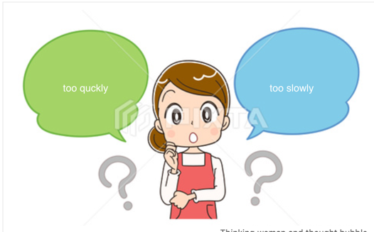

The average speed for presentation is a 150 words per minute.
Try timing yourself with a script and see if you speak at the right speed.
How fast or slow you speak.
Don't speak too quickly.
Important techniques: chunking, stress and pauses.
A group of words that you say as one phrase

The important thing is a chunk.
Mark the chunks and mark the important words to stress, pause before and after the main point.
When you stress a word, it's a little bit louder with a different pitch. And the vowel sounds will be clearer and a little longer.

Practice.
Conversation 1.
- Could you pass me the marker, please?
- This black one?
- No, the blue one.
Conversation 2.
- This meeting went well. Our last meeting was terrible. We spent hours talking about one issue.
- Did you figure it out?
- Yes. We finally came up with a solution.

Intonation.
Rising or falling intonation.
You'll sound more confident and sure of yourself, if you use falling intonation at the end of the sentences in your speech.

Practice.
-It's a very important point. You can make a difference. (low rise)
The first one sounds a bit like a question.
-It's a very important point. You can make a difference. (low fall)
The second one sounds like it's a definite, true fact.

using rising intonation at the end of any sentence

Interesting to know
This speech pattern is sometimes called uptalk. It's a common pattern among younger people in the US, Australia and Britain. Uptalk is also a common intonation pattern in different languages. So, say you're from a Scandinavian country like Norway, you might speak English with rising intonation, because that's the intonation pattern in Norwegian. Just keep in mind that if it makes you sound tentative, like you're not sure, like you're asking someone to agree with you.

Abbreviation

When we give talks, sometimes we assume that everyone knows what we do.
This is also important, because you may pronounce the abbreviation differently than people are used to.
To explain an abbreviation, use the expression stands for or is short for. 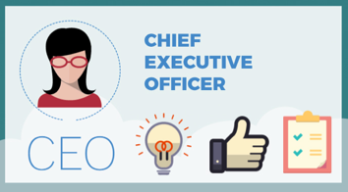

You can also introduce the meaning with a phrase like, that is.
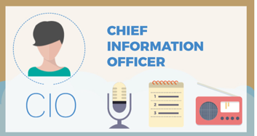

initialism
acronym

Sometimes abbreviations are spoken as words and other times as letters.

Practice.
Let's look at a couple of other examples.
You may study in a MOOC. So what's a MOOC? It's a massive open online course.
So is the word MOOC an acronym or an initialism?
What do you think?
But what about something that you might study, like an MBA?
Is that an acronym or an initialism?

Fillers.

A filler like or can be okay in between sentences.
Example:
- Let me see ...(um)...
- well
a sound or word that fills in a space

We use fillers a lot in everyday informal conversation. But they do not help you appear professional, and definitely should not be a part of a presentation. Most of the time we're not even aware how often we say these words. The idea is to think of a word like, think, every time you want to you use a filler. Basically slow down and think in silence. Don't be afraid of silence. Use silence as a pause when you would normally use a filler.

Practice.
Read this short paragraph:
- Think about the meaning.
- What's the main point?
- Identify words that go in chunks.
- And what words should you stress?
- What are the most important points?
- Pause before and after them.
Why is our city the best place for your convention? It's one of the most beautiful cities in the world. But more than that, we have the best convention center and hotels in the country. And we have the staff in our tour center to help you with every step. But don't just take my word for it, come and see it for yourself.
Did the reader chunk, pause, and stress words in the same way that you expected?

Set of common guidelines for presentations is A, B, C, D.
A means get people's attention.
B stands for benefit. What benefit will the audience get from listening to your talk?
C is credibility. Credibility means you're well qualified and the audience can feel confident that you know what you're talking about. They can believe what you say.
D stands for direction. What direction are you going in your talk? What's your plan or your agenda? Signal that you're ready to begin.

Practice

I. Are the following good or bad ideas when you’re preparing to give a presentation? Choose good idea or bad idea.
1. Practice your presentation more than once
good idea bad idea
2. Stand tall.

good idea bad idea
3. Always walk back and forth in front of the podium.
good idea bad idea
4. Don’t move your body during a presentation.
good idea bad idea
5. It’s important to read from your script.
good idea bad idea
6. Face the audience and have eye contact.
good idea bad idea
7. Speak quickly.
good idea bad idea
8. Pause before and after your main point.
good idea bad idea
9. Stress the final letter in an abbreviation where you say the letters, such as IBM.
good idea bad idea
10. Use fillers frequently instead of silence.
good idea bad idea
II. What is the purpose of each sentence? Select the right answer.

1. Last year, activities related to conventions added more than $1 billion to the economy in our city.
• Ask a question.
• Introduce yourself
• Present a surprising statistic.
• Present your objectives.
• Show the direction of your talk.
• Tell a story.

2. How many of you went to a convention in the last 5 years?
• Ask a question.
• Introduce yourself.
• Present a surprising statistic.
• Present your objectives.
• Show the direction of your talk
• Tell a story.

3. Last week, Las Vegas hosted the largest convention in history.
• Ask a question.
• Introduce yourself.
• Present a surprising statistic
• Present your objectives.
• Show the direction of your talk.
• Tell a story.

4. First, we’re going to explain reasons for the problem. Then…
• Ask a question.
• Introduce yourself.
• Present a surprising statistic.
• Present your objectives.
• Show the direction of your talk.
• Tell a story.

5. I’m the director of the Tourism Board.
• Ask a question.
• Introduce yourself.
• Present a surprising statistic.
• Present your objectives.
• Show the direction of your talk.
• Tell a story.

6. Let me show you our plan.
• Ask a question.
• Introduce yourself.
• Present a surprising statistic.
• Present your objectives.
• Show the direction of your talk.
• Tell a story.

III. Choose the best word to complete these sentences.

- Raise your hands _______ you have been to a convention in the last 5 years.

when if
- _______ you could increase the number of visitors to the city by 200% in three years?

If What if
- _____ you have been to a convention in the last 5 years?

When How many of
- First, I’m going to ______ you our plan for our presentation.

introduce show
- ______ what we are going to show you today.

Here's This
- EFL ________ English as a foreign language.

is for stands for

Here are some guidelines for giving a presentation:
- Use a strong voice with falling intonation, that carries to the back of the room.
- Greet the audience and then pause.
- Introduce yourself if they don't already know you. When you introduce yourself and any co-presenters, be sure to include information about your background or experience that's relevant to the topic. Say who you are, and why you're a good person to speak on this topic.
- Frame your topic by also mentioning how your talk will benefit the audience. It's time to give an overview of your presentation.
- Tell the audience what you're going to tell them, the goal and possibly how this will benefit them. If you have co-presenters, say what each person will do.
- Motivate your audience to listen to you. You need a hook, something that catches the audience's attention. The first possibility is to ask a question, the second kind of hook is to tell an interesting story. The third kind of hook is to give some surprising information to your audience.
- Most presentations have three key points. If you're showing your overview or objectives in a slide or a handout use short noun or verb phrases or possibly short question

LESSON TWO

Objectives: First, we'll look at how to use signposts to transition from one point to another and from one speaker to another in presentations. Then, talk about best practices for dealing with questions, as well as interruptions from the audience.
Before you start
Watch the first part of the video and note phrases which you think are the signposts. check your answers at the second part of the video.

words or phrases guides the listener coherently through what is being said

We use signposts to transition from one point to another and from one speaker to another in presentations.
The first set of words: to begin, first, then and next, show that you're moving in a sequence or to say when something is going to happen. We always pause before and after signposts.

When you move from one part of your speech to another, you can use transitions to the next topic. For example: Let's move on to talk about our options.
question you ask the audience but don’t expect answer

Another way to move from one element to another is with the use of rhetorical questions.
For example: So, why does this happen?

Here are some more example of using rhetorical questions to signpost.
In this case, they signal that you're going to explain the significance or effects of something.
- What's the significance of this?
- What does this mean for you?
- Why is this important?
And, of course, you can also use statements. Notice that we use the word this a lot to
refer back to something that we just said. This is important because it provides a great opportunity for us. This step is important to prevent later problems. Sometimes, you refer back to something that you mentioned earlier. As I mentioned before/earlier
If you think people don't understand something? You might decide to go back to an idea or to a previous slide. Here's some ways you can do that. Go back and back up, both have the idea of reverse.
- Let's go back a bit here.
- Let me go back a minute.
- Backing up a minute.
Sometimes, you mention something briefly and then let people know that this is not the only thing you have to say about it. You'll come back to it later. I'll come back to this later. We'll discuss this in more detail in a few minutes. We often introduce details by using a word that categorizes the items that follow. So in this sentence, instead of saying things, we might say factors, issues or reasons, which are a bit more specific than things. There are two important things to consider. There are two important factors to consider. There are two important issues to consider. There are two important reasons to consider. Remember that another means one other. So if you only have two items, you can say one is red, the other is blue. You don't say the another. But if you have more than two, you can use another in a list of more than two, or say the first, second, third, etc. One reason is cost. The other reason is time. There are several reasons. One is cost. Another is time, and the last is. Make it clear when you're giving an example.
- Let me give you an example.
- Here's an example.
- Let's look at an example.
- For example, let's look at fuel costs.
Sometimes, you can make a point clearer. So, you want to show that you are rephrasing. In other words, often, introduces a simple or more direct rephrase. What I mean and what I'm saying introduce more explanation of a previous point, not necessarily a shorter rephrase In other words, it's too expensive. What I mean is that everyone can use it, not just tech people. What I'm saying is that this plan won't work 100% of the time.

What about when you move to another speaker? Here's some ways that you can introduce another person.
Let's say that your co-presenter is named Mark. Mark would respond to any of these transitions by saying thank you before starting his part. Now I'm going to turn it over to Mark. And now, Mark is going to talk about the possible solutions to the problem. A conclusion usually includes a summary of your key points plus a closing sentence. It's great if you can come upwith a great last statement, especially if it's something that your audience can remember. Transitioning to the conclusion usually involves a phrase, something like this.
- So, to recap.
- To close,I'd like to summarize my main points.
- In conclusion, let me just suggest that you keep these three points in mind.
- I'd like to close by recommending these next steps.
- I'd like to close with this quote from Mark Twain.
- Thank you for your attention is a bit more formal, so most people just say thank you.
Do not say thank you for your listening.
Practice
I. What is the purpose of each sentence.
1. So what can we do about this?
- to give more information
- to go to the next point
- to explain why something is significant
- to introduce possible solutions
2. Let’s look at this in more detail.
- to give more information
- to go to the next point
- to explain why something is significant
- to introduce possible solutions
3. Let’s move on to talk about the cost.
- to give more information
- to go to the next point
- to explain why something is significant
- to introduce possible solutions
4. This is important to avoid later problems.
- to give more information
- to go to the next point
- to explain why something is significant
- to introduce possible solutions
5. We’ll discuss this in more detail in a few minutes.
- to give an example
- to change speakers
- to explain a previous point or return to a previous slide
- to promise more later
6.Backing up a minute, when I spoke about the issue, I didn't mean that it was impossible.
- to give an example
- to change speakers
- to explain a previous point or return to a previous slide
- to promise more later
7. Here’s an example of what I mean.
- to give an example
- to change speakers
- to explain a previous point or return to a previous slide
- to promise more later
8. Now Sheila is going to talk about possible solutions
- to give an example
- to change speakers
- to explain a previous point or return to a previous slide
- to promise more later
9. As I mentioned earlier, the cost is minimal.
- to rephrase
- to refer back
- to review or summarize
- to end
10. To close, let me suggest a course of action.
- to rephrase
- to refer back
- to review or summarize
- to end
11. In other words, there’s no easy solution.
- to rephrase
- to refer back
- o review or summarize
- to end
12. OK, so to recap, we’ve talked about these important issues: cost and timing.
- to rephrase
- to refer back
- to review or summarize
- to end

II. Choose the best word to complete these sentences.
1. Let’s move ______ to the next point.
in on
2. I’d like to ______ back just a minute to show you that chart again
move go
3. Before we look ________ costs, let’s discuss the time involved in each option.
at to
4. There are several options _______.
considering to consider
5. Thank you for ________.
your attention your listening
6. I’d like to close by ________ you one question.
ask asking
7. Now I’m going to turn ________ to Professor Jenkins
over it over
8. What I mean ________ it’s going to be expensive
is that that
9. This step is important ______ prevent more problems.
to for
10. So, what ______do about this problem?
we can can we

What about getting questions from your audience. If your worried at all about this part of presenting, get prepared, try to imagine what questions you have to answer.
When you anticipate the questions, you can practice answering them.
You have two questions about how to handle questions.
Let people ask them any time or ask them to save their questions until you finish your presentation in a formal presentation, the second option is much more common.
It helps you manage time more effectively to save the questions until the end.
Examples:
- Feel free to stop me anytime with your questions.
- I'd be happy to answer questions at the end of my talk.
- We'll have time for questions at the end.
If someone asks you a question, but you prefer to answer questions at the end of your presentation, say something like this to politely let people to know that you want to wait to answer those questions.
- I'd be happy to answer that question at the end.
- Let's talk about that at the end in a few minutes.
- Would you mind waiting to ask that question?

Sometimes people ask you a question about something that you're just about to cover.
Here are some responses you can use. These responses only work if the answers are going to be shown in the remainder of your talk.
- Good question.
- I'll come to that in a few minutes.
- Yes, I'm just about to talk about that.
- At the end of your presentation, ask for questions.
And make sure you make that plural by the way. It's questions.
- So, does anyone have any questions?
- Any questions or comments?
- I'm happy to answer any questions?
- What questions do you have?
Sometimes people in the audience can't hear other people's questions so you should repeat them.
- Could everyone hear?
- I'll repeat the question.
- Let me repeat that.
Sometimes it's difficult to hear or understand a question from the audience. Here are some ways to ask for repetition. With the last two questions here, you need to try to rephrase the question, to say what you think they want to say.
- I'm sorry, I didn't quite catch that.
- Could you repeat that, please?
- I'm sorry.
- Are you asking how long it will take to launch this?
- Do you mean why can't we get it done faster?
There are two kinds of difficult questions. One that you can't answer and ones that you don't want to answer. The most important thing is to respond positively, no matter what. Say something like..
- That's a great question.
- Or yes, good question.
Then you can say something to explain why you can't answer it.
- I don't know the answer to that off the top of my head.
- I don't know the answer to that right here.
- I'd like to think about that.
- I'd like to talk to you about that in the break.
- Interesting question, but that's not something I looked at.
- That's a good question, but I don't know the answer.
What if someone disagrees with you, or is upset about something you said?Just like when you're in a meeting or negotiation, it's important to stay positive. Use expressions like these to empathize or show understanding.
- I understand how you must feel.
- I understand that you have a different point of view.
- I'm sorry that you disagree.
- It's true that not everyone agrees about this.
- I don't think you're right about that.
And, if it looks like it's going to get into a bit of an argument, say something like let's not get into that discussion right now or maybe we can talk about that later. You can repeat thank you everyone to indicate that the time for questions has ended.

Practice
- Choose the best sentence to use for an effective, professional presentation. The items follow the progression of a typical presentation. Introduction to the Presentation:

- Good afternoon. My name is Pat Jonas. I’m here today to talk about trends in the travel industry.

- How are you doing? Nice to be here today, isn’t it? I’m certainly happy to be here! My name’s Pat Jonas .

- Choose the best sentence to use for an effective, professional presentation. The items follow the progression of a typical presentation. Introduction to the Presentation

- Today I’m going to show you what’s going on in the travel industry. I believe you all work in travel agencies, don’t you? So you’re all aware that a lot of people don’t use travel agencies anymore.

2. I’d like to start with a statistic I saw last week in the news. Did you know that only 18% of customers book their travel through agents like you?

- Choose the best sentence to use for an effective, professional presentation. The items follow the progression of a typical presentation. Introduction to the Presentation;

- So in the next twenty minutes. I’m going to talk about what we can do to increase our business and to bring people back from online sites.

- I know you’re all aware of this, and worried, too, aren’t you? I’m sorry, but that’s just reality.

- Choose the best sentence to use for an effective, professional presentation. The items follow the progression of a typical presentation. Introduction to the Presentation

- Now let me introduce my overview.

- Here’s an overview of my talk.

- Choose the best sentence to use for an effective, professional presentation. The items follow the progression of a typical presentation. Introduction to the Presentation

- We’ll have time for questions at the end.

2. Just interrupt me anytime if you have some questions, or if I’m not clear.

- Choose the best sentence to use for an effective, professional presentation. The items follow the progression of a typical presentation. Later in the Presentation

- First, let’s take a look at changes in the market, particularly two groups – millennials, that is, people born between 1981 and 1996, and seniors.

- I’m going to describe two groups, millennials and folks in the AARP.

- Choose the best sentence to use for an effective, professional presentation. The items follow the progression of a typical presentation. Later in the Presentation

- So, you know, millennials like, don’t, you know, talk the same way we uh older people do, and uh, they don’t uh, you know, like, make travel decisions the same way either .

- As you know, millennials are very tech-savvy, so they use online and digital devices to research and book travel.

- Choose the best sentence to use for an effective, professional presentation. The items follow the progression of a typical presentation. Later in the Presentation

- So, what can we do to attract their business?

2. This is a big problem, so do you have any ideas what to do about it?

- Choose the best sentence to use for an effective, professional presentation. The items follow the progression of a typical presentation. Later in the Presentation

- Could you be quiet in the back, please?

- I see you want to talk about this, but I have some surprising information for you. Are you ready for it?

- Choose the best sentence to use for an effective, professional presentation. The items follow the progression of a typical presentation. Later in the Presentation

- Let’s go back a bit here. Statistics don’t always tell the whole story. What’s missing here is the increase we’ve seen recently.

- I forgot to say that the statistics don’t always give all the facts we need to know.

- Choose the best sentence to use for an effective, professional presentation. The items follow the progression of a typical presentation. Later in the Presentation

- Some types of travel are perfect for the person-to-person contact that an agent provides. For example, few people are want to commit to eco-travel without personal contact.

- Some types of travel are perfect for the person-to-person contact that an agent provides. Eco-travel requires first-hand experience and is a bit of a risk .

- Choose the best sentence to use for an effective, professional presentation. The items follow the progression of a typical presentation. Later in the Presentation

- OK, that’s it. Here are some suggestions for you to think about .

- To close, here are my suggestions for each of the challenges I outlined.

- Choose the best sentence to use for an effective, professional presentation. The items follow the progression of a typical presentation. Later in the Presentation

- Thank you for your listening.

2.Thank you.

- Choose the best sentence to use for an effective, professional presentation. The items follow the progression of a typical presentation. Later in the Presentation

- Do you have any question?

- And now I’d be happy to answer any questions.

- Choose the best sentence to use for an effective, professional presentation. The items follow the progression of a typical presentation. Later in the Presentation

- Could you repeat that, please?

- What? I don’t understand you.
- Choose the best sentence to use for an effective, professional presentation. The items follow the progression of a typical presentation. Later in the Presentation

- Don’t yell. I’m not going to talk about that .

- I can see that you’re upset.

- Choose the best sentence to use for an effective, professional presentation. The items follow the progression of a typical presentation. Later in the Presentation

- I don’t believe that’s true.

- That’s a lie.

- Choose the best sentence to use for an effective, professional presentation. The items follow the progression of a typical presentation. Later in the Presentation

- I’m sorry. I’m not an expert in that area.

- Why are you asking me that question ?

LESSON THREE

Before you read

Watch the video. What do you think about it?

Objectives: This lesson is all about creating slides to support a presentation. First, the purpose of using slides in an oral presentation and what elements are necessary. Then learn how to create slides that are clear and easy to read. Remember, slides support your presentation, they do not give your talk. Everything you say should not be on the slides.

let's look at vocabulary related to slides that you make on a computer.
We'll be using these words a lot as we go through good and bad examples of slides.

type that you use

First, font.
For example, Times New Roman or Arial.
Font size, you can be 11 point or 28 point.
Upper and lower case means capital letters are not capitalized.
The word graphics refers to visuals, like images or design elements.
a group of sentences about one topic

Text means words. We use paragraphs to write messages.
We don't use paragraphs in slides.
We often use lists in slides. An item means each thing that is listed.
Most lists and slides are bulleted with some kind of a bullet mark in front of each item.
a symbol, used in text to show separate things in a list

A bullet point is an item in a list marked by a bullet.

Guidelines
- Do not read from your slides
- Do not use complete sentences in slides
- Use large font (30 points is recommended)
- Keep your slides simple and easy to read with good color contrast
- Make your list short and be consistent about capital letters and words forms
- Check your spelling
- Do not overuse animation. Keep it simple.

We wouldn't do that in a presentation.
Let me show you some common mistakes that people make when they create slides, look at the slide and decide what the major problem is.

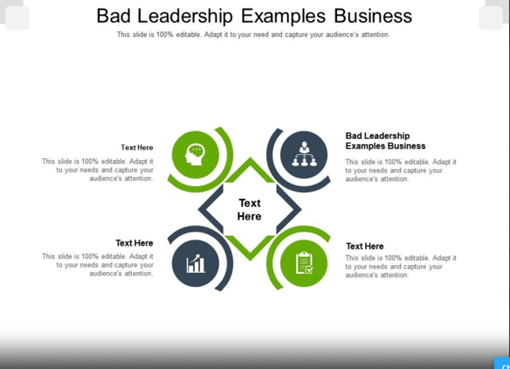

Your smallest font size should be 30 point. People in the audience would be able to read it.
Make a different slide that highlights the point you wanted to make with data from
this slide. This is much more effective.
Use all caps in the heading of a slide but don't use caps for more than one or two words. It's difficult to read. Remember that no one wants to read your presentation, they want to hear it.
If you give a definition, use a graphic. Or a few words, not a complete sentence.
In fact, never write a complete sentence on a slide unless it's a short quote.
Bear in mind color combination may look okay on your computer but there's not enough contrast for it to show up well when you project it. Choose colors that have a much bigger contrast between them. This means use a dark color for the background and a very light color for the text, like white or yellow.
Here's one idea, it has short verb phrases. As you talk, you would put them into sentences but the audience doesn't need to read the complete sentences.
Here's the same idea but with noun phrases.
Another idea would be to use images with the statistics. Rather than words on the slide.

Don’t use the items are different types of phrases. Making items consistent is always difficult. But let's make them all nouns.
And last point, animation. Having your slides fly in with all sorts of effects is not very professional. On the other hand it's not fun to be in an audience and finish reading a slide way before the speaker goes through each point. So use a simple appear animation to have each point appear as you speak. Your audience will thank you.

Practice
- What’s the Mistake with these Slides?
- Identify the problem with each slide.

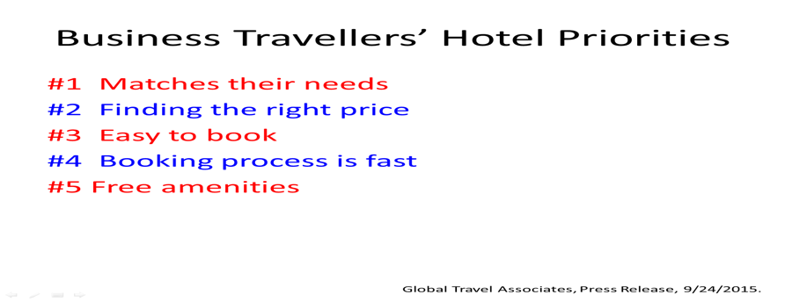
- The point size is too small.
- The items in the list are not consistent.
- The items in the list have too many words.

- Identify the problem with each slide.
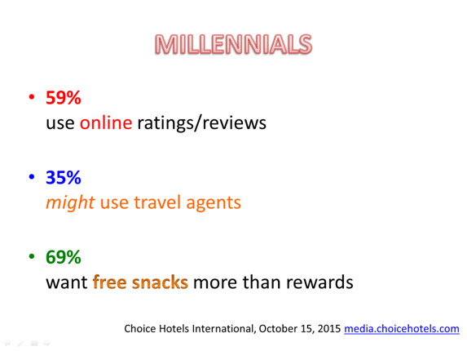

- The heading should have capital letters.
- There is too much information on the slide.
- The first sentence should have capital letters and a period at the end

- Identify the problem with each slide.
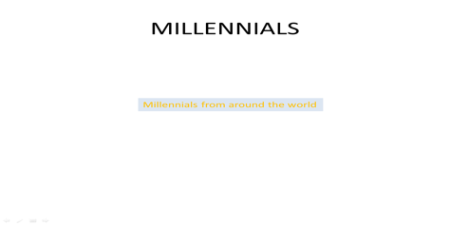
- There are too many words in the item.
- The heading should not be all capital letters.
- The color is not enough of a contrast.

- Identify the problem with each slide.

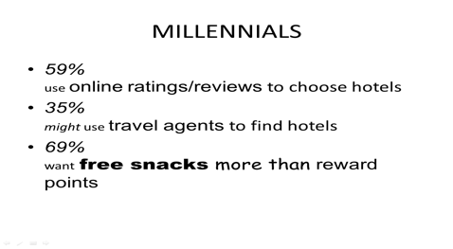
- The items in the list are not consistent.
- Each item should begin with a capital letter.
- There are too many font styles and sizes.

- Identify the problem with each slide.

- It is difficult to read.
- It has too much on it.
- There is not enough white space.

- Identify the problem with each slide

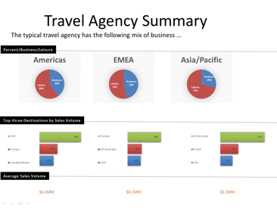
- The heading should have capital letters.
- There is too much information on the slide.
- The first sentence should have capital letters and a period at the end.

- Identify the problem with each slide
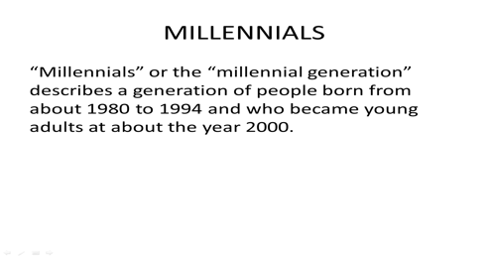
- This long definition should not be written out on the slide.
- The heading should not be capital letters.
- This should be bullet points, not a sentence.
- Identify the problem with each slide

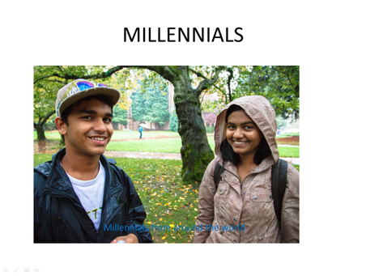

- The photo is not clear.
- There is not enough contrast to read the words on the photo.
- There is a grammar error in the text.

- Identify the problem with each slide

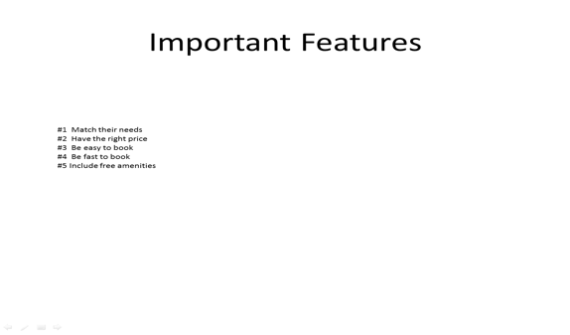

- The items in the list are inconsistent.
- The text is too small.
- The items should not all begin with capital letters.

- Identify the problem with each slide

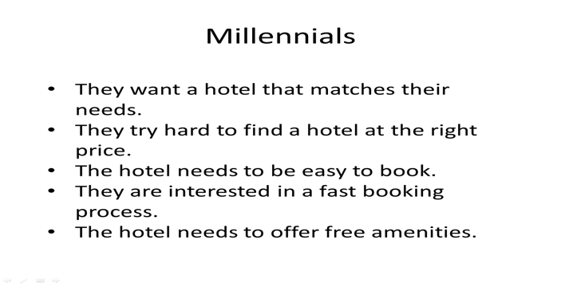
- The items should not all begin with capital letters.
- The sentences in the list are too long.
- The items in the list are inconsistent.

LESSON FOUR

Before you read

Watch the video. Discuss it with a partner how visuals can influence on an opinion.

Objectives: Use graphs and charts effectively. Use specific language to describe graphs and charts and draw attention to data on a slide. Work on using large numbers accurately, and the vocabulary we use to describe trends. And finally, to summarize its importance and relevance to your topic.

Remember that slides support your main ideas. Use graphs and charts only when necessary, don't overdo it. Keep them simple.
Complicated charts with too much data on are difficult for you to explain and for
the audience to see.
It's really irritating to hear a presenter apologize, well I know you can't see this very well.
If we can't see it, don't use it, or give it in a handout if it's important for the audience to have.
Give your audience enough time to view the slide and don't go into too much detail.
Spend the appropriate amount of time for your audience to understand what the slide shows and how it's relevant to the main point of your presentation.

let's look at some vocabulary for common visuals used in business to describe data.
A table uses rows and columns to show data using text and numbers.

column

ITEM | PRICE
A | 50
B | 70
TABLE.
raw
row

Generally speaking, tables are not great to show in a presentation because they usually have too much information and it's difficult to read.

It's better to show the information from a table in a different kind of visual.

A line graph is a diagram that shows the relationship between two sets of numbers,
for example, how something changed over time.

The x-axis is the horizontal line of a graph. The y-axis is the vertical line.
On the graph, we usually use a line to show changes.
We begin with a solid line, and then to show more information, we use another line of a different color like a orange line. Or we use a dotted line or a broken line.
But in a presentation using slides, it's often difficult to see the difference between these lines.

A bar chart, or bar graph, is sometimes easier to see on a slide, because it uses larger visual elements to show information about data.
There are many different kinds of charts, but these are the most common ones used in business. A bar chart, or bar graph, shows quantities in columns, usually different color columns. This is very helpful if you're showing several things at the same time, for
example, how the use of mobile devices has increased over time, compared to desktops or laptops.

A pie chart is often used to show percentages. In marketing a pie chart often shows market share or segment.
One thing to be careful about is the key. The key explains what the colors in a chart represent.
Make sure the key is large enough for people in the audience to read, or instead of a key, label the segments clearly.

Practice

- Take a look at the chart. What kind is it? Circle the correct one.

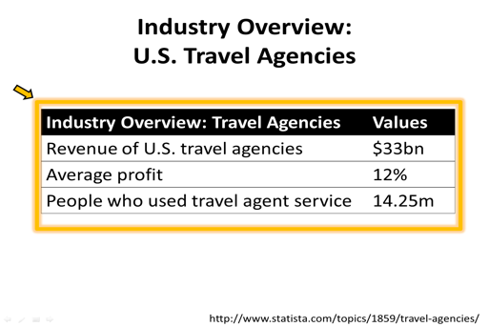

a broken line graph
a pie chart
a dotted line graph
a key
a table
a segment
a line graph
a bar graph

- What kind of graph is this?
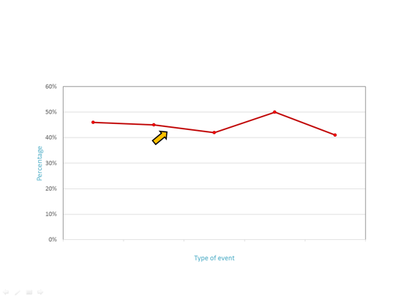
a table
a line graph
a bar graph
a dotted line graph
a broken line graph
a pie chart
a key
a segment

- What kind of graph is this?
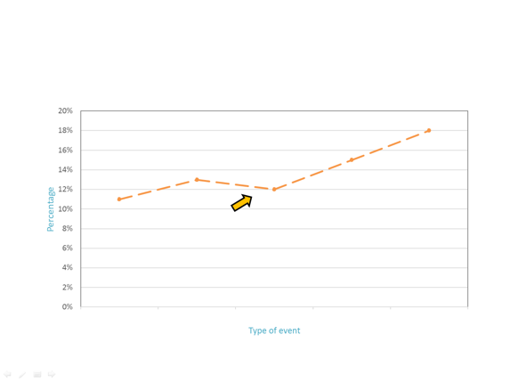
a table
a line graph
a dotted line graph
a bar graph
a broken line graph
a pie chart
a key
a segment

- What kind of graph is this?
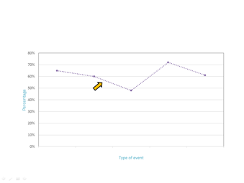
a table
a segment
a key
a broken line graph
a line graph
a dotted line graph
a pie chart
a bar graph

- What kind of graph is this?
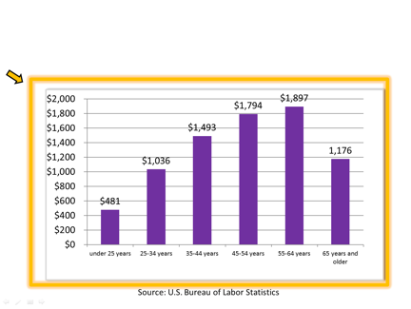
a segment
a broken line graph
a table
a bar graph
a pie chart
a dotted line graph
a key
a line graph

- What kind of graph is this?
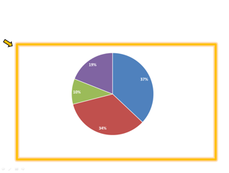
a segment
a broken line graph
a table
a bar graph
a pie chart
a dotted line graph
a key
a line graph

- What is this element that the arrow is pointing to?
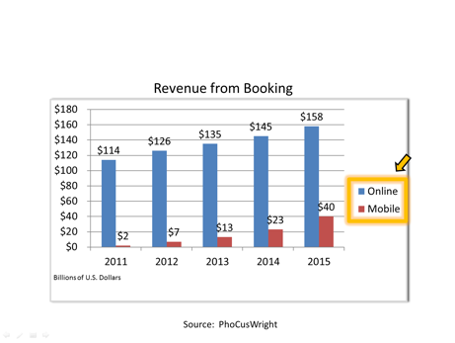
a segment
a key

Explaining graphs
When you show a chart or graph, introduce it, and explain its relevance. Basically, what are you showing, and why is it important?
Here are structures and vocabulary that are common when you describe a visual.

Visual | Verb | Noun or noun clause
This graph | shows | the relationship
This chart | explains | how/why/when sells fail
This diagram | illustrates | the process

You can also use the verb illustrate in these expressions. This illustrates the point, illustrates the problem. Or maybe illustrates the need.

Visual | Verb | Noun or noun clause
This table | provides | data for 20…
This table | lists | the name of countries with
This table | gives | information about
Remember that you don't have to point out every detail.
Direct people's attention to the most important information.
Here are some of the expressions we might use for this.

Direct attention:
As you can see, the biggest change was from 2000 to 2004, when the industry lost more than 100,000 travel agents.
Let me point out that in year 2000, we had over 120,000 agents.Now we only have 64,000.
It's important to notice that this change began in 2000.
When you point out specific information, you may decide to use a pointer on the remote slide changer. The little red laser pointer that shows on the screen. This can be helpful, but be careful when you use it.
Here are ways that we explain the importance of the information and the visual, and its relevance to your talk.

Shows importance or relevance:
This means that we need to increase our online presence.
This clearly shows that we need to find a way to reach millenials.
This is important because we are losing market share to mobile apps.
What this shows is that mobile apps are gaining market share.

Mention the source:
This graph, from the Bureau of Labor Statistics shows that….
This information, data comes from Travel Weekly….
If you give some information that's not in a chart but you include it in your speech,
you can use phrases like this to introduce the information.

Source of research:
According to Travel Weekly, there are about half as many agents now.
A study by WTTC, that is the World Travel and Tourism Council, states that our industry contributes to 9.8% of world GDP.
The WTTC reports that the travel and tourism industry employs 284 million people worldwide.
The WTTC looked at the data and found that 1 in 11 jobs in the world is related to travel and tourism.

Practice

I. Look at this chart from the UN World Travel Organization (UNWTO) and the complete the sentence.

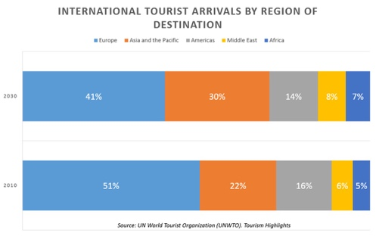

This chart f____ the UNWTO s_______ the international tourists arrivals by destination. A_____ y______ c______ s_______ Europe is the most common destination. However,
a______ t_________ the UNWTO, Europe’s s______e of international tourists will decrease by 2030 as more p______e travel to Asia and the Pacific, the Middle East, and Africa. Travel to countries in the America a______ f_______ 16% of arrivals in 2010, but is expected to fall by 2% in 2030.

LESSON FIVE

Before you read

Watch the video. What do you think about the idea to present numbers and data like storytelling.

Objectives: focus on stating numbers and dates clearly and accurately and using quantifiers such as 20% or a higher number of to comment on data. Last, you'll compare and rank using amount and degree words.

We usually think about data in terms of large numbers.
So let's start there.
Large numbers:
a thousands flights 1,000
a million visitors 1,000,000
a billion people 1, 000,000, 000
a trillion dollars. 1, 000,000,000,000
At least that's the way they are in some areas of the world like the United States. Billion doesn’t use in English and German system. Abbreviations for millions and billions are m and b or bn.
Notice that we do not put an S on these words when they're giving
an actual amount.

If you need to say a specific number such as
209 two hundred (and) nine
1,417 one thousand four hundred seventeen
220,502 two hundred thousand five hundred (and) two
In most cases, we don't give a detailed, specific number. We round the number.
So, 1,419 becomes 1400 one thousand forty
10,880 becomes 11,000 eleven thousand
When you don't use the specific amount, you can say about or around or almost to show that you're giving an approximate amount.
19820 about 20000
789483 almost 800000
990000 around a million
Dates vs numbers
We usually say dates as two pairs.
For example:
in 1995 nineteen ninety five
in 2016 twenty sixteen
However, for the years between 2000 and 2010, we use the word thousand
in 2000 two thousand
in 2008 two thousand eight

Practice
Say the phase or number
4000 people.
In 1999.
420,650.
1,295,000.
$50,000.
From 2009 to 2010.
More than 3 billion.
In 2018.
In 1925.
12,000.
16.6 million.
100,000.

describing data:

Let's look how describing data. We often need to say how frequently something occurs.
Two out of three is a very common expression.
For example, two out of three customers preferred the blue one.
One out of every seven minutes is spent on Facebook.
And did you know that one in four Americans eats fast food every day?
So the important thing to notice here is phrases, two out of three, or one in four.
But also notice the verb. It agrees with the first number, so 2 out of 3 is plural,
1 out of 7 minutes is singular.
You might be wondering that you can use
66% instead of 2 out of 3
The reason is for emphasis.
If you say 66% of the people it seems kind of general, but if you say two out of three, it seems like, that's a lot.
Or we could say 15% of the time that people are on the Internet, they're on Facebook, but saying one out of every seven minutes online is spent on Facebook sounds much more dramatic. So you can use this to emphasize frequency.
Of course percentages are very important in many cases when we report on data.
We say the word point for the decimal, and we use the word percent.
For example 18.5%, or she got 49.2% of the vote.
When you use percentages in sentences, the following words determine whether the verb is singular or plural.
Let look at a couple of examples.
Twenty percent of the jobs are part-time.
Jobs is a count noun and it's plural here, so the verb is also plural.
In the next sentence work is noncount, so look at the verb, it's singular.
Twenty percent of the work is already finished.

Practice

What will the verbs be in this sentences?
- Half of people are/ is international.
- Twenty five percent of the population are/is local.
- The number of students are/is surprising now.
- A number of students are/is finished this work.

Percent vs percentage

There's a difference between percent and percentage.
Use percent when you could use the percentage sign, in other words, when you could use a number.
For example:
There is a 20% increase.
The rate increased by 20%.

Use percentage when you could replace the word with number or rate.
For example:
The percentage was greater in the second quarter.
The increase in the percentage of people without jobs was surprising.

Ranking

Let’s look at lists that rank things first to last.
This chart represents the amount tourists spent abroad.
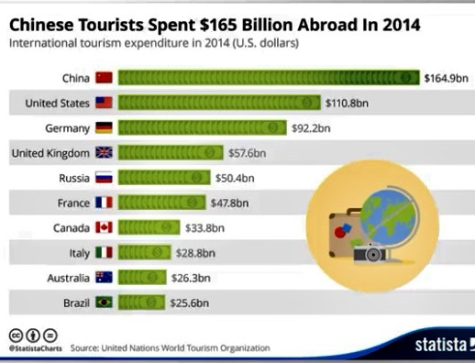

Think about how you would express the ranking.
All of these start with the name of the country.
For example:
China was first in the amount its tourists spent abroad.
The US was second.
China was number one in tourist dollars spent abroad.
Germany was number three.
China ranked first in the amount tourists spent abroad.
Brazil ranked tenth.
It's a good idea to know the ordinal numbers that express the order in a list for ranking. First, second, third, fourth, fifth, sixth, seventh, eighth, ninth, tenth, eleventh, twelfth and so on.
Let’s looked at ways to make comparisons and how we use comparisons in talking about data.
A simple comparison would be describing nouns in subject position. Think about how you would compare Pokhara and Zurich.
Here's some examples looking at budget or low cost travel to various cities.
- You could say Pokhara isn't as expensive as Zurich.
- Pokhara is less expensive than Zurich.
- Zurich is more expensive than Pokhara.
- Pokhara is much less expensive than Zurich. (add an intensifier)
- Zurich is much more expensive than Pokhara.
- Zurich is a lot more expensive than Pokhara.
- Zurich is slightly more expensive than New York, or a little. (use the word slightly, if there's not such a big difference)
- Zurich is a little more expensive.
- It's a little bit more expensive. (informal way instead of slightly)
- Cuzco is twice as expensive as Pokhara.
- Zurich is four times as expensive as Cuzco.
- Zurich is the most expensive.( use superlatives)
- Pokhara is the least expensive
Let's go back to the detail about comparisons with verbs.
Instead of using the name of the country, China ranks first, etc, let's use tourists or people from China as the subjects, and the verb spend.
For example:
- Chinese tourists spent more abroad than tourists from the US. (comparisons)
- Tourists from Brazil spent less than tourists from China.
- US tourists spent the second highest amount. (superlative)
- German tourists accounted for the third highest spending(rank)

Practice

- Look at the chart . Complete the sentences to give details about the data.

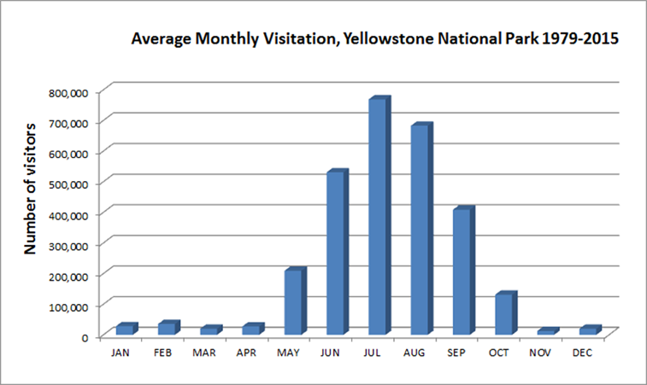

- ___ between May and October.
The most of visitation is / Most people visit

- The number of visitors in May ____ about half the number in September.
Is/ are
- ___ people visit in September as in May.
Twice as may/ two times
- July has ___ visitors.
the more/ most
- There are ___ visitors in August ___ in June.
as many…as / more than
- December has ___ more visitors than November does.
slightly / a lot
- The ___ highest number of people visited in August.
second/ number two
- Forty four ____ of the young people consulted social media.
percentage/ percent
- The ___ of people who consult social media varied according to age.
percentage/ percent
- Most of the travelers who consult social media ___ younger than 35.
percentage/ percent
Trends
You may know the word trend or trendy related to something that's popular. But for our purposes, that is, describing data, a trend is a change over time.
For example:
You can have an upward trend or a downward trend in something.
A trend usually means that there were some minor ups and downs, but overall, things moved in one direction.
For example:
There was an upward trend in travel to Cuba last year.
There's been a downward trend in airline ticket sales over the past six months.
You could also say a decline or gradual decrease or increase.
Notice that the preposition in is used with the following noun that had the change.
For example:
There's been a gradual increase in the number of visitors.
We saw a decline in sales.
Notice that we introduce these noun phrases with expressions like there was or we saw.
Many of the nouns we use for changes are also verbs.
The word, decline, and it's opposite, growth, are often used with words related to the economy. And sometimes we don't use an article before growth. We usually use, there was a decline in interest rates.
For example:
We saw growth in the economy.
We can add information about the kind of change with expressions like these, a sharp decline, steady growth.And of course we use the nouns increase and decrease.
Drop means a sudden change downwards.
For example:
We took advantage of the drop in prices.
The drop in the number of tourists was bad news for business.

A sudden change upwards might be called a jump or an uptick.
For example:
The jump in oil prices caused panic in the market.
The uptick in the price of gas worried consumers.
And a very short jump is sometimes called a spike.
For example:
A spike is usually temporary.
There was a spike in the number of phone calls after the new product was announced.

Vocabulary: verbs.
The words increase and decrease are very common, as are rise and fall or go up and go down.
For example:
The number of tourists increased.
The percentage decreased.
Inflation rose last year.
Interest rates fell.
Unemployment went down in the last quarter.
Salaries went up.
Notice that we only used up and down with the verb go.
Do not say the market grew up.
Notice that these verbs are all active not passive.
They show a change that happened in the data.
Also be careful about the difference between these two verbs rise and raise.
The best way to remember is that the longer verb can take an object. The shorter verb with only four letters does not take an object.
For example:
We had raised prices by 5%.
The price often rises when demand increases.

Vocabulary: the degree of change.
In the examples adjectives and adverbs are used to describe the degree of change, how much, or how quickly something changed.
Small and slight are similar in meaning, not very much.
Huge, of course, means very large, and significant means large or important.
Gradual means that something happened slowly over time.

Adjectives showing degree of change go before the nouns | Adverbs showing the degree of change go after the verbs
a small change | salaries rose significantly
a huge drop | the number of visitors increased slightly
a slight increase | costs increased dramatically
a very significant decrease | sales fell sharply
a fairly significant decrease | Costs went down a slight amount
a gradual change | They declined a bit
 | Costs increased quite a lot

Vocabulary: proposition
Here are some prepositions in expressions of time which is used to describe trends.
In that period, during the first quarter of the year, between March and June, from March to June.
We also use from and to, to show a change from one number to another.
Sometimes we only point out one end of the change.
For example:
Their market share increased to 45%.
Notice, the use of the preposition in, to show what the change was in but if you want to say how much, then you use the preposition of after a noun. However, after a verb use by or no preposition.
Compare sentence a and b. In which sentence is the price now $50.
- Ticket prices increased to $50.
- Ticket prices increased by $50.

Additional adverb

Sometimes you may be able to use these verbs that illustrate multiples.
The number of visitors doubled.
Sales tripled in the second year.
If there's a lot of up and down movement, you can use the verb, fluctuated.
If they go up and down and then become flat, you can say, leveled off.
For examples:
The number of users fluctuated at first.
Then it leveled off.
When something stays about the same, you can use the verb stay or remain.
For example:
Sales remained or stayed steady even during the recession.
Here are some other less common verbs, but great words for illustrating certain changes.
The number of visits peaked at 250,000.
Visits reached a high of 250,000 in 2012.
Then the number of visits dropped to a low of 47,000.
Visits dipped below 100,000 in 2015.

Grammar

Present simple could be used, for example, when you talk about a percentage.
For example:
Younger people go online more often than older people.
But when you talk about a trend, it's not usually in the simple present. A lot of the time, we're describing data that's historical. That is, it happened in the past. So your verbs will be in the past.
For example:
Sales declined between January and March.
If the trend is still happening or had no definite time in the past, use the present perfect or the present perfect progressive.
For example:
Sales have declined over the past few months.
Sales have been declining recently.
Sometimes, you're describing a trend or change that's taking place right now.Then you might use the present progressive to show that it's a situation that's still in progress.
For example:
As you can see in this chart, older people are now buying online more frequently.

Practice

- Choose the correct words to describe the chart.

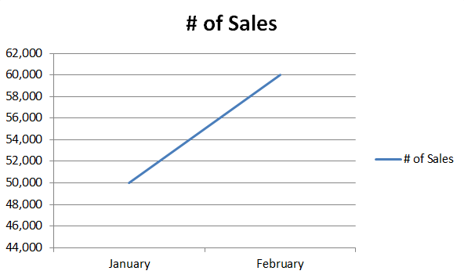
- There was ____ sales.
an upward trend in / increased by

- Sales increased _____ twenty percent.
of/by

- Look at these two pie charts.
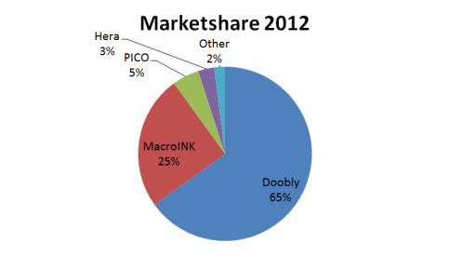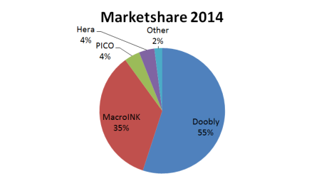
- Doobly had a decline ____ 10% ___ marketshare.
of ... in / by ... of
- 4. MacroINK's market share increased ____.
slightly/significantly
- PICO's market decreased ____.
from 5% to 4% / between 6% and 12%
- This chart shows the change in market share ___ a two-year period.
to/in
- Look at this bar chart. You will use them to answer the questions.
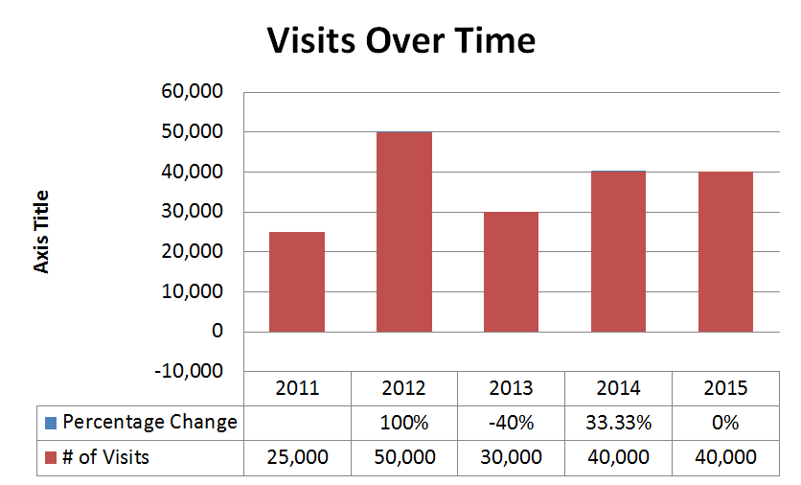

- The number of visits _________ dramatically ______ 2011 to 2012.
decreased....to/increased...from
- Visits do______ ______ 2011 ______ 2012.
tripled over...but/doubled between...and...
- The number of visits ______ in 2012.
peaked/plummeted
- Visits ______ sharply in 2013.
rose/dropped
- Visits fell ______ 60% in 2013.
for/by
- Visits ______ ______ in 2014.
leveled off/decreased dramatically
- Create a three-slide presentation to display different type of Graphs. Use the following data to create a line graphs, a pie chart, and a bar graph. See instructions on how to create Charts and Graphs.
Type of Inspiration | 25-34 age group | 35-54 | Above 55
Vacation activities | 65% | 46% | 11%
Attractions | 60% | 45% | 13%
Restaurants | 48% | 42% | 12%
Travel Destinations | 72% | 50% | 15%
Hotels | 61% | 41% | 18%
Line Graphs Data: Who Draws Inspiration from Social Media by age group
Amount of Money | Sales
$1 - $10,000 | 37%
$10,001 - $25,000 | 34%
$25,001 - $50,000 | 10%
Over $50,000 | 19%
Pie Chart Data: Annual Social Media Budget Allocation
Bar Graph Data: Average Annual Travel expenditures by Age of Head of Household
Age Group | Annual travel expenditure
under 25 years | $481
25-34 years | $1,036
35-44 years | $1,493
45-54 years | $1,794
55-64 years | $1,897
65 years and older | $1,176
Upload your slide presentation (PPT, PPTx, PDF)
Review one of your groupmate’s presentations. Use the following to review:
- Was the data for the line graphs input correctly?
- Was the data for the pie chart input correctly?
- Was the data for the bar graph input correctly?

LESSON SIX
Watch the video and try to guess what is the next topic.

Objectives: This lesson focus is on persuasive language. Focus on public speaking techniques, organizing a presentation, beginning, ending, and using visuals to support our points. Develop awareness of vocabulary to persuade.

What's the difference between an informative presentation and a persuasive presentation?
Persuasive presentations may try to convince someone to take action. They may try to get someone to support you, for example, if you make a proposal at work. Or you might be trying to get people to change their minds. Persuasion is very important people who are in marketing trying to sell products or services, but it's also very important in other areas of business when you're trying to sell an idea
As you plan your persuasive presentation, keep in mind the ABCD guidelines and apply to persuasive presentations.
Attention
- begin with attention grabber
- explain why your audience should believe you
- choose a story or a statistic that will demonstrate that you know what you're talking about.
Benefit
- identify the problem
- offer solution
- show uniqueness

Credibility
- support your ideas with strong evidence
- built trust and rapport (based on a feeling that you like each other)
- address the concerns of your audience
- show that the other agrees
Direction:

Useful Expressions: Persuasive Language

Establishing Credibility
- Honestly,
- To be honest,
- To tell you the truth,
- If you’re like me,
- I’m sure you’re wondering what/where/how/why/if/whether…
- You may be asking yourself what/where/how/why/if/whether…
- As you know,
- We all know that
- Clearly,
- Obviously,
- Without a doubt
- There’s no question that
- Everyone agrees
- Many of our guests/clients…

Adjectives
- breathtaking
- magnificent
- spectacular
- memorable
- unforgettable
- magical
- exceptional
- superb
- remarkable

Adverbs
- absolutely beautiful
- truly magical
- incredibly convenient
- surprisingly affordable
- professionally decorated
- newly renovated
- totally redesigned

Phrases
- in the heart of
- just steps away from
Practice
Making Sentences More Compelling
Complete the sentences.
1. ___, it is a bit cold here in the winter.
a. To be honest b. If you’re like me
2. ___, you’re probably wondering about the cost.
a. Honestly b. If you’re like me
3. ___ the truth, there is a lot of traffic, which is why the subway is a great way to get to work.
a. Tell b. To tell you
4. I’m sure ___ about the cost.
a. information b. you’d like to know
5. As you know, ___ one of the busiest airports in the world.
a. we have b. that we have
6. Everyone agrees ___ a great place to live.
a. is b. that this is
7. ___ a doubt, this is an amazing place to live.
a. No b. Without
8. The mountain is a ___ place to visit.
a. clearly b. spectacular
9. It will be one of the most ___ experiences of your life.
a. incredibly b. memorable
10. Our _____ renovated hotel is located in the heart of the city.
a. recent b. newly
Additional links and advises
PowerPoint
Adding Graphics to Power Point Presentations
If you are using PowerPoint for your final presentation, follow these instructions.
- Select the placeholder box where you want the chart.
- Go to the Insert tab and find the Illustrations group.
- Click on Chart and then click OK.
- Enter data into the pop-up Excel file and then close the window.
Adding Audio to PowerPoint Presentations
To add audio in PowerPoint, you must have PowerPoint 2010 or later. Follow these instructions.
- Go to the Insert tab and find the Media group.
- Click on the drop down menu under Audio and select Record Audio.
- In the dialogue box, name the audio for the slide number and then press the red button.
- Go to the next slide and repeat instructions 1-4.
Google Slides
Adding Graphics to Google Slides Presentations
If you are using Google Slides, charts are best used from Google Sheets.
- Create your chart in Google Sheets.
- Copy the chart and paste it into your presentation slide.
Or you may also insert a chart first and edit in Sheets:
- Go to the Insert tab and select Chart.
- Then select the type of chart you want.
- A box should appear with the link titled Edit In Sheets.
- Edit the data in Sheets and the information should carry over automatically.
Adding Audio to Google Slides Presentations
There are several ways to add audio in Google Slides. You can record audio separately using Audacity: http://www.audacityteam.org/ and then uploading the audio files to your YouTube account. You may also use screen capture techniques, which is discussed in the next section.
For audio, Coursera recommends using Vocaroo: http://vocaroo.com/. To use Vocaroo, follow these directions:
- Go to http://vocaroo.com/.
- Click on red button that says Click Here to Record for your target slide.
- Vocaroo gives you unlimited attempts to record audio. Once satisfied, look at the bottom of
the page for the link that reads Click Here to Save.
- You will be given a shareable link. Copy the link and then paste it into your target slide in a separate text box.
- Repeat steps 1-4 for each slide.
Screen Capture
Jing
Jing is a free screen capture tool that allows up to 5 minutes of recording. The output is a Flash interactive hosted on their server.

To use Jing, download the application for your computer at this link:
https://www.techsmith.com/jing.html
Tutorials can be located at this link: https://www.techsmith.com/tutorial-jing.html.

Practice
Use the following to review before you start to create your own presentation:
- Does the presentation meet the length requirement 3 to 5 minutes?
- Are the slides clear and do they support the presentation?
- Is there at least one chart?
- Did the presenter explain the information in the chart clearly?
- Did the presenter use signposts during the presentation?
- Is the presenter’s voice clear (not too fast, quiet or using too many fillers)?
- Did the presenter use a hook in the presentation?
- Did the presenter introduce himself/herself?
- Did the presenter include three main points?
- Does the presenter sound enthusiastic and use strong positive vocabulary?
- Were you persuaded by the presentation?

REFERENCES

- Ботвіна Н. Міжнародні культурні традиції: мова та етика ділового спілкування. АртЕк, 2000. 205 с.
- Brieger N. Teaching Business English Handbook. York Associates Publication, 1997. 103 р.
- Lucas Stephen E. The Art of Public Speaking. McGraw-Hill, 1995. 382 р.
- Locker Kitty O. Business and Administrative Communication. Ed. Richard D. Irwin, Inc., 1995. 672 р.
- https://m.youtube.com/watch?v=Zo0LFM5Jcs7
- https://m.youtube.com/watch?v=6r9DAyP46l0
- https://m.youtube.com/watch?v=THn-I-byBIA
- https://m.youtube.com/watch?v=E91bGT9BjYk
- https://m.youtube.com/watch?v=502ILHjX9EE
- https://m.youtube.com/watch?v=Tuw8hxrFBH8
- https://www.techsmith.com/jing.html
- https://www.techsmith.com/tutorial-jing.html

Навчальне видання

PRESENTATION TECHNIQUE

МЕТОДИЧНІ РЕКОМЕНДАЦІЇ

для здобувачів вищої освіти першого (бакалаврського) рівня
I-II років навчання спеціальності 081 Право
та III-IV років навчання спеціальності 071 Облік і оподаткування
економіко-правового факультету

Укладач:
Рудік Ірина Валеріївна

Підп. до друку 22.12.2021. Формат 60 х 90 1/16.
Ум.-друк. арк. 2,5. Обл.-вид. арк.. 1,4.
Тираж 100. Зам. № 841.
Віддруковано цифровим друком у ФОП «Жмай О. В.»
Україна, 65012, м. Одеса, пров. Канатний, 5, оф. 1
Тел. (048) 728-62-52

